Planning Proposal
General Administrative Amendment

Draft Administrative Amendment No. XX to Lake Macquarie Local Environmental Plan 2014

Pre Gateway version
Local Government Area: | Lake Macquarie City Council (LMCC)
Name of Draft LEP: | Lake Macquarie Local Environmental Plan (LMLEP) 2014 (Draft Amendment No. XX)
Subject Properties: | - Item 1: 35 McCullough Street, Cooranbong (Lot 8450 DP 1250919); 119 Avondale Road, Cooranbong (Lot 22 DP 1165277)  - Item 2: 8 Patrick Drive, Cooranbong (Lot 100 DP 1242869)  - Item 3: 5 Caravel Street, Teralba (Lot 1420 DP 1258043); 176 Fishermans Drive (Lot 2100 DP 1254074); 1 Bowline Street, Teralba (Lot 301 DP 1224163); 32 Pitt Street, Teralba (Lot 202 DP 1254623); 30 Pitt Street, Teralba (Lot 201 DP 1254623); 20 Pitt Street, Teralba (Lot 131 DP 1216056); 9 Caravel Street, Teralba (Lot 1213 DP 1242552); 9A Caravel Street, Teralba (Lot 1118 DP 1250120); 9B Caravel Street, Teralba (Lot 1333 DP 1250129); 9C Caravel Street, Teralba (Lot 216 DP 1254623); 11 Caravel Street, Teralba (Lot 839 DP 1232514); 11A Caravel Street, Teralba (Lot 537 DP 1234978); 11B Caravel Street, Teralba (Lot 615 DP 1239124); 11C Caravel Street, Teralba (Lot 927 DP 1239128); 11D Caravel Street, Teralba (Lot 731 DP 1241994); 13 Caravel Street, Teralba (Lot 439 DP 1228495); 14 Caravel Street, Teralba (Lot 121 DP 1216056); 15 Caravel Street, Teralba (Lot 339 DP 1224163); 16 Caravel Street, Teralba (Lot 122 DP 1216056); 17 Caravel Street, Teralba (Lot 132 DP 1216056); 20 Regatta Close, Teralba (Lot 101 DP 1216056); 24 Regatta Close, Teralba (Lot 1121 DP 1250120)  - Item 4: 3/15 Tallawalla Road, Valentine (Lot 3 SP 98435)  - Item 5: 44 Government Road, Wyee Point (Lot 517 DP 1047107)  - Item 6: 31C Skye Point Road, Coal Point (Lot 91 DP 1243593)  - Item 7: 91C Skye Point Road, Coal Point (Lot 222 DP 1240401)  - Item 8: 87C Skye Point Road, Coal Point (Lot 224 DP 1240401)  - Item 9: 32 Yambo Street, Morisset (Lot 2 DP 809113)  - Item 10: 13B Saltwater Row, Murrays Beach (Lot 514 DP 270485)  - Item 11: 185C Skye Point Road, Coal Point (Lot 1001 DP 1247527)  - Item 12: 159 George Booth Drive, Seahampton (Lot 40 DP 1187664); Hunter Expressway, Seahampton (Lot 41 DP 1187664)  - Item 13: 20 Sixth Street, Seahampton (Lot 30 DP 1085228)  - Item 14: 1 Grant Road, Coal Point (Lot 112 DP 803904); 3 Grant Road, Coal Point (Lot 2 DP 311027); 5 Grant Road, Coal Point (Lot 1341 DP 844700)  - Item 15: 29B Haddington Drive, Cardiff South (Lot 38 DP 827464)  - Item 16: Main Road, Dora Creek (CAD ID 166539266)  - Item 17: 23 Park Road, Speers Point (Lot 1 DP 998238)  - Item 18: 1 Windross Drive, Warners Bay (Lot 2140 DP 1245603);  10 Burgin Way, Warners Bay (Lot 23 DP 1248084);  10 Hindmarsh Street, Warners Bay (Lot 235 DP 1221805);  10 Olsen Crescent, Warners Bay (Lot 204 DP 1221805);  10 Windross Drive, Warners Bay (Lot 220 DP 1221805);  11 Burgin Way, Warners Bay (Lot 12 DP 1248084);  11 Windross Drive, Warners Bay (Lot 209 DP 1221805);  12 Burgin Way, Warners Bay (Lot 24 DP 1248084);  12 Olsen Crescent, Warners Bay (Lot 205 DP 1221805);  12 Windross Drive, Warners Bay (Lot 221 DP 1221805);  13 Burgin Way, Warners Bay (Lot 13 DP 1248084); 1  4 Burgin Way, Warners Bay (Lot 25 DP 1248084);  14 Olsen Crescent, Warners Bay (Lot 206 DP 1221805);  14 Windross Drive, Warners Bay (Lot 1 DP 1230850);  15 Burgin Way, Warners Bay (Lot 14 DP 1248084);  15 Windross Drive, Warners Bay (Lot 208 DP 1221805);  16 Burgin Way, Warners Bay (Lot 26 DP 1248084);  16 Olsen Crescent, Warners Bay (Lot 1 DP 1230849);  16 Windross Drive, Warners Bay (Lot 2 DP 1230850);  17 Burgin Way, Warners Bay (Lot 15 DP 1248084);  17 Windross Drive, Warners Bay (Lot 207 DP 1221805);  18 Burgin Way, Warners Bay (Lot 27 DP 1248084);  18 Olsen Crescent, Warners Bay (Lot 2 DP 1230849);  18 Windross Drive, Warners Bay (Lot 3 DP 1230850);  19 Burgin Way, Warners Bay (Lot 16 DP 1248084);  19 Windross Drive, Warners Bay (Lot 10 DP 1230849);  2 Burgin Way, Warners Bay (Lot 20 DP 1248084);  2 Hindmarsh Street, Warners Bay (Lot 2 DP 1256156);  20 Burgin Way, Warners Bay (Lot 28 DP 1248084);  20 Olsen Crescent, Warners Bay (Lot 3 DP 1230849);  21 Burgin Way, Warners Bay (Lot 17 DP 1248084);  21 Windross Drive, Warners Bay (Lot 9 DP 1230849);  22 Burgin Way, Warners Bay (Lot 29 DP 1248084);  22 Olsen Crescent, Warners Bay (Lot 4 DP 1230849);  23 Burgin Way, Warners Bay (Lot 18 DP 1248084);  23 Windross Drive, Warners Bay (Lot 8 DP 1230849);  24 Olsen Crescent, Warners Bay (Lot 5 DP 1230849);  25 Windross Drive, Warners Bay (Lot 7 DP 1230849);  26 Olsen Crescent, Warners Bay (Lot 6 DP 1230849);  3 Burgin Way, Warners Bay (Lot 8 DP 1248084);  3 Hindmarsh Street, Warners Bay (Lot 228 DP 1221805);  3 Phoenix Drive, Warners Bay (Lot 6 DP 1248084);  3 Windross Drive, Warners Bay (Lot 213 DP 1221805);  31 Olsen Crescent, Warners Bay (Lot 102 DP 1212396);  31 Windross Drive, Warners Bay (Lot 229 DP 1221805);  33 Olsen Crescent, Warners Bay (Lot 224 DP 1221805);  33 Windross Drive, Warners Bay (Lot 230 DP 1221805);  35 Windross Drive, Warners Bay (Lot 1 DP 1256156);  37 Windross Drive, Warners Bay (Lot 2 DP 1249100);  4 Burgin Way, Warners Bay (Lot 19 DP 1248084);  4 Hindmarsh Street, Warners Bay (Lot 232 DP 1221805);  4 Olsen Crescent, Warners Bay (Lot 201 DP 1221805);  4 Windross Drive, Warners Bay (Lot 217 DP 1221805);  5 Burgin Way, Warners Bay (Lot 9 DP 1248084);  5 Hindmarsh Street, Warners Bay (Lot 227 DP 1221805);  5 Phoenix Drive, Warners Bay (Lot 7 DP 1248084);  5 Windross Drive, Warners Bay (Lot 212 DP 1221805);  52 Fairfax Road, Warners Bay (Lot 5 DP 1248084);  52A Fairfax Road, Warners Bay (Lot Lot 4 DP 1248084);  52B Fairfax Road, Warners Bay (Lot 3 DP 1248084);  52C Fairfax Road, Warners Bay (Lot 2 DP 1248084);  52D Fairfax Road, Warners Bay (Lot 1 DP 1248084);  54 Fairfax Road, Warners Bay (Lot 216 DP 1221805);  54A Fairfax Road, Warners Bay (Lot 215 DP 1221805);  56 Fairfax Road, Warners Bay (Lot 2141 DP 1245603);  6 Burgin Way, Warners Bay (Lot 21 DP 1248084);  6 Hindmarsh Street, Warners Bay (Lot 233 DP 1221805);  6 Olsen Crescent, Warners Bay (Lot 202 DP 1221805);  6 Windross Drive, Warners Bay (Lot 218 DP 1221805);  7 Burgin Way, Warners Bay (Lot 10 DP 1248084);  7 Hindmarsh Street, Warners Bay (Lot 226 DP 1221805);  7 Windross Drive, Warners Bay (Lot 211 DP 1221805);  8 Burgin Way, Warners Bay (Lot 22 DP 1248084);  8 Hindmarsh Street, Warners Bay (Lot 234 DP 1221805);  8 Olsen Crescent, Warners Bay (Lot 203 DP 1221805);  8 Windross Drive, Warners Bay (Lot 219 DP 1221805);  9 Burgin Way, Warners Bay (Lot 11 DP 1248084);  9 Hindmarsh Street, Warners Bay (Lot 225 DP 1221805);  Drainage Reserve, 29C Windross Drive, Warners Bay (Lot 236 DP 1221805);  Drainage Reserve, 30 Windross Drive, Warners Bay (Lot 30 DP 1248084);  Public Reserve, 50B Phoenix Drive, Warners Bay (Lot 3 DP 1056730).
Land Owner: | - Multiple private owners  - Johnson Property Group  - McCloy Group  - Transport for NSW (former Roads and Maritime Service)  - Lake Macquarie City Council
Applicant: | Lake Macquarie City Council
Folder Number: | F2019/00945/05
Date: | 31 January 2020
Author: | Adam Kennedy - Strategic Landuse Planner

Tables:
Table No. | Details
1 | Itemised explanation of provisions
2 | Assessment of the Planning Proposal against relevant SEPPs
3 | Consistency with applicable Section 9.1 Ministerial Directions

Maps:
Map No. | Details
1 | Locality
2 | Items 1 – 5 – Zone Boundary Alignments
3 | Items 6 -13 – Land Reservation Acquisition
4 | Item 14 – Foreshore Building Line
5 | Item 15- 17 – Schedule 5 Environmental Heritage
6 | Item 18 – Urban Release Map

Photos:
Photo No. | Details
Nil

Other Attachments:
Attachment No. | Details
1 | Letter from the National Trust of Australia (NSW) advising the listing of Dora Creek road (former rail) bridge on Trust Register.
2 | Secretary’s Certificate – Satisfactory Arrangements for designated State public infrastructure – Development Application DA 1470/2013
3 | Secretary’s Certificate – Satisfactory Arrangements for designated State public infrastructure – Development Application DA 791/2016
4 | Letter from Transport for NSW (former Roads and Maritime Service) regarding Item 16 – new heritage item - Dora Creek road (former rail) bridge at Main Road, Dora Creek

Part 1 – OBJECTIVES OR INTENDED OUTCOMES
The objective of the Planning Proposal is to amend Lake Macquarie Local Environmental Plan 2014 (LMLEP 2014) in order to:
- Items 1 to 5: Alter land use zones, minimum lot sizes, height of building, and reservation acquisition mapping to rectify boundary misalignments that have been identified due to approved subdivision development. Item 3 will also remove land reservation mapping from a number of properties dedicated to Council.
- Items 6 to 13: Remove land reservation acquisition mapping from a number of properties already acquired by Council or other Government agencies;
- Item 14: Amend the foreshore building line to correct an anomaly at three properties;
- Item 15 to 17: Amend property descriptions that are heritage listed, heritage mapping and include new heritage item known as the Dora Creek road (form rail) bridge into Schedule 5 Environmental Heritage; and
- Item 18: Remove urban release area mapping from subject properties that have already made satisfactory arrangements to contribute to the provision of State public infrastructure and prepared a development control plan.

Part 2 – EXPLANATION OF PROVISIONS
The proposed objectives will be achieved by amending LMLEP 2014 as outlined below:
Table 1: Itemised explanation of provisions
Item No. | Explanation of provision
- Amend the Land Zoning Map applying to part of the subject properties from a R2 Low Density Residential zone to a R3 Medium Density Residential zone, and from a R3 Medium Density Residential zone to a B4 Mixed Use zone;
- Amend the Minimum Lot Size Map to part of the subject properties applying a 900m² lot size to the R3 Medium Density Residential zone and no lot size to the B4 Mixed Use zone; and
- Amend the Height of Building Map to part of the subject properties applying a 10m height limit to the R3 Medium Density Residential zone and a 13m height limit to the B4 Mixed Use zone.
Discussion:
The purpose of Item 1 is to rectify zone boundary misalignments to the subject properties to facilitate the ongoing delivery of approved development.
The subject properties were originally rezoned in 2008 under the State Environmental Planning Policy (Major Projects North Cooranbong) Amendment 2008. Consent was also granted for Concept Plan (07_0147) under the North Cooranbong SEPP for a staged 2,500 lot residential, commercial and recreational subdivision.
Subsequent development applications were approved throughout 2008 to 2018 for subdivision staging, subdivision construction and associated infrastructure works. Development of the subject properties were approved in 2017 for subdivision and associated infrastructure works (DA/1272/2017 and DA/1725/2017). These approvals created the zone boundary misalignments to facilitate the delivery of road and stormwater infrastructure.
2 | - Amend the Land Zoning Map applying to part of the subject property from a R2 Low Density Residential zone to a E2 Environmental Conservation zone;  - Amend the Minimum Lot Size Map to part of the subject properties applying a 40ha lot size to the E2 Environmental Conservation zone; and  - Amend the Height of Building Map to part of the subject properties applying a 5.5m height limit to the E2 Environmental Conservation zone.  Discussion:  The purpose of Item 2 is to rectify zone boundary misalignments to the subject property land to reflect approved development and the dedication of a biodiversity offset lot to Council.  The subject property was rezoned in 2017 from RU6 Transition to R2 Low Density Residential and E2 Environmental Conservation as part of Amendment 21 to LMLEP 2014. A staged residential subdivision (DA/1496/2017) of the subject property was approved in 2019.  After the rezoning and during assessment of the DA, the proponent and Council agreed, that approved Lot 314 (the subject property) would be dedicated to Council as a biodiversity offset lot. It was determined that the long-term management of the subject property was best achieved through this outcome. This dedication was included as part of condition 4 of the development consent (DA/1496/2017).  Consequently, Lot 314 incorporates a portion of R2 Low Density Residential zoned land which is misalignment to its intended use as a biodiversity offset site.
3 | - Amend the Land Zoning Map applying to part of the subject properties from a R2 Low Density Residential zone to a RE1 Public Recreation zone, and from a RE1 Public Recreation zone to a R2 Low Density Residential zone;  - Amend the Minimum Lot Size Map to part of the subject properties applying a 450m² lot size to the R2 Low Density Residential zone and no lot size to the RE1 Public Recreation zone; and  - Amend and Remove Land Reservation Acquisition Map to reflect the zone boundary alignments to the RE1 Public Recreation zone and properties that were dedicated to Council.  Discussion:  The purpose of Item 3 is to rectify zone boundary misalignments to the subject lands to facilitate the ongoing delivery of approved development.  Under Lake Macquarie Local Environmental Plan 1984 (LMLEP 1984) the subject properties were zoned 2(a) Residential and 6(c) Open space (Local Reservation), with adjustments made to the zone boundaries in 1992 as part of Amendment 72 to LMLEP 1984. During land use revisions from LMLEP 1984 to LMLEP 2004 the properties were applied a 2(1) Residential Zone and 6(1) Open Space. Similarly, during the conversion from LMLEP 2004 to LMLEP 2014 the properties were applied a R2 Low Density Residential zone and RE1 Public Recreation zone.  Development of the properties were approved in 2005, when consent was granted for a staged 413-lot residential subdivision (DA/3478/2002). An additional development application applying to the properties (DA/2413/2007) was approved in 2009, granting consent for another 72 residential lot subdivision adjacent to the Northern Railway to the south-west.  The approval of these residential subdivisions and associated infrastructure works created the zone boundary misalignments to the subject properties.  Due to the approved subdivisions, the following properties were dedicated to Council for purpose of a public reserve requiring the Land Reservation Acquisition Map to be removed:  - 9 Caravel Street, Teralba (Lot 1213 DP 1242552) – dedicated on 28 November 2018  - 9A Caravel Street, Teralba (Lot 1118 DP 1250120) – dedicated on 22 January 2019  - 9B Caravel Street, Teralba (Lot 1333 DP 1250129) – dedicated on 25 January 2019  - 9C Caravel Street, Teralba (Lot 216 DP 1254623) – dedicated on 05 July 2019  - 11 Caravel Street, Teralba (Lot 839 DP 1232514) – dedicated on 29 June 2017  - 11A Caravel Street, Teralba (Lot 537 DP 1234978) – dedicated on 25 August 2017  - 11B Caravel Street, Teralba (Lot 615 DP 1239124) – dedicated on 14 February 2018  - 11C Caravel Street, Teralba (Lot 927 DP 1239128) – dedicated on 14 February 2018  - 11D Caravel Street, Teralba (Lot 731 DP 1241994) – dedicated on 28 October 2019  - 13 Caravel Street, Teralba (Lot 439 DP 1228495) – dedicated on 04 December 2017  - 15 Caravel Street, Teralba (Lot 339 DP 1224163) – dedicated on 11 October 2016  - 17 Caravel Street, Teralba (Lot 132 DP 1216056) – dedicated on 12 January 2016  - 24 Regatta Close, Teralba (Lot 1121 DP 1250120) - dedicated on 22 January 2019
4 | - Amend the Land Zoning Map applying to the subject property from a R2 Low Density Residential zone to a R3 Medium Density Residential zone;  - Amend the Minimum Lot Size Map to the subject property applying a 900m² lot size to the R3 Medium Density Residential zone; and  - Amend the Height of Building Map to the subject property applying a 10m height limit to the R3 Medium Density Residential zone.  Discussion:  The purpose of Item 4 is to rectify a zone boundary misalignment that occurred in 2018 due to an approved Multi Dwelling (DA/1238/2016) and subsequent approval of a 3-lot residential Strata Subdivision (STC/44/2018) to the subject property.
5 | - Amend the Land Zoning Map applying to the subject property from a R2 Low Density Residential zone to a B1 Neighbourhood Centre zone;  - Amend the Minimum Lot Size Map to the subject property applying no lot size to the B1 Neighbourhood Centre zone; and  - Amend the Height of Building Map to the subject property applying a 10m height limit to the B1 Neighbourhood Centre zone.  Discussion:  This purpose of Item 5 is to rectify a zone boundary misalignment to the subject property.  The subject property was zoned Residential 2(a) under LMLEP 1984. Development for this subject property was approved in 1998 for a 159 staged residential subdivision (DA 95/487), with a subsequent amendment in 2002 for a staged 16-lot residential and 1-lot commercial subdivision (95/487B).  During preparation of LMLEP 2004 the subject property was zoned to 3(1) Urban Centre (Core) to reflect the approved subdivision.  Consequently, the registered subdivision parcel boundaries were not recorded until the gazettal of LMLEP 2004 creating the boundary misalignment to the property which remained unchanged during the conversion from LMLEP 2004 to LMLEP 2014.
6 | Amend Land Reservation Acquisition Map by removing the subject property. The subject property was acquired by Council for public reserve on 25 June 2018.
7 | Amend Land Reservation Acquisition Map by removing the subject property. The subject property was acquired by Council for public reserve on 06 April 2018.
8 | Amend Land Reservation Acquisition Map by removing the subject property. The subject property was acquired by Council for public reserve on 20 April 2018.
9 | Amend Land Reservation Acquisition Map by removing the subject property. The subject property was acquired by Council for construction of public library on 06 April 2018.
10 | Amend Land Reservation Acquisition Map by removing the subject property. The subject property was acquired by Council for public reserve on 20 September 2018.
11 | Amend Land Reservation Acquisition Map by removing the subject property. The subject property was acquired by Council for public reserve on 14 December 2018.
12 | Amend Land Reservation Acquisition Map by removing the subject property. The subject property was acquired by National Parks and Wildlife Service for national park on 13 July 2017.
13 | Amend Land Reservation Acquisition Map by removing the subject property. The subject property was acquired by National Parks and Wildlife Service for national park on 13 July 2017.
14 | Amend Foreshore Building Line Map from 12m to 26m at 1, 3 and 5 Grant Road, Coal Point.  Discussion:  The amendment seeks to correct a mapping anomaly.  The mapping anomaly occurred through a misinterpretation of Council’s Lake Macquarie Foreshore Building Line Resolution 1988 Map No.27 (FBL Resolution), which guided foreshore development including Foreshore Building Line (FBL) setbacks included in LMLEP 2014.  The FBL Resolution (1988) had applied a 26m FBL setback for 1 and 3 Grant Road, while the neighbouring properties of 5 and 7 Grant Road were applied a 10m FBL setback. See map below. The reason for a 10m FBL in the 1988 resolution for 5 Grant Road was because of the small size of the historic lot. If a 26m FBL was applied this would have meant that there was no building envelope for 5 Grant Road.  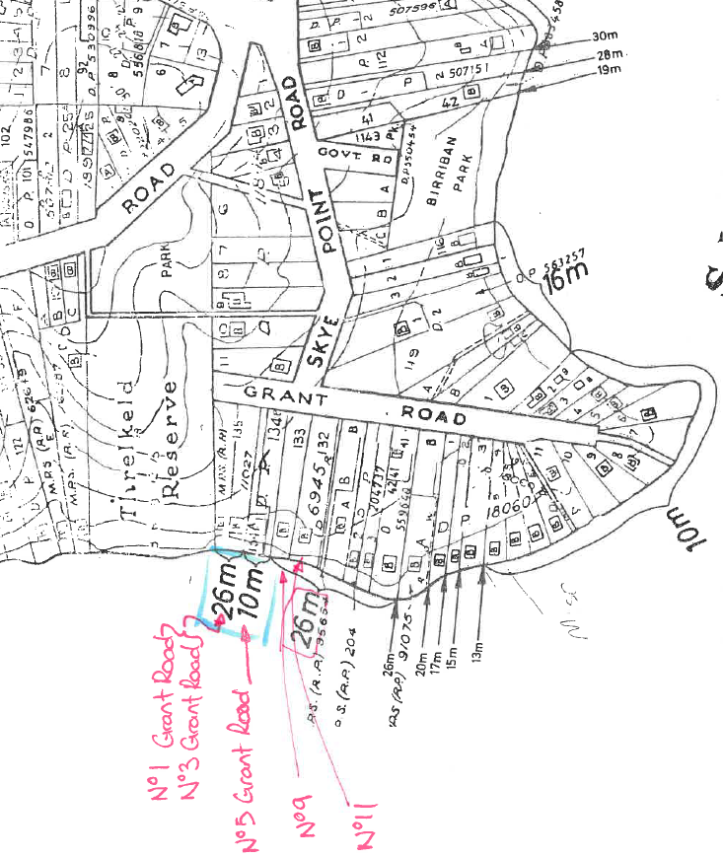  Extract from Lake Macquarie Foreshore Building Line Resolution 1988 Map No.27 (FBL Resolution)  In 2009, Council adopted an Integrated Foreshore Management Strategy (IFMS) and Action Plan, as the basis for addressing a variety of foreshore issues including a review into FBL setbacks. The IFMS developed a general methodology for establishing revised minimum FBL setback of 12m across the City.  During preparation of LMLEP 2014, the FBL misinterpretation occurred where a 12m FBL was incorrectly applied to 1 and 3 Grant Road, instead of the 26m FBL setback.  Council approved boundary adjustments for 5 and 7 Grant Road (DA/28/1994 and DA/2587/2001), which resulted in 7 Grant Road no longer having water frontage and 5 Grant Road being a larger lot.  Dwellings built on 3 and 5 Grant Road since 2001 have been setback 26m to be consistent with surrounding dwellings.  This proposed amendment ensures that future development on 1 Grant Road will be setback consistent with surrounding dwellings.
15 | Amend Schedule 5 Environmental Heritage to remove property description 14A Almora Close, Cardiff South and replace with 29B Haddington Drive, Cardiff South.  Discussion:  The amendment will update a property description to be consistent with the location of heritage item 41 known as ‘Former Colliery Tramway’.
16 | Amend Schedule 5 Environmental Heritage to include a new Local Heritage Item known as Dora Creek road (former rail) bridge at Main Road, Dora Creek.  Discussion:  The purpose of Item 16 is to list the Dora Creek road (former rail) bridge as a local heritage item under Schedule 5 of LMLEP 2014.  Council received notification that the above item had been listed by the National Trust of Australia (NSW) on its Trust Register on 31 July 2019 advising to apply provisions to conserve its heritage significance. The National Trust Register Listing Report (refer to Attachment 1) provided a Statement of Significance and Comparative Context which outlined the local significance of the Dora Creek Road (former rail) Bridge to the Lake Macquarie Local Government Area.  The Dora Creek road (former rail) bridge is structurally and functionally significant. The Dora Creek road (former rail) bridge is a rare example of a large wrought iron plate web girder bridge with an attached pedestrian footpath constructed in 1887. Additionally, at a 159.72m span, the bridge is the largest of its type in the State.  In 1958, a steel through-girder bridge was constructed immediately upstream of the former rail bridge to cater for advances in rail technology and the deteriorating condition of the former rail bridge. The former rail bridge was converted to the current road bridge during this time, however the local Dora Creek community had sought a road bridge connection from 1922.  Aesthetically, the Dora Creek road (former rail) bridge is significant as it is identified as a local landmark structure with views from either bank of Dora Creek and the Dora Creek township.  Council has consulted with Transport for NSW (former Roads and Maritime Service), who on 2 October 2019 advised no objection and reinforced the local significance of the Dora Creek road (former rail) bridge (refer to Attachment 4). Transport for NSW stated that the bridge would be listed on its Section 170 Register under the Heritage Act 1977, complementing the heritage listing of the adjoining upstream Dora Creek Railway Underbridge.
17 | Amend Heritage Map (HER_009A) to reflect subject property heritage description under Schedule 5 Environmental Heritage.  Discussion:  The purpose of Item 17 is to rectify a mapping anomaly to Heritage Map (HER_009A) to incorporate the entire subject property to reflect heritage item 149 known as ‘Speers Point Park (including shelter shed and Minenwerfer (or German mortar))’.  Council was made aware of the anomaly during the assessment of a multi-arts space development (DA/1336/2019) at the subject property which did not consider the European heritage significance of the park.  The subject property is listed as a local heritage item under Schedule 5 of LMLEP 2014 known as ‘Speers Point Park’. However, the corresponding Heritage Map (HER_009A) only identifies the shelter shed and minenwerfer structure.  Under LMLEP 2004 the shelter shed (previous Item SP-36) and minenwerfer (previous Item number SP-37) were listed as heritage items, however Speers Point Park was not listed as a heritage item. Following the adoption of the Speers Point Master Plan and Plan of Management (PoM) in 2008, it was recommended to include Speers Point Park as a heritage item due to its historical and social significance as outlined in the Statement of Significance from the PoM below.  Speers Point Park as a whole, formerly known as Lake Macquarie Park, is considered significant through its association with the cultural history of settlement and development in both the Lake Macquarie and Newcastle districts. Historical and social significance is supported by the known historical record through the establishment and development of the park as a direct result of community demand with its early management by elected community individuals in the form of a Trust.  An identifiable social link with families and industries in the Newcastle and Lake Macquarie districts is apparent through the continuity of use of the park for social and recreation pursuits since its inception through to the present.  Furthermore, individual items contained within the park (Shelter Shed and Minenwerfer monument) are considered culturally significant at the local level, as reflected by their listing on the Lake Macquarie Local Environmental Plan 2004.  The continuity and variety of use of the park for more than 100 years, and the potential deposition of relics and artefacts that represent these various historical phases also give the park scientific value. This value is derived from the prospective information that these items could contribute about the history of the park and people who utilised its space.  Therefore, Speers Point Park is considered significant primarily for its historical and social values. In addition, the park is considered moderately significant for its scientific values owing to the potential to contribute further information to the existing historical record. Significance is applied at the local level and is of a representative value.  Following the conversion of LMLEP 2004 to LMLEP 2014, Speers Point Park was included as a heritage item under Schedule 5 to be consistent with the Speers Point Master Plan and PoM. However, during the conversion the anomaly with the heritage map occurred.
18 | Amend Urban Release Map (URA_009C) by removing the subject properties from ‘Warners Bay Area 1’ Urban Release Area.  Discussion:  The purpose of Item 19 is to partially remove the Urban Release Area (URA) map, known as ‘Warners Bay Area 1’ from the subject properties that have made satisfactory arrangements to contribute to the provision of State public infrastructure and have prepared a development control plan. The removal of the URA map from these properties will reduce administrative complexity at the development application stage.  In 2007, Council adopted the East Munibung Hill Precinct Area Plan and Urban Design Guidelines (07ST0026) which incorporated the subject properties. The Area Plan’s aim was to ensure a more rigours and integrated approach to assessing future development within the broader East Munibung Hill area.  In 2010, Amendment No. 11 to LMLEP 2004 rezoned the subject properties from Zone 10 Investigation Zone to Zone 2(1) Residential, Zone 2(2) Residential, and Zone 7(2) Conservation (Secondary). Additionally, Amendment 11 included the subject properties as a URA within Clause 62 of LMLEP 2004. The amendment did not require the preparation of a site specific DCP, as the broader East Munibung Hill Precinct Area Plan applied.  When LMLEP 2004 was converted to LMLEP 2014, land listed as a URA in Clause 62 and Schedule 8 of LMLEP 2004, were combined into Part 6 of LMLEP 2014.  The combination of these two clauses into Part 6 of LMLEP 2014 did not properly reflect the differences of the former clauses in LMLEP 2004, and failed to acknowledge that the subject properties within the URA known as ‘Warners Bay Area 1’ were never intended to require a site specific DCP as the broader East Munibung Hill Precinct Area Plan applied.  In 2015 and 2017, Council approved two development applications (DA/1470/2013 and DA/791/2016 respectively) for the subject properties, granting consent for two residential subdivisions. Concurrently, to these development approvals were the executed Planning Agreements for each residential subdivision known as 2014/6855 Warners Bay, Aranik, Aranik Investments Planning Agreement (applied under DA/1470/2013) and 2017/8322 52 Fairfax Road, Warners Bay, DPC Holdings NSW Planning Agreement (applied under DA/791/2016).  During the ongoing development of these subdivisions, Council obtained documentation from the Department of Planning, Industry and Environment advising that satisfactory arrangements were made for the provision of State infrastructure and services in accordance with Clause 6.1 of LMLEP 2014, for all subject properties. Refer to the Secretary’s Certificate of Satisfactory Arrangements at Attachment 2 and Attachment 3.

Part 3 – JUSTIFICATION
Section A – Need for the Planning Proposal
- Is the planning proposal a result of any strategic study or report?
The Planning Proposal is not the result of a strategic study or report relevant to the subject properties. The subject properties have been identified as a result of routine administrative processes arising from anomalies, and administrative errors within LMLEP 2014.
- Is the planning proposal the best means of achieving the objectives or intended outcomes, or is there a better way?
In order to achieve the proposed administrative amendment, the following options were considered:
Option 1
Submit a Planning Proposal to correct anomalies, administrative errors and the inclusion of a heritage item within Schedule 5 of LMLEP 2014.
This is the recommended option as it will achieve the objects of the EP&A Act 1979 by maintaining currency with changing community expectations and facilitating development, environmental and heritage conservation outcomes.
Option 2
Not pursue an amendment to the LMLEP 2014.
This is not the preferred option, as the effect of not submitting a Planning Proposal to amend the administrative aspects of the LMLEP 2014, renders the LEP as being less effective. It also does not achieve the overall objectives of the EP&A Act in providing an LEP which is current, addresses the views and concerns of the community, while facilitates development, environmental and heritage conservation outcomes.
Section B – Relationship to Strategic Planning Framework
- Is the planning proposal consistent with the objectives and actions of the applicable regional or sub-regional strategy (including the Sydney Metropolitan Strategy and exhibited draft strategies)? Is the planning proposal consistent with a council’s local strategy or other local strategic plan?
Hunter Regional Plan 2036 (HRP)
The HRP sets out a vision for the Hunter City Region to connect communities through a range of housing choices, employment, amenities and services. The proposal is consistent with the HRP as it will allow for a current LEP, reduce administrative complexity and improve development, environmental and heritage conservation outcomes.
Greater Newcastle Metropolitan Plan 2036 (GNMP)
The GNMP provides strategies and actions to deliver on the vision of the Hunter Regional Plan 2036 for the Newcastle Metropolitan Area. The proposal is consistent with the four outcomes of the GNMP.
- Is the planning proposal consistent with a council’s local strategy or other local strategic plan?
Lake Macquarie City Community Strategic Plan 2017-2027
The Lake Macquarie City Community Strategic Plan 2017-2027 has been developed with the people of Lake Macquarie outlining the vision and values of the community and providing clear strategies to achieve this.
The Planning Proposal is consistent with the vision and values as it ensures a current LEP, reduces administrative complexity and improve development, environmental and heritage conservation outcomes.
Draft Lake Macquarie Local Strategic Planning Statement
The draft Lake Macquarie Local Strategic Planning Statement aims to guide future development within the City and complements the aspirations within the Imagine Lake Mac Strategy. It sets seven planning priorities that articulate the special characteristics of the City supported by strategies and action to deliver these priorities.
The most relevant of these planning priorities which align with the Planning Proposal include:
- Planning priority 1: A city of vibrant centres – Where people live, work, visit and play;
- Planning priority 2: A City to call home – Where diverse housing options cater to everyone’s needs; and
- Planning priority 6: A city with a vast natural environment – That is valued, protected and enhanced.
Imagine Lake Mac Strategy
Imagine Lake Mac contains a number of aspirations for the City to guide future development which reflect the planning priorities within the draft Lake Macquarie Local Strategic Planning Statement. The most relevant of these aspirations, which align with the Planning Proposal include “A city to call home – that provides growth for new housing and diversity of housing”, and “A city with a vast natural environment - that protects and enhances natural landscape and heritage”.
Lake Macquarie Heritage Strategy 2017
The Lake Macquarie Heritage Study 2017 has been developed to identify and manage the diverse heritage within Lake Macquarie through the facilitation of nine objectives.
The most relevant of these objectives that align with the Planning Proposal include:
- Objective 2 - To increase knowledge and proactive management of heritage in the City of Lake Macquarie through the identification and listing of heritage items and conservation areas; and
- Objective 8 - To increase community participation and proactive conservation and management of heritage in the City of Lake Macquarie through the good example set by Council in the proper management of Council owned or operated heritage places.
Lake Macquarie Development Control Plan 2014 – North Cooranbong Precinct Area Plan
The purpose of the North Cooranbong Precinct Area Plan is to guide the design of subdivision, housing and commercial development within the North Cooranbong Urban Release Area. The North Cooranbong Precinct Area Plan incorporates the zone and subdivision layout from Concept Plan (07_0147) approved under State Environmental Planning Policy (Major Projects North Cooranbong) Amendment 2008.
As the Area Plan reflects the Concept Plan (07_0147), the alteration to zone boundaries envisaged in this Planning Proposal under Item 1 will necessitate an amendment to the Area Plan.
- Is the planning proposal consistent with applicable State Environmental Planning Policies?
The Planning Proposal is consistent with the relevant State Environmental Planning Policies (SEPPs) as outlined in Table 1 below.
Table 1: Assessment of the Planning Proposal against relevant SEPPs
SEPP | Relevance | Implications
SEPP No. 19 – Bushland in Urban Areas | The aim of this policy is to protect and preserve bushland within urban areas. | Items 1-3  The Planning Proposal is consistent with this policy as the proposal protects bushland identified for environmental or public open space by correcting zone to boundary anomalies removing incorrect residential and commercial zones.
SEPP No. 55 – Remediation of Land | The aim of this policy is to promote the remediation of contaminated land for the purpose of reducing the risk of harm to human health or any other aspect of the environment. | Item 1  The Planning Proposal is generally consistent with this policy.  Pursuant to Clause 6(4)(a), the properties are identified as potentially contaminated or contaminated land within Council mapping. Additionally, as per Clause 6(4)(b), the properties are identified as a class of land that underwent agricultural/horticultural activities and airport (now disused) activities for decades which may have caused contamination.  Previous approved developments for the Watagan Park Estate (inclusive of the subject properties) were accompanied by a number of contamination assessments. Most relevant to the properties are the following assessment reports:  - Remediation Action Plan – Stage 2 Subdivision Works 119 Avondale Road, Cooranbong (DA/942/2018 - Council ref: D08910624);  The remediation action plan seeks to enable suitability of land for a proposed school and residential uses. Recommended removal of contaminated soils or on-site treatment to reduce contaminated soils.  - Preliminary Site Investigation – 9 Courin Drive Cooranbong NSW (DA/1725/2017 - Council ref: D08541330/);  This report concluded that the subject property is considered to present a low risk of contamination that would not preclude future low to medium density residential uses.  Lastly, it is anticipated that any further subdivision of the subject property and subsequent development will require further contamination assessment, along with compliance to the Remediation Action Plan at the development application stage.
SEPP (Affordable Rental Housing) 2009 | The aim of this SEPP is to provide a consistent planning regime for the provision of affordable rental housing. | Items 1 – 4  The Planning Proposal is consistent with this policy as the subject properties are zoned for residential and mixed-use development, and affordable housing will be permissible on the land under the SEPP.
SEPP (Coastal Management) 2018 | The aim of the policy is to manage development in the coastal zone and protect the environmental assets of the coast. | The Planning Proposal is consistent with this policy. A number of properties are within the Coastal Environment Area under the policy. However, the proposal merely rectifies mapping anomalies or property descriptions. Any future development application applying to these properties will consider Clause 13 of the SEPP.
SEPP (Infrastructure) 2007 | The aim of the policy is to facilitate the effective delivery of infrastructure. | Items 1 – 5  The Planning Proposal is consistent with this policy as it will not hinder the delivery of any infrastructure applying to the subject properties. Rather, the proposal will rectify zone to boundary anomalies which will facilitate the ongoing delivery of infrastructure within residential and commercial subdivisions.  Item 16  The Planning Proposal is consistent with this this policy. The listing of the Dora Creek road (former rail) bridge as a local heritage item will not impede the delivery of future infrastructure works. Any future development would be required to submit a heritage impact assessment and consult with Council pursuant to Clause 14 of the SEPP.
- Is the planning proposal consistent with applicable Ministerial Directions (s.9.1 directions)?
An assessment of the Planning Proposal and its consistency against the applicable Ministerial Directions is provided at Table 2 below.

Table 2: Consistency with applicable Section 9.1 Ministerial Directions
Ministerial Direction | Objective/s | Consistency / Comment
1.1 Business and Industrial Zones | (a) Encourage employment growth in suitable locations,  (b) Protect employment land in business and industrial zones, and  (c) Support the viability of identified centres. | Item 1  The Planning Proposal will be consistent with the objectives of this direction. The rezoning of a partial residential zone to a business zone will retain the existing floorspace area for future employment land.  Item 5  The Planning Proposal is considered consistent. The rezoning of a partial residential zone to business zone will increase the potential floorspace area for future employment lands.
1.2 Rural Zones | Protect the agricultural production value of rural land. | This direction does not apply as the proposal will not affect land within an existing rural zone.
1.3 Mining, Petroleum Production and Extractive Industries | Ensure that the future extraction of State or regionally significant reserves of coal, other minerals, petroleum and extractive materials are not compromised by inappropriate development. | The direction does not apply as the proposal will not prohibit or restrict existing or potential mining, petroleum production or mineral extractive industries.
1.4 Oyster Aquaculture | To consider and protect priority Oyster Aquaculture areas and oyster aquaculture when preparing a planning proposal | The direction does not apply as the proposal is not within a priority Oyster Aquaculture Area or oyster aquaculture outside a priority oyster aquaculture area.
1.5 Rural Lands | Protect agricultural production value of rural land, and facilitate the orderly and economic development of rural lands for rural and related purposes | This direction does not apply to the Lake Macquarie Local Government Area.
2.1 Environment Protection Zones | Protect and conserve environmentally sensitive areas. | Item 2  The Planning Proposal will be consistent with the objectives of this direction. The rezoning of a partial residential zone to an environmental zone will facilitate conservation outcomes through the dedication of biodiversity offset lot to Council.
2.2 Coastal Management | Protect and manage coastal areas of NSW. | Items 4, 5, 14, 16 and 17  The Planning Proposal will be consistent with the objectives of this direction. The subject properties are identified within the ‘Coastal Environment Area’. The Planning Proposal will not intensify future development and is consistent with relevant provisions of NSW Coastal Policy.
2.3 Heritage Conservation | Conserve items, areas, objects and places of environmental heritage significance and indigenous heritage significance. | Item 15  The Planning Proposal will be consistent with the objectives of this direction. The Planning Proposal rectifies anomalies to the Lot and DP and property address for the heritage item.  Item 16  The Planning Proposal will be consistent with the objectives of this direction. The inclusion of the Dora Creek road (former rail) bridge as a local heritage item will enhance the heritage profile within the Lake Macquarie Local Government Area, while future works will be carried out in line with its heritage significance improving long-term conservation.  Item 17  The Planning Proposal will be consistent with the objectives of this direction. The Planning Proposal will rectify mapping anomalies to align with heritage item description.
2.4 Recreation Vehicle Areas | Protect sensitive land or land with significant conservation values from adverse impacts from recreation vehicles. | The direction does not apply as the Planning Proposal is not located on sensitive land with significant conservation values that is impacted by recreational vehicles.
3.1 Residential Zones | (a) Encourage a variety and choice of housing types to provide for existing and future housing needs,  (b) Make efficient use of existing infrastructure and services and ensure that new housing has appropriate access to infrastructure and services, and  (c) Minimise the impact of residential development on the environment and resource lands. | Item 1  The Planning Proposal will be inconsistent with the objectives of this direction. Although, the Planning Proposal will alter an existing residential zone by rezoning 1.2 hectares it to a higher density residential zone. The Planning Proposal will also rezone 1,490m² of an existing residential zone to business zone. This is considered a minor inconsistency and is justified as the proposed alterations will facilitating infrastructure works and be consistent with the approved subdivision layout.  Item 2  The Planning Proposal will be inconsistent with the objectives of this direction. The Planning Proposal will alter an existing residential zone by rezoning 1,500m² to an environmental zone. This is considered a minor inconsistency and is justified as the residential zone will facilitate the dedication of a biodiversity offset lot pursuant to development approval (DA/1496/2017).  Item 3  The Planning Proposal will be inconsistent with the objectives of this direction. The Planning Proposal will alter an existing residential zone by rezoning 1.64ha hectares to a public recreation zone. This is considered a minor inconsistency and is justified as the proposed alterations will facilitating infrastructure works and be consistent with the approved subdivision layout.  Item 4  The Planning Proposal will be consistent with the objectives of this direction. The Planning Proposal will alter an existing lower density residential zone to a higher density residential zone to be consistent with the approved subdivision layout.  Item 5  The Planning Proposal will be inconsistent with the objectives of this direction. The Planning Proposal will alter an existing residential zone by rezoning 485m² to a business zone. This is considered a minor inconsistency and is justified as the proposed alterations will be consistent with approved subdivision layout.  Conclusively, the Planning Proposal requests concurrence from the Director-General of the Department of Planning, Industry and Environment that the inconsistent provisions in the LEP are of minor significance.
3.2 Caravan Parks and Manufactured Home Estates | (a) Provide for a variety of housing types, and  (b) Provide opportunities for caravan parks and manufactured home estates. | The direction does not apply as the proposal will not prohibit or restrict caravan parks or manufactured home estates.
3.3 Home Occupations | Encourage the carrying out of low-impact small businesses in dwelling houses. | The proposal is consistent with the direction as the proposal will not prohibit home occupations from being carried out.
3.4 Integrating Land Use and Transport | Ensure that urban structures, building forms, land use locations, development designs, subdivision and street layouts achieve the following planning objectives:  (a) improving access to housing, jobs and services by walking, cycling and public transport, and  (b) increasing the choice of available transport and reducing dependence on cars, and  (c) reducing travel demand including the number of trips generated by development and the distances travelled, especially by car, and  (d) supporting the efficient and viable operation of public transport services, and  (e) providing for the efficient movement of freight. | Items 1 - 5  The Planning Proposal is consistent with the objectives of this direction. The Planning Proposal will enable ongoing efficiencies to the current and future approved road networks within residential and commercial subdivisions.
3.5 Development Near Regulated Airports and Defence Airfields | (a) Ensure the effective and safe operation of aerodromes, and  (b) Ensure that their operation is not compromised by development that constitutes an obstruction, hazard or potential hazard to aircraft flying in the vicinity, and  (c) Ensure development for residential purposes or human occupation, if situated on land within the Australian Noise Exposure Forecast (ANEF) contours of between 20 and 25, incorporates appropriate mitigation measures so that the development is not adversely affected by aircraft noise. | The direction does not apply as the proposal is not in the proximity of an operating regulated airport or defence airfield.
3.6 Shooting Ranges | (a) Maintain appropriate levels of public safety and amenity when rezoning land adjacent to an existing shooting range,  (b) Reduce land use conflict arising between existing shooting ranges and rezoning of adjacent land,  (c) Identify issues that must be addressed when giving consideration to rezoning land adjacent to an existing shooting range. | The direction does not apply as the Planning Proposal is not within the proximity of a shooting range.
4.1 Acid Sulfate Soils | Avoid significant adverse environmental impacts from the use of land that has a probability of containing acid sulfate soils. | Items 2, 4, 5, 14 and 17  The subject properties are identified in LMLEP 2014 maps as having Class 2 and 5 Acid Sulfate Soils. The Planning Proposal is consistent with the direction as Council’s LMLEP 2014 and LMDCP 2014 currently contain appropriate controls to ensure potential Acid Sulphate Soils are minimised, which will be addressed at the development application stage.
4.2 Mine Subsidence and Unstable Land | Prevent damage to life, property and the environment on land identified as unstable or potentially subject to mine subsidence. | Items 3,4,5,14 and 17  The Planning Proposal is inconsistent with this direction. The Planning Proposal is located on a number of Mine Subsidence Districts and will be referred for consultation to the Subsidence Advisory NSW.
4.3 Flood Prone Land | (a) Ensure that development of flood prone land is consistent with the NSW Government’s Flood Prone Land Policy and the principles of the Floodplain Development Manual 2005, and  (b) Ensure that the provisions of an LEP on flood prone land is commensurate with flood hazard and includes consideration of the potential flood impacts both on and off the subject land. | Item 14  The Planning Proposal will be consistent with the objectives of this direction. The subject properties are partially subject to high hazard-flooding. The Planning Proposal will apply a 26m FBL setback provision to the properties reducing the flooding risk. Any future development would be further restricted to build within the high-hazard flooding area.
4.4 Planning for Bushfire Protection | (a) Protect life, property and the environment from bush fire hazards, by discouraging the establishment of incompatible land uses in bush fire prone areas, and  (b) Encourage sound management of bush fire prone areas. | Items 1, 2, 3 and 5  The direction applies as these properties are located within bush fire prone land. The Planning Proposal will generally be consistent with the direction as the subject properties have undertaken prior bushfire assessments that have satisfied the Planning for Bushfire Guidelines 2006 being approved and conditioned by Council and/or the NSW Rural Fire Service. A list of the relevant bushfire assessments are listed below and will be provided to the NSW Rural Fire Service:  Item 1:  Bushfire Threat Assessment report – Super Lot Site, Watagan Park, North Cooranbong NSW, prepared by MJD Environmental (DA/1725/2017 - Council ref: D08541325).  Item 2:  Bushfire Threat Assessment report – 617 Freemans Drive, Cooranbong NSW, prepared by MJD Environmental (DA/1496/2017 Council ref: D08508301).  Item 3:  Bushfire Protection Assessment for proposed Torrens title residential subdivision stages 21, 22 & 23, No.20 Pitt Street & 20 Myrtle Street Teralba, prepared by Australian Bushfire Protection Planners (DA/2413/2007 Council ref: D0108974).  Item 5:  Bushfire Threat Assessment for Proposed Mixed Development at Lot 517 DP 1047107, prepared by Harper Somers O’Sullivan (DA/628/2006/A Council ref: D00445689).  Item 14  The direction applies as these properties are located within bush fire prone land. The Planning Proposal is inconsistent with the direction. This item will be referred to the NSW Rural Fire Service for comment. Nevertheless, Item 14 applies only to the FBL setback, with dwellings currently existing on both properties. Any future development would need to comply with the Planning for Bushfire Protection Guidelines 2006 and Council’s LMDCP 2014 at the development application stage.
5.10 Implementation of Regional Plans | Give legal affect to the vision, land use strategy, goals, directions and actions contained in Regional Plans | The Planning Proposal is consistent with the objectives of this direction. The Planning Proposal rectifies anomalies or inconsistencies within LMLEP 2014 which will result in a current and efficient LEP to facilitate ongoing development, environmental and heritage outcomes aligning with the goals of the Hunter Regional Plan and Greater Newcastle Metropolitan Plan.
6.1 Approval and Referral Requirements | Ensure that LEP provisions encourage the efficient and appropriate assessment of development. | The proposal is consistent with the  direction as it does not contain any  provisions that require concurrence, or  identify development as ‘designated’.
6.2 Reserving Land for Public Purposes | (a) Facilitate the provision of public services and facilities by reserving land for public purposes, and  (b) Facilitate the removal of reservations of land for public purposes where the land is no longer required for acquisition. | Item 3  The Planning Proposal is inconsistent with the direction as it alters existing zoning or reservations of land for public purpose.  The Planning Proposal requests concurrence from the Director-General of the Department of Planning, Industry and Environment that the inconsistency is of minor significance.  The Planning Proposal will alter the current RE1 Public Recreation zone within the Billy’s Lookout Residential Subdivision from 19.12 hectares to 18.85 hectares. This represents a loss of 1.8% of public open space within the residential subdivision and is considered of minor significance. Additionally, the Planning Proposal will rectify the zone boundary anomaly occurring at the subdivision stage. This will reduce administrative complexity and ensure the efficient delivery of the subdivision development.
6.3 Site Specific Provisions | Discourage unnecessarily restrictive site-specific planning controls. | The direction is consistent with the direction (4)(c). The amendment will not impose additional development standards to those already contained within the LMLEP 2014.
Section C – Environmental, Social and Economic Impact
- Is there any likelihood that critical habitat or threatened species, populations or ecological communities, or their habitats, will be adversely affected as a result of the proposal?
As the Planning Proposal generally applies to administrative corrections, anomalies and zone boundary misalignments within approved subdivision developments there are no impacts on critical habitat or threatened species, populations or ecological communities, or their habitats.
The subject property in Item 2 will ensure it is altered and rezoned entirely to an E2 Environmental Conservation zone facilitating the dedication of a biodiversity offset lot to Council, which will result in a positive environmental outcome.
- Are there any other likely environmental effects as a result of the planning proposal and how are they proposed to be managed?
The subject properties in Items 1 to 5 are bushfire prone land, with item 1 containing contaminated land. Previous development applications have assessed the environmental effects of these properties implementing appropriate mitigation measures. The Planning Proposal will not result in deviation from these prior assessments. As such, there is not likely to be any environmental effects from the Planning Proposal.
The subject properties in Items 14 are identified as high hazard flood prone land and bushfire prone land. Nevertheless, the Planning Proposal will reduce adverse impacts of flooding by applying a foreshore building line that restricts development within flood prone land. Additionally, consultation with the NSW RFS will be undertaken to guarantee appropriate conditions are in place to ensure mitigation of bushfire risks, however, any future development will be required to adhere to bushfire prone land provisions within LMDCP 2014.
Given that the remainder of the Planning Proposal generally applies to administrative corrections and mapping anomalies there are no foreseeable environmental effects as a consequence of the proposal.
- How has the planning proposal adequately addressed any social and economic effects?
Item 17 will rectify a mapping anomaly to include Speers Point Park to reflect the heritage description. This will result in a benefit social impact as it recognises the historic and social significance of Speers Point Park safeguarding it from future development adverse impacts. Economically, listing the property as a heritage item will require a Heritage Impact Statement for future development. This may produce adverse economic impacts as the cost to prepare a development application would increase for the landowner being Council.
Consultation with Council’s Development Assessment and Certification and Assets Management departments on 18 October 2019 raised no reservations to this issue as LMLEP 2014 currently lists the subject property as a heritage item already requiring the need to prepare a HIS.
The subject properties in Item 18, have certified satisfactory arrangements made for the provision of State infrastructure and services. Therefore, there will be no risk to Council or the state of lost development contributions.
Overall, there will be positive social and economic outcomes from the proposed amendments as it clarifies current administrative processes, corrects mapping anomalies and errors in property descriptions, thereby facilitating development, environmental and heritage conservation outcomes.
Section D – State and Commonwealth Interests
- Is there adequate public infrastructure for the planning proposal?
Yes. The subject properties in items 1 – 5 are currently within approved and / or developed subdivisions. The realignment of the zone boundary for these properties will ensure infrastructure can be efficiently delivered in future.
Yes. Item 16, the listing of the Dora Creek road (former rail) bridge will not impede the delivery of future infrastructure works. Listing as a heritage item would only require a Heritage Impact Statement during future works. Consultation with Transport for NSW (former Roads and Maritime Service) on 2 October 2019 raised no objection to the listing.
Yes. The subject properties in Item 18 are within approved and / or developed subdivisions, which have certified satisfactory arrangements made for the provision of State infrastructure and services.
- What are the views of State and Commonwealth public authorities consulted in accordance with the Gateway determination?
Consultation with State and Commonwealth public authorities will be conducted in accordance with the Gateway determination as below:
- Subsidence Advisory NSW regarding consistency with Section 9.1 Direction 4.2
- NSW Rural Fire Service regarding consistency with Section 9.1 Direction 4.2
- Department of Planning, Industry and Environment regarding consistency with Section 9.1 Direction 6.2.

Part 4 – MAPPING
Map 1 – Locality
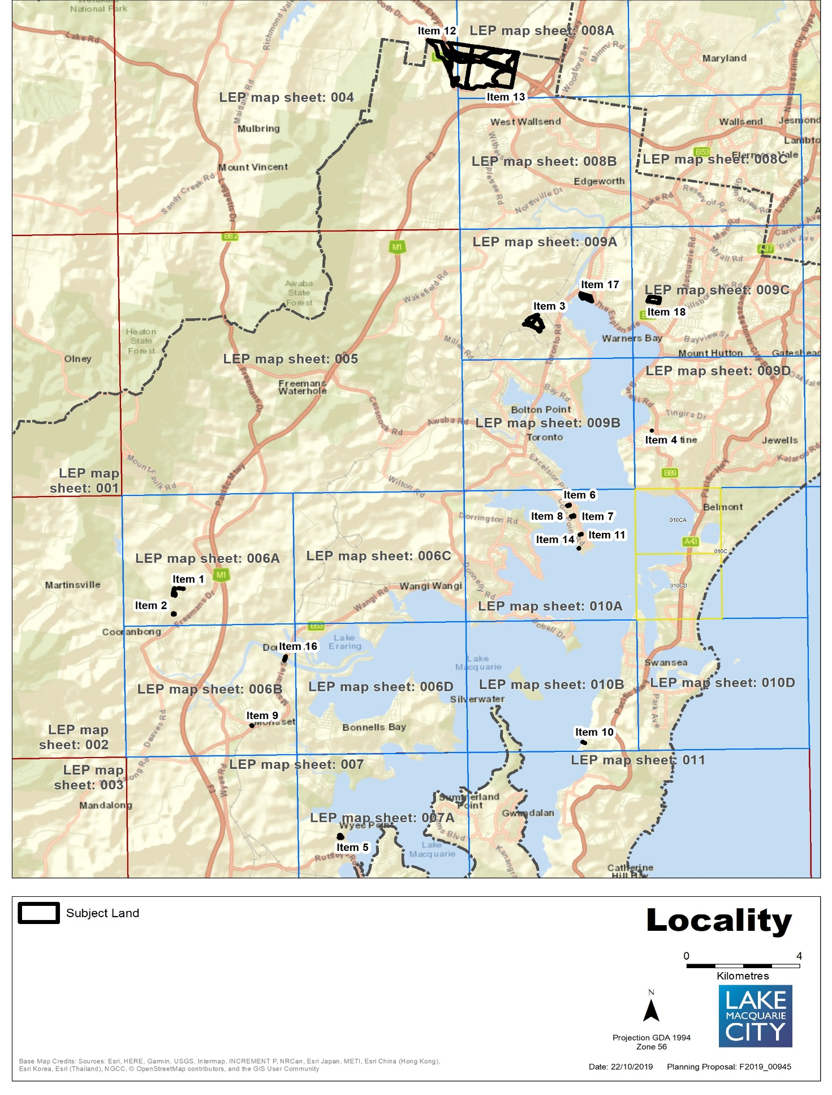
Map 2a – Item 1 – Aerial, Existing Zones, Minimum lot size, Height of building
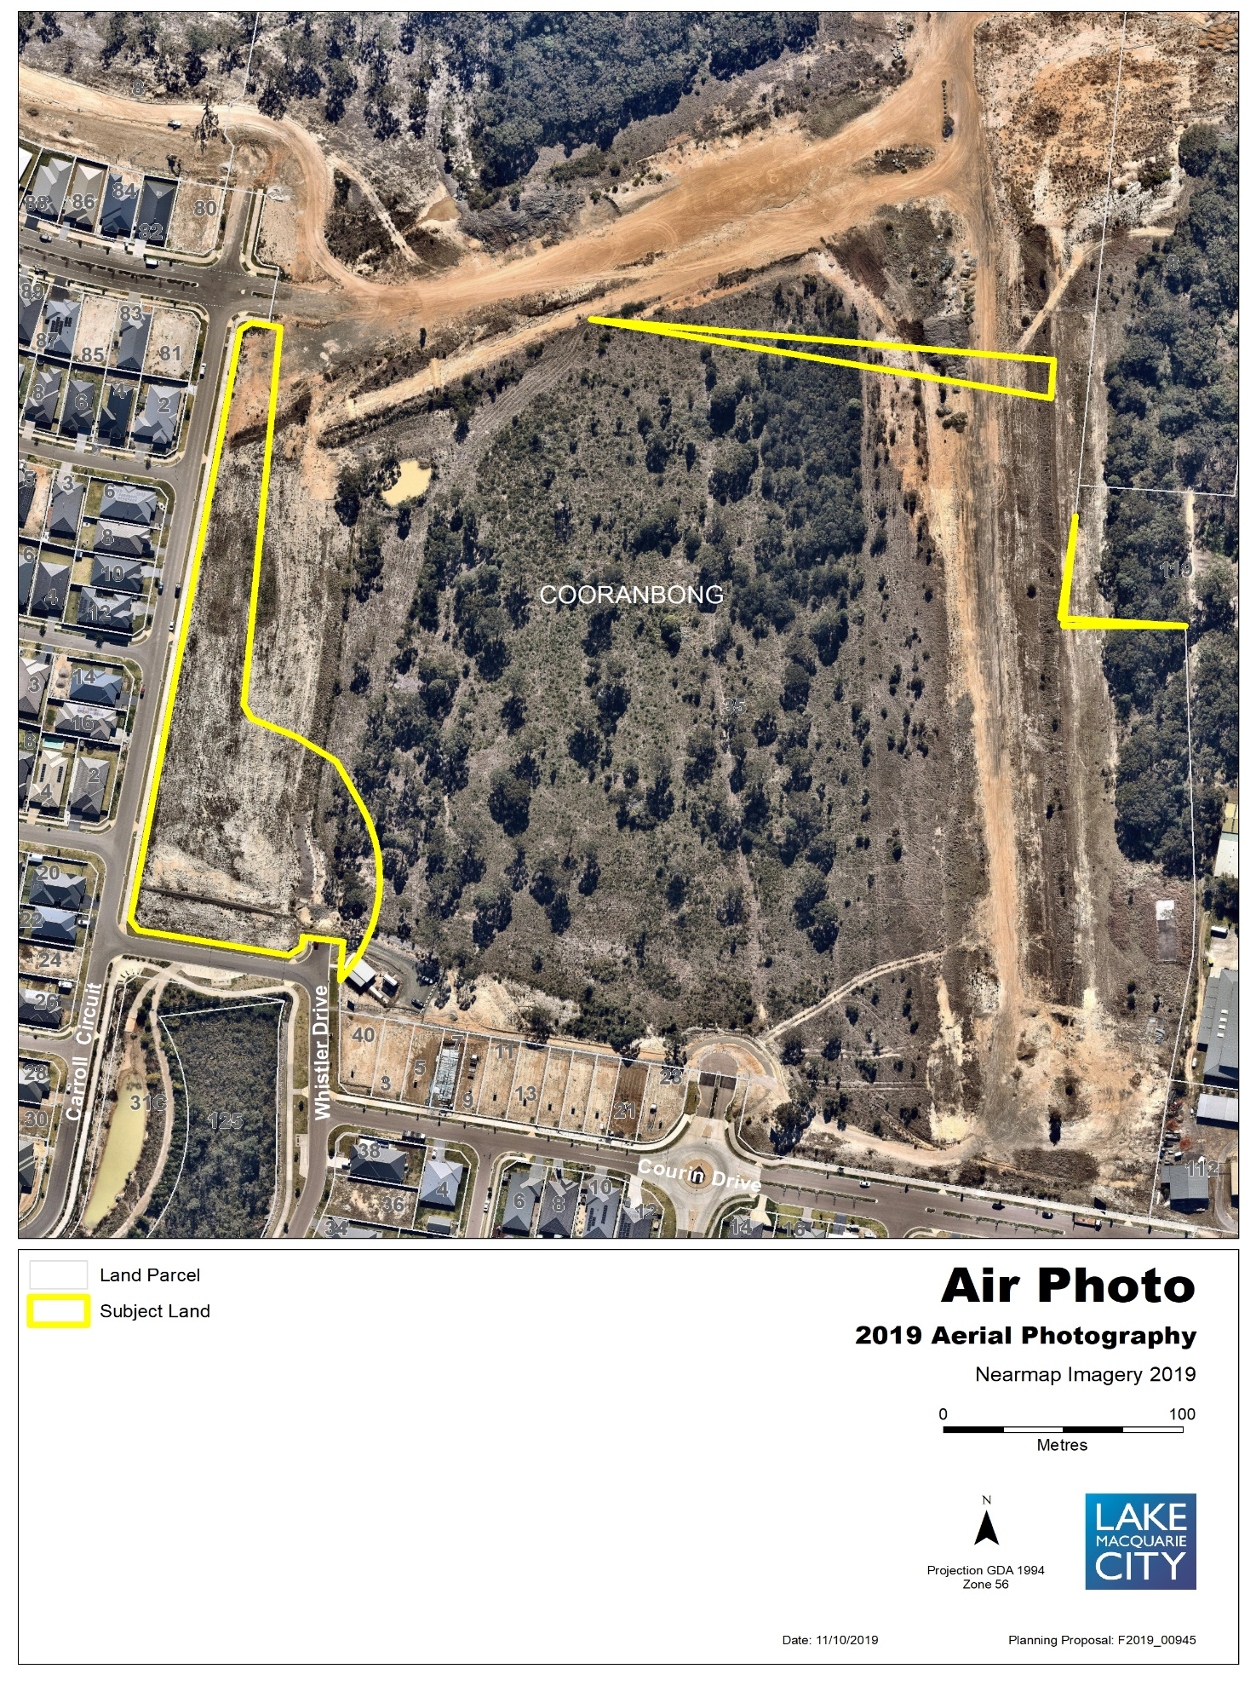

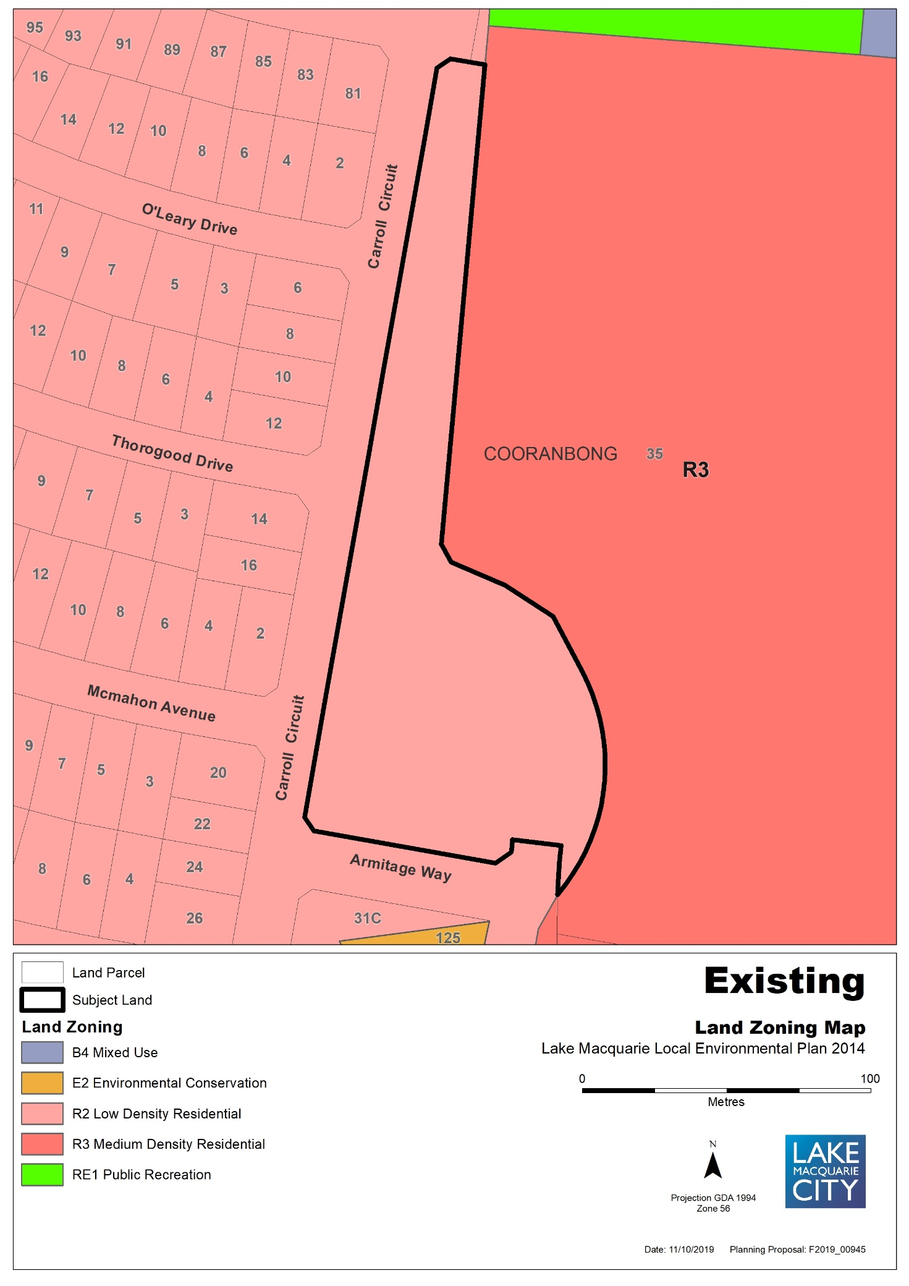
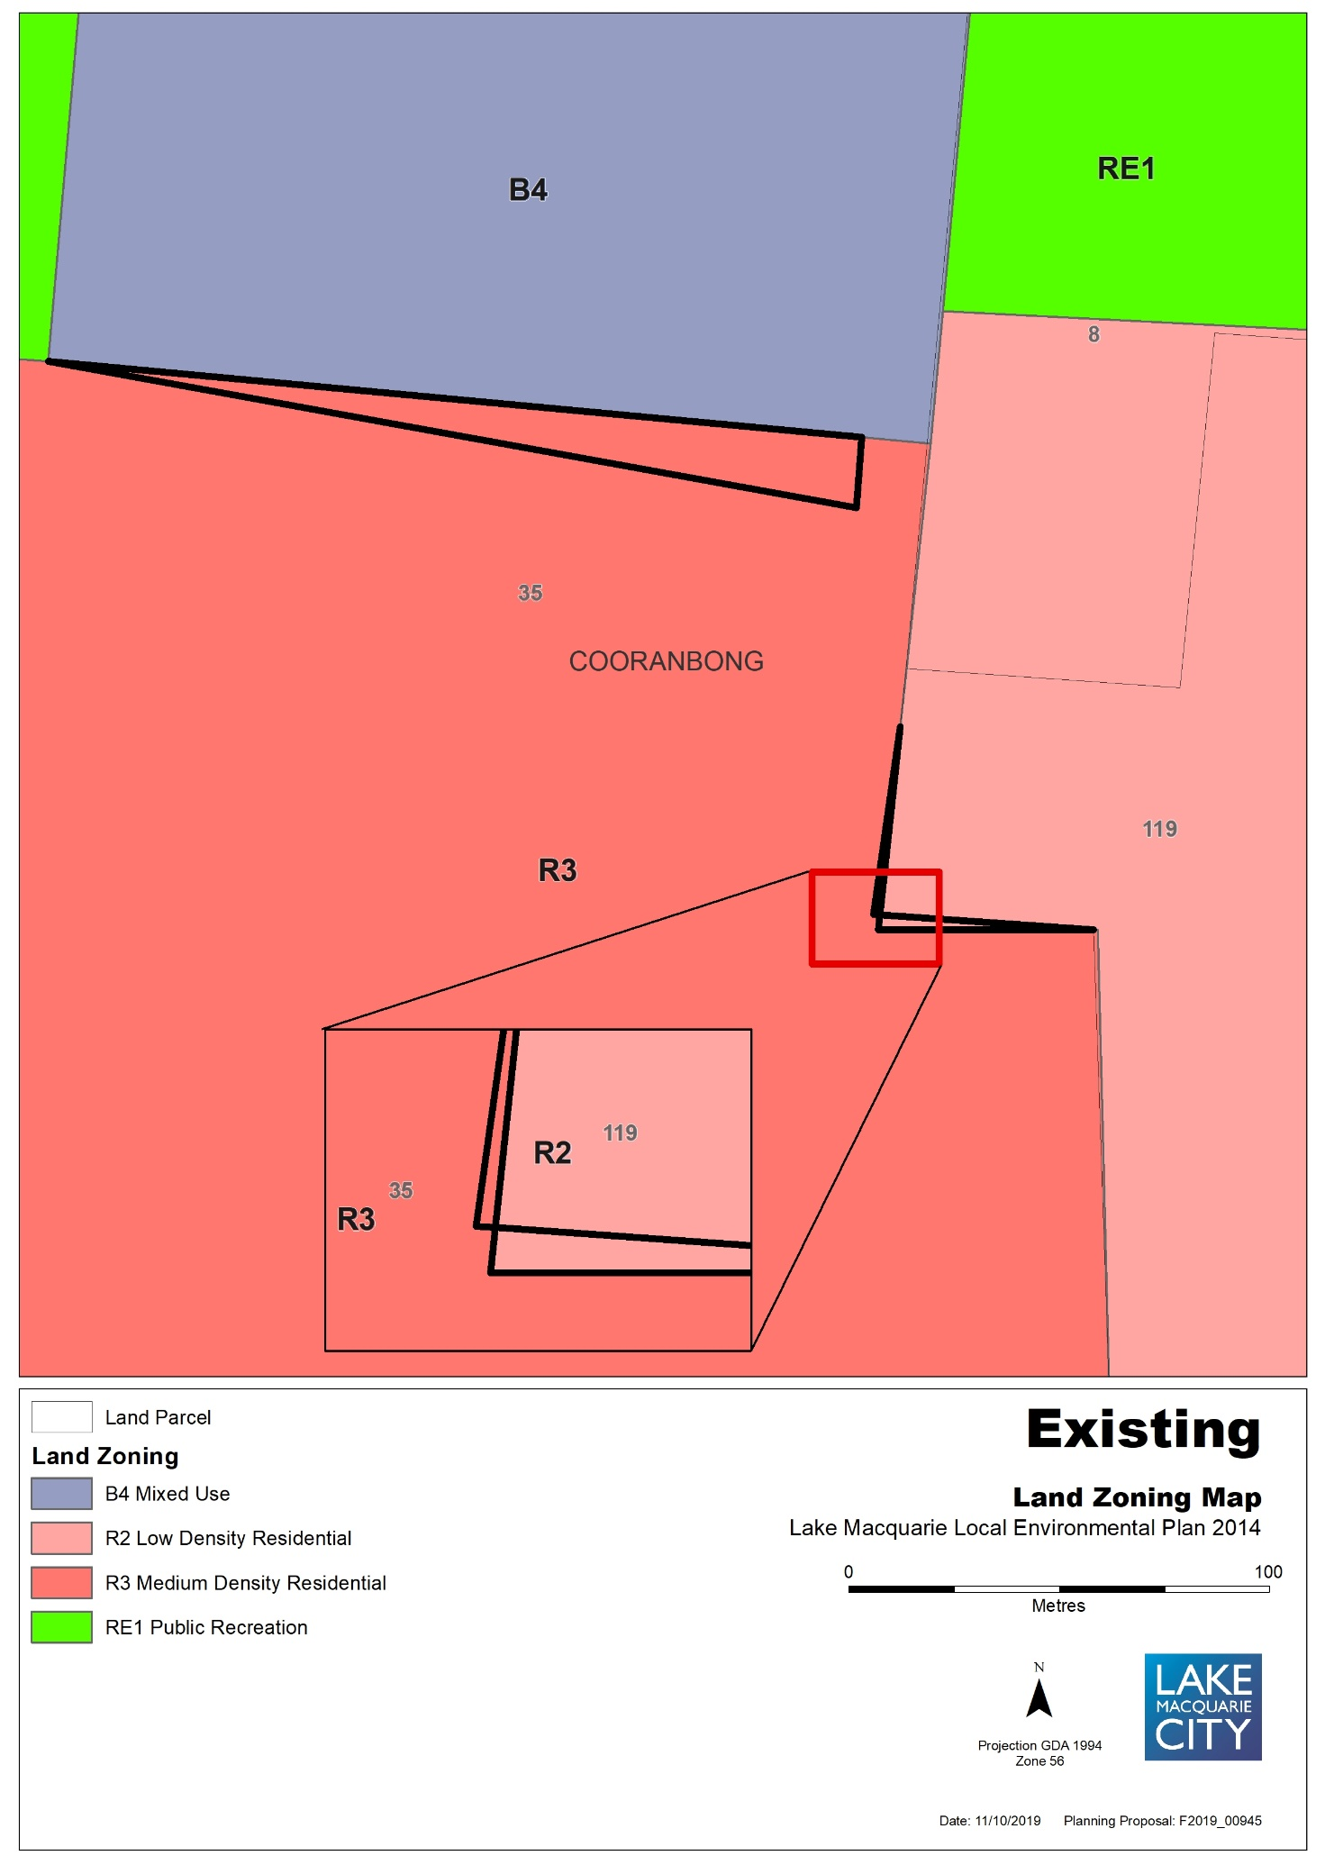
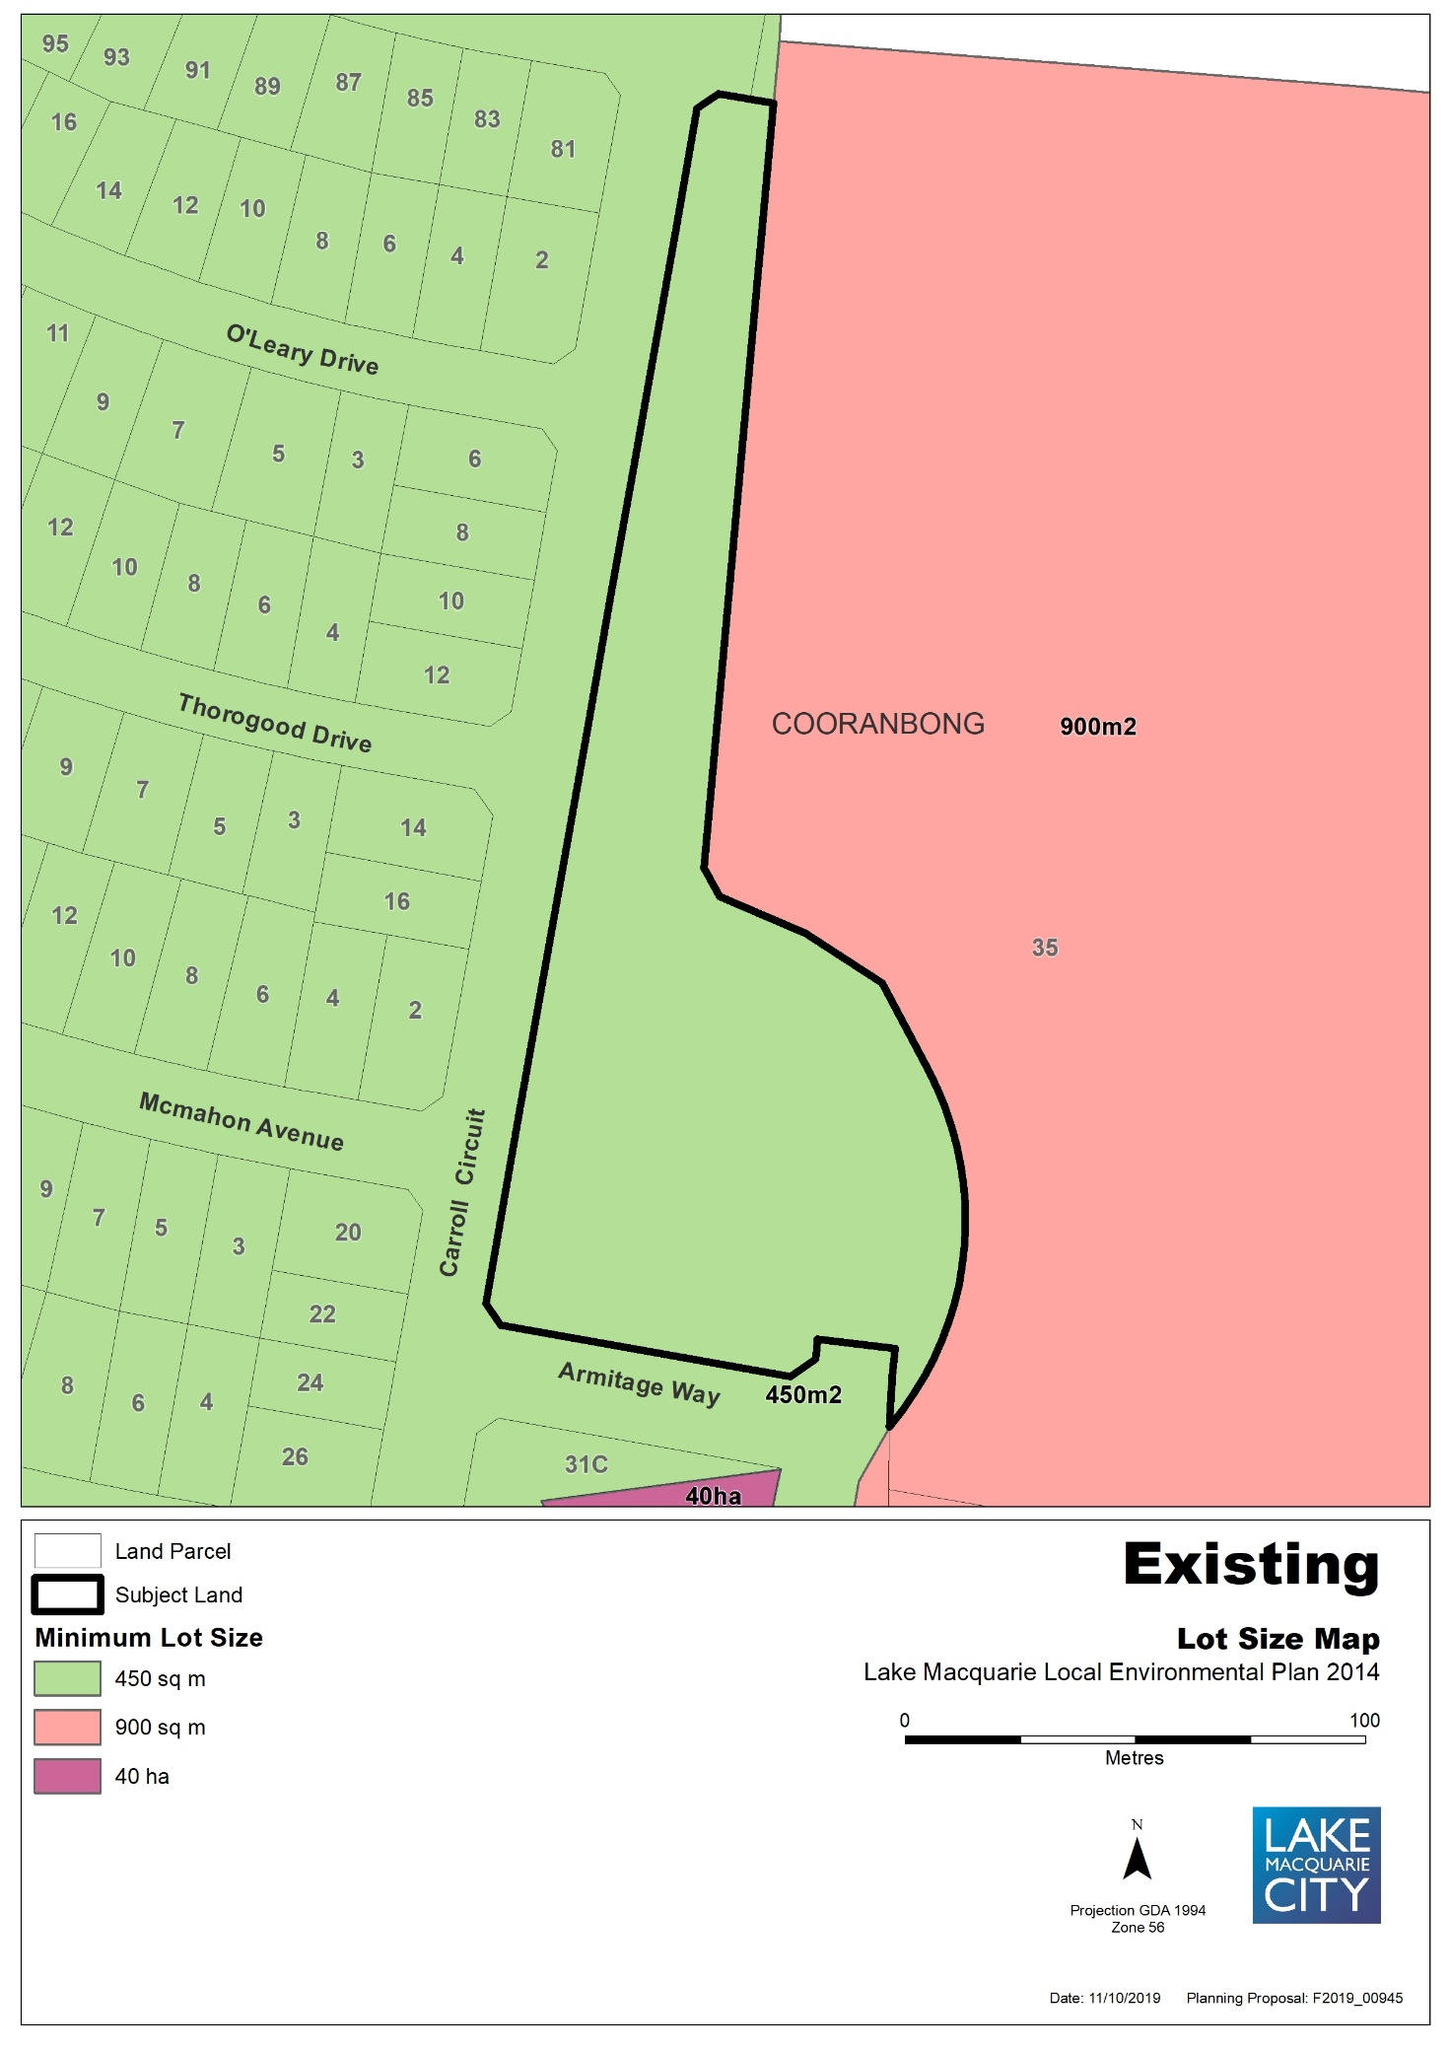

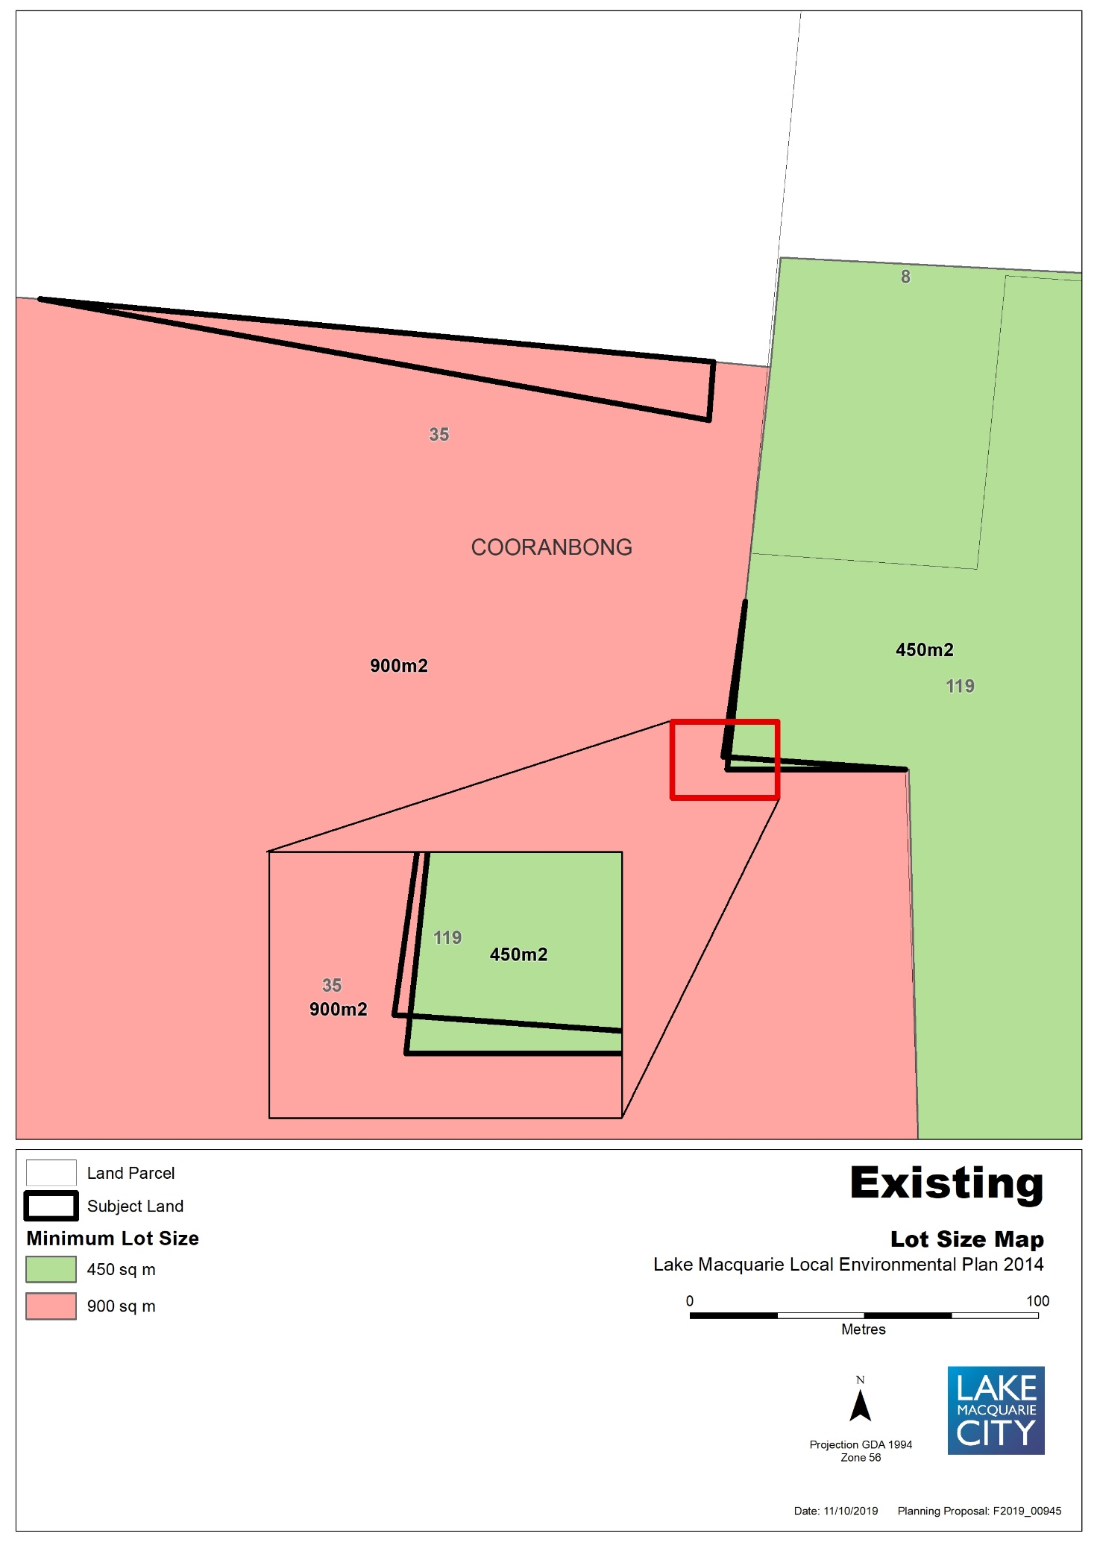

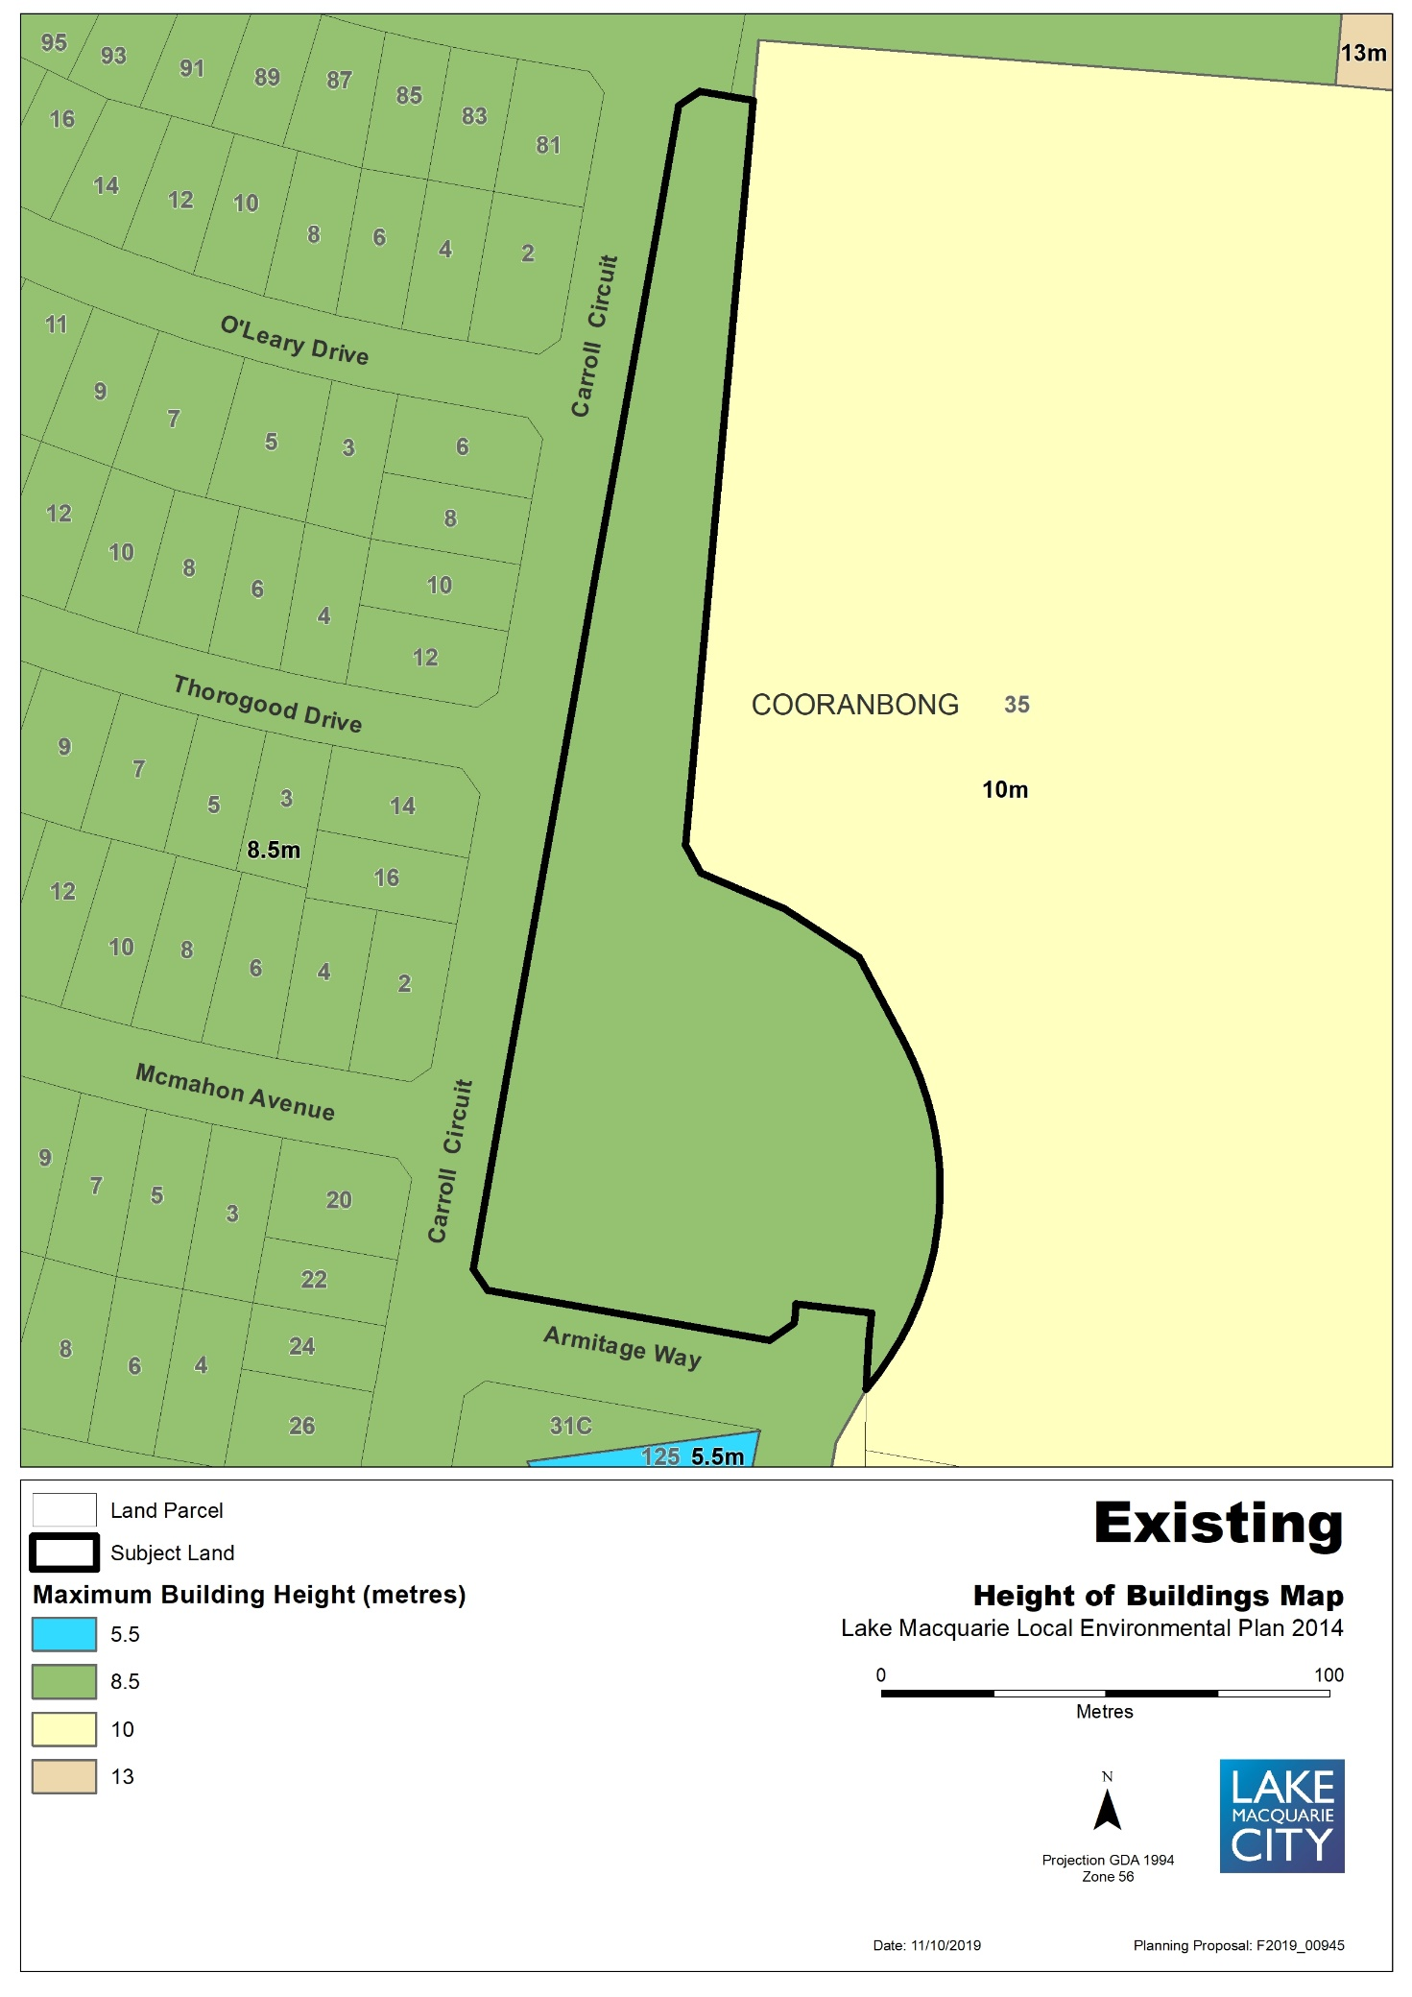

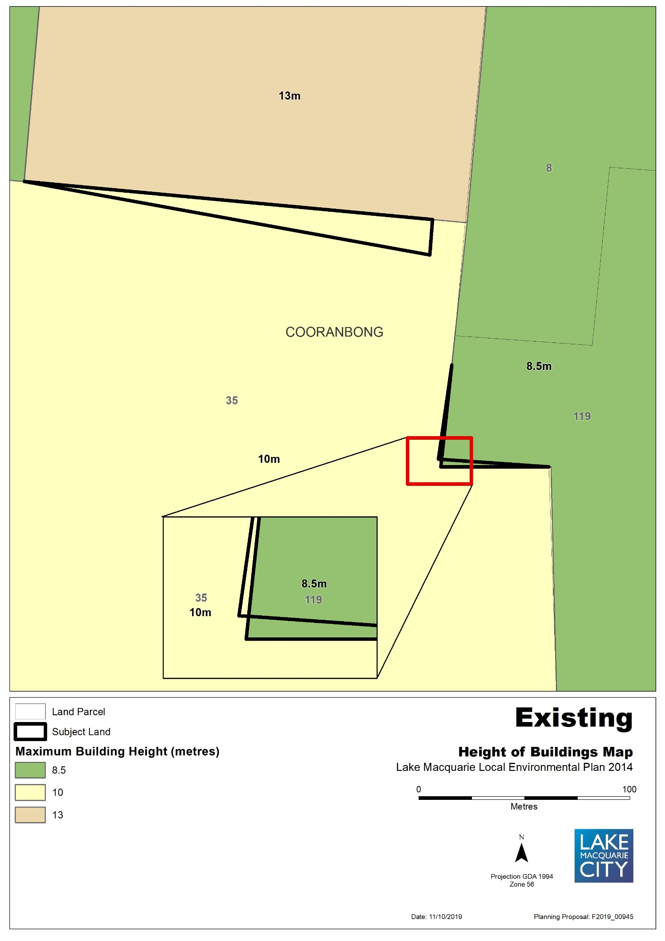

Map 2b – Item 1 – Proposed Zones, Minimum lot size, Height of building
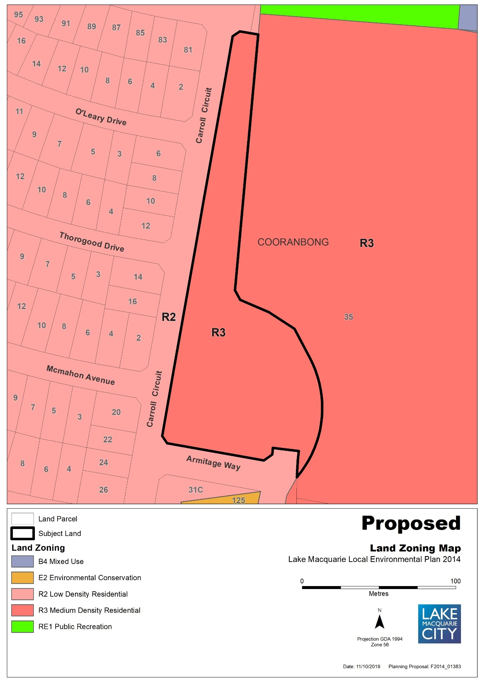
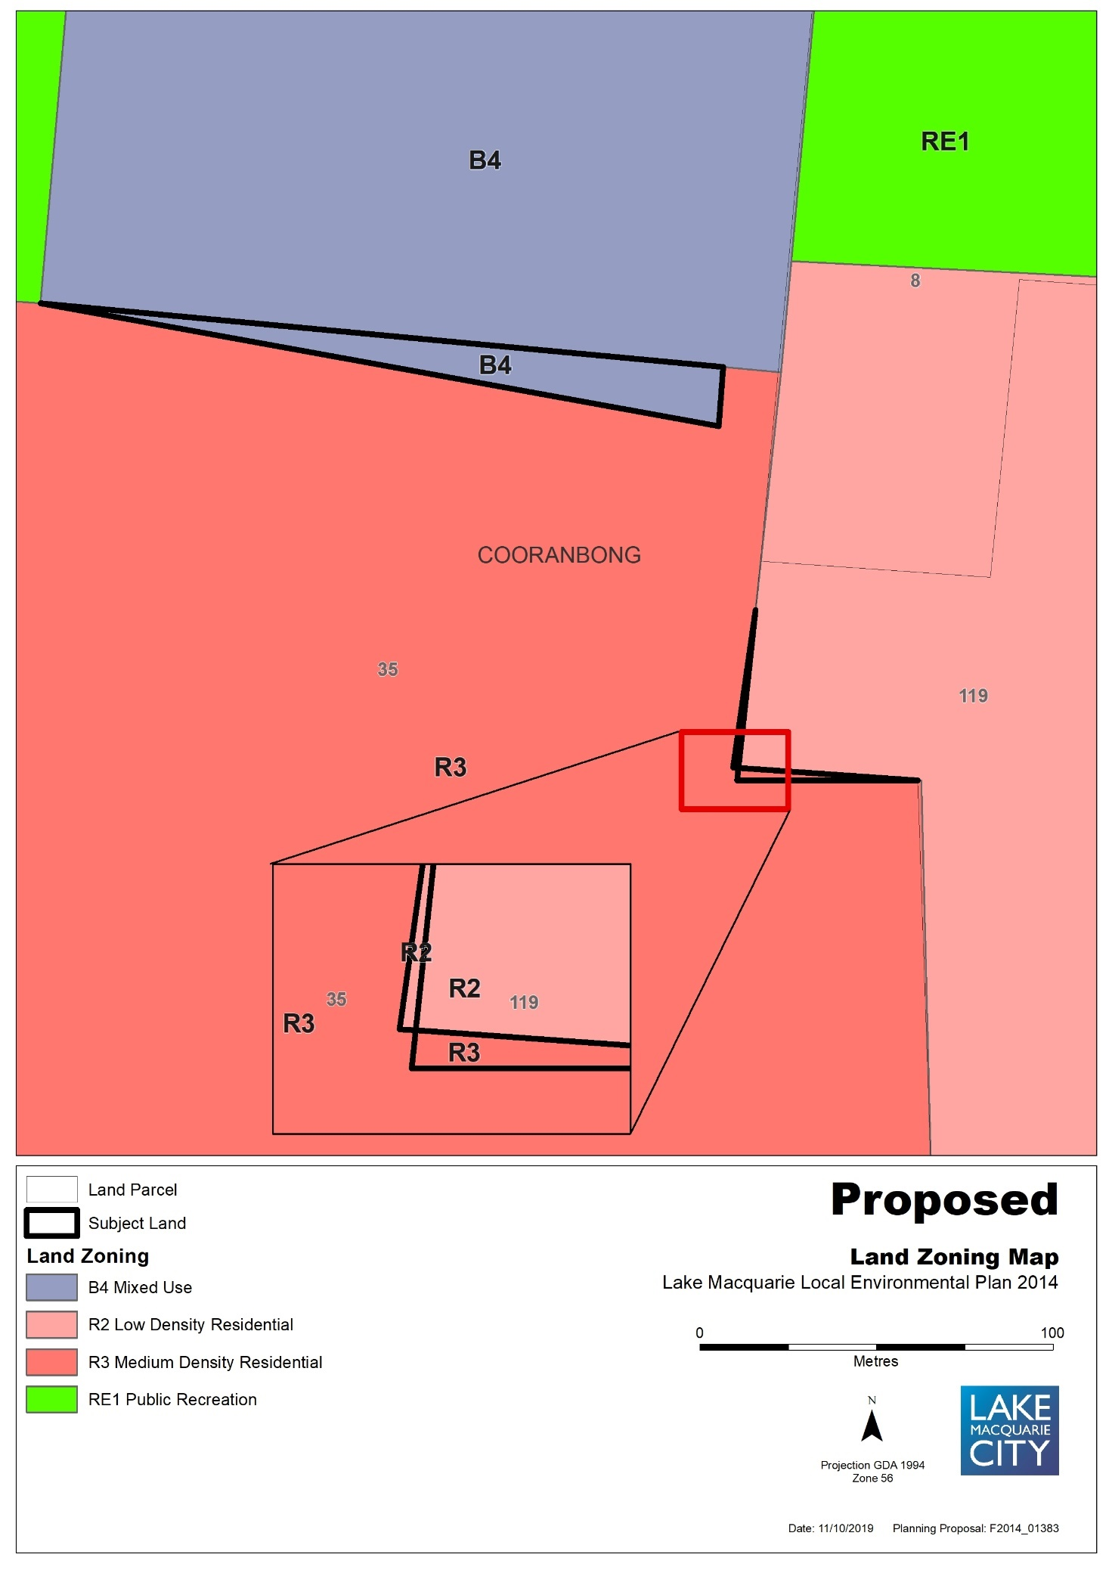

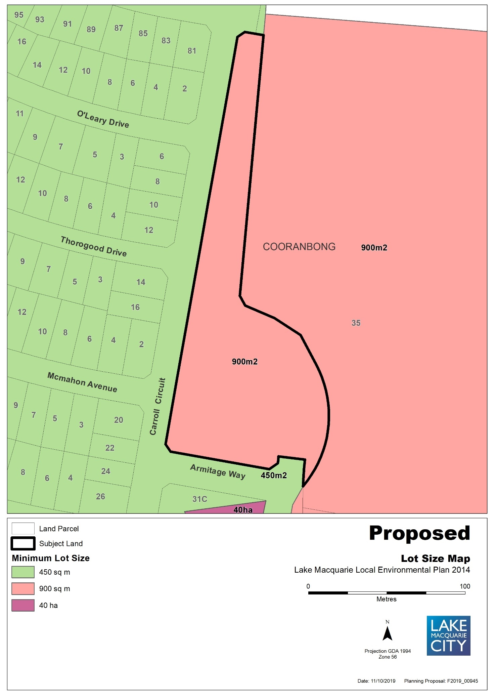

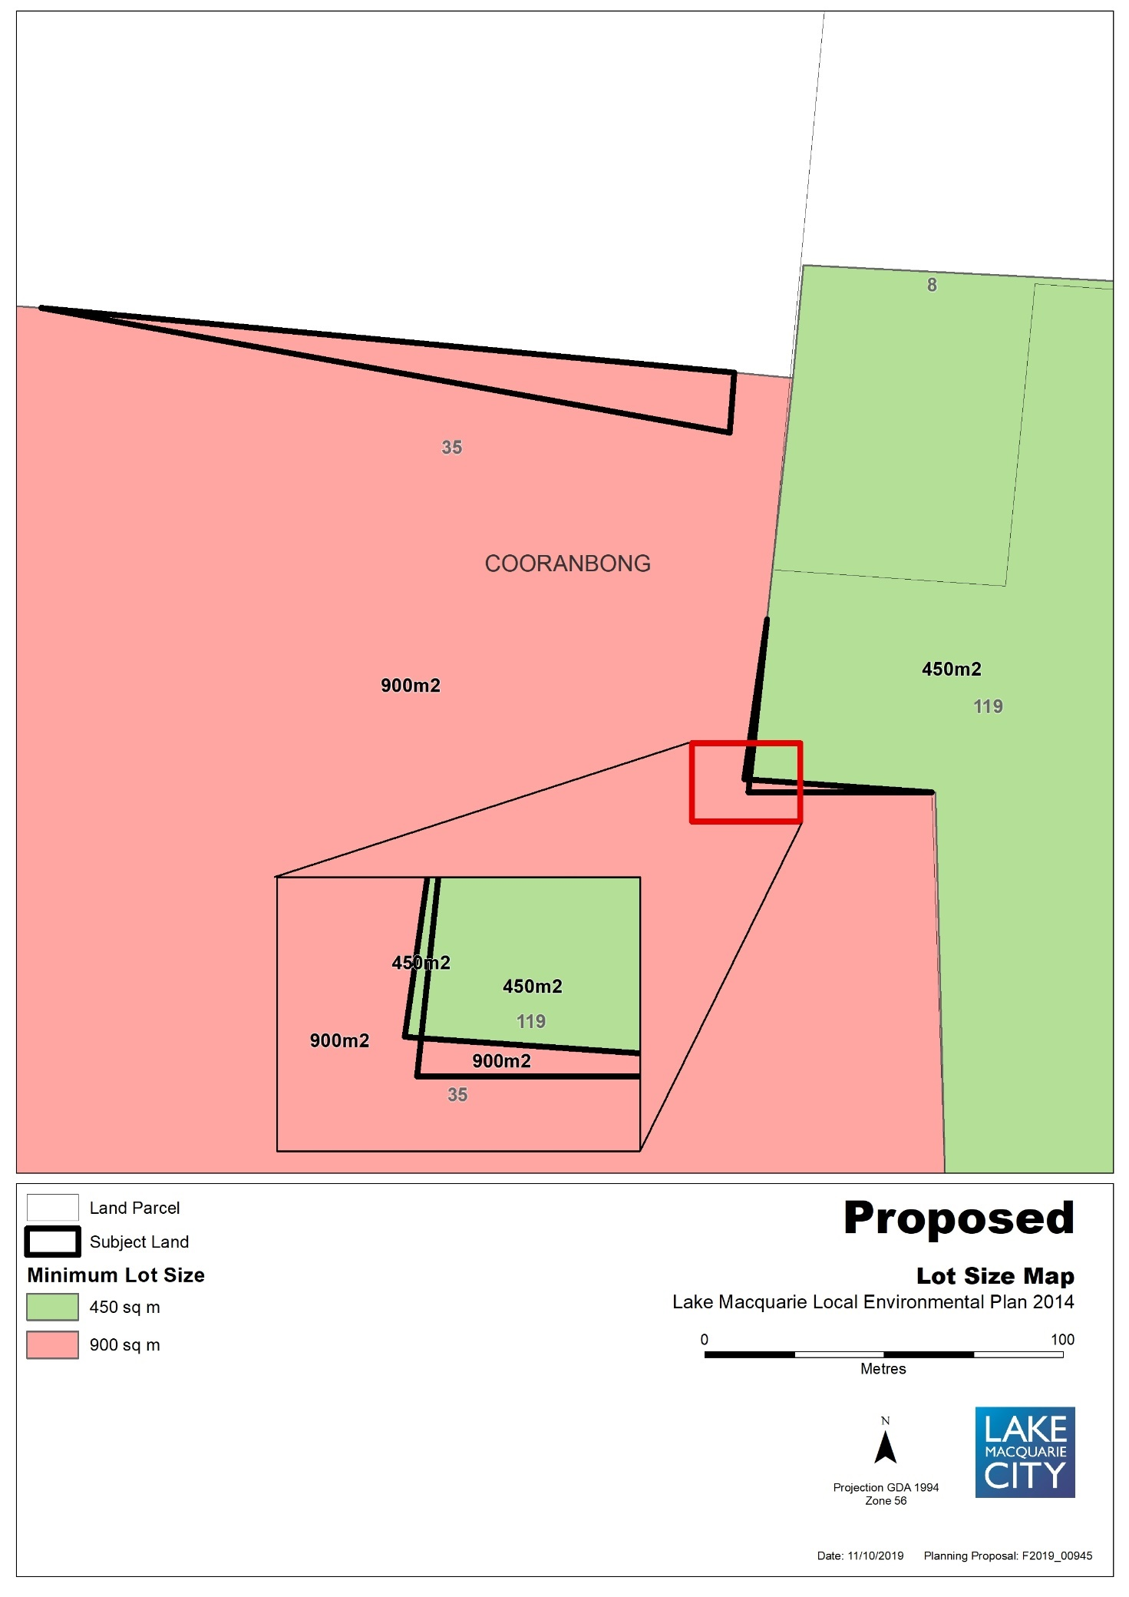

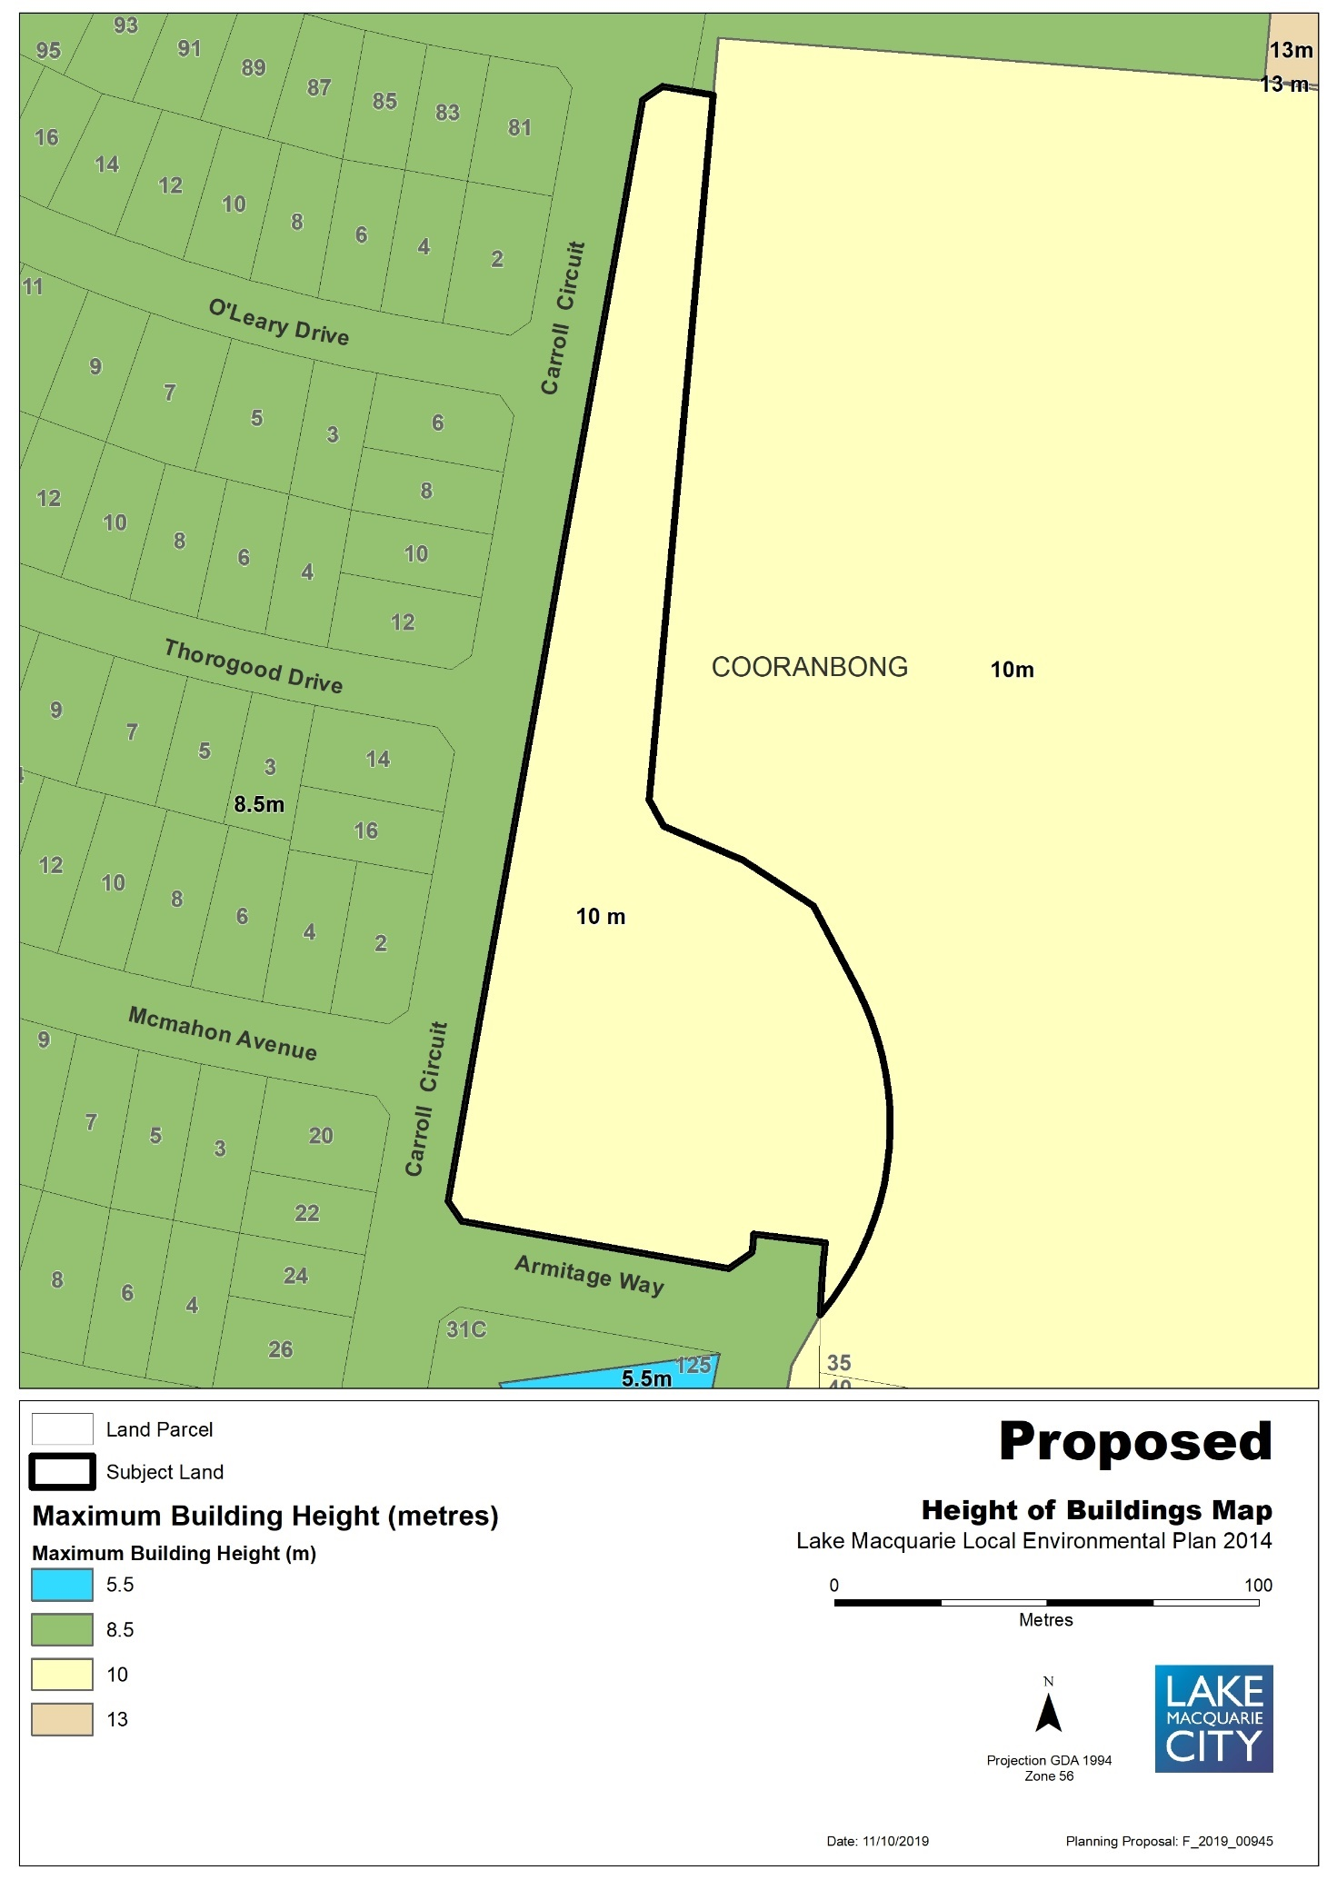

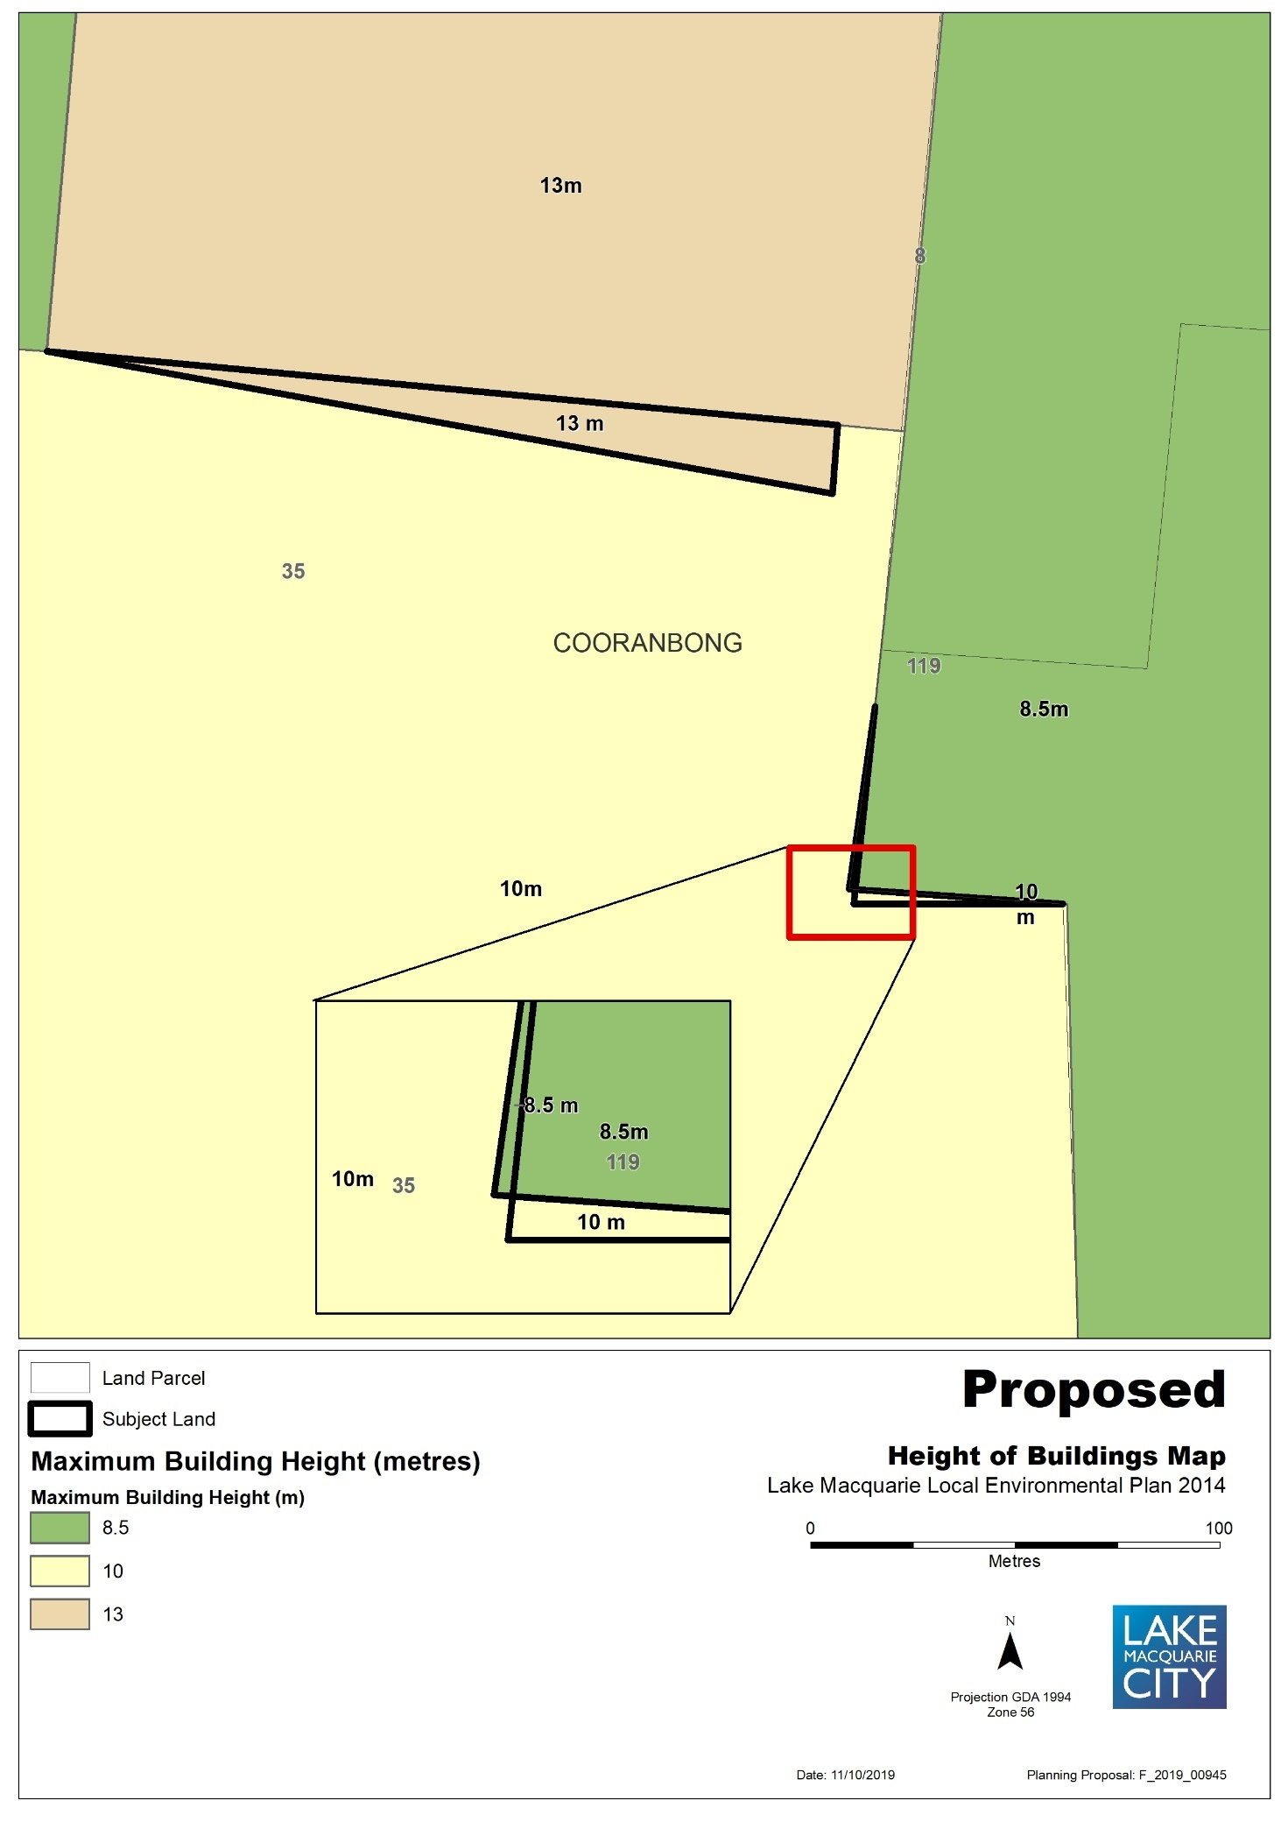

Map 3a – Item 2 – Aerial, Existing Zones, Minimum lot size, Height of building
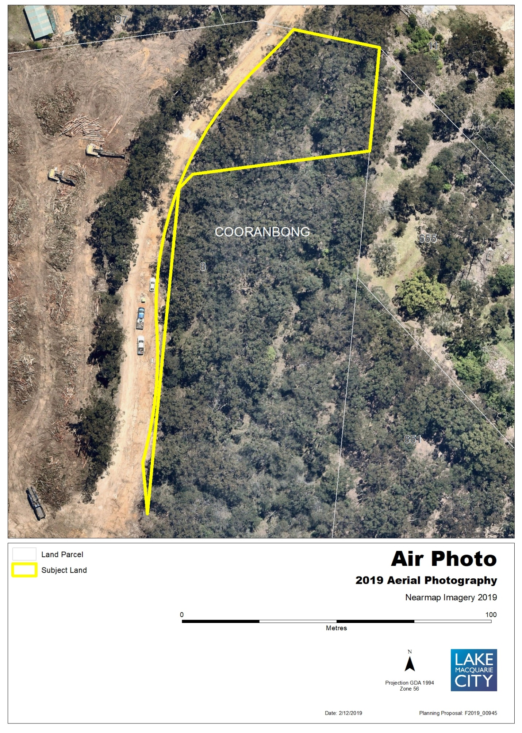

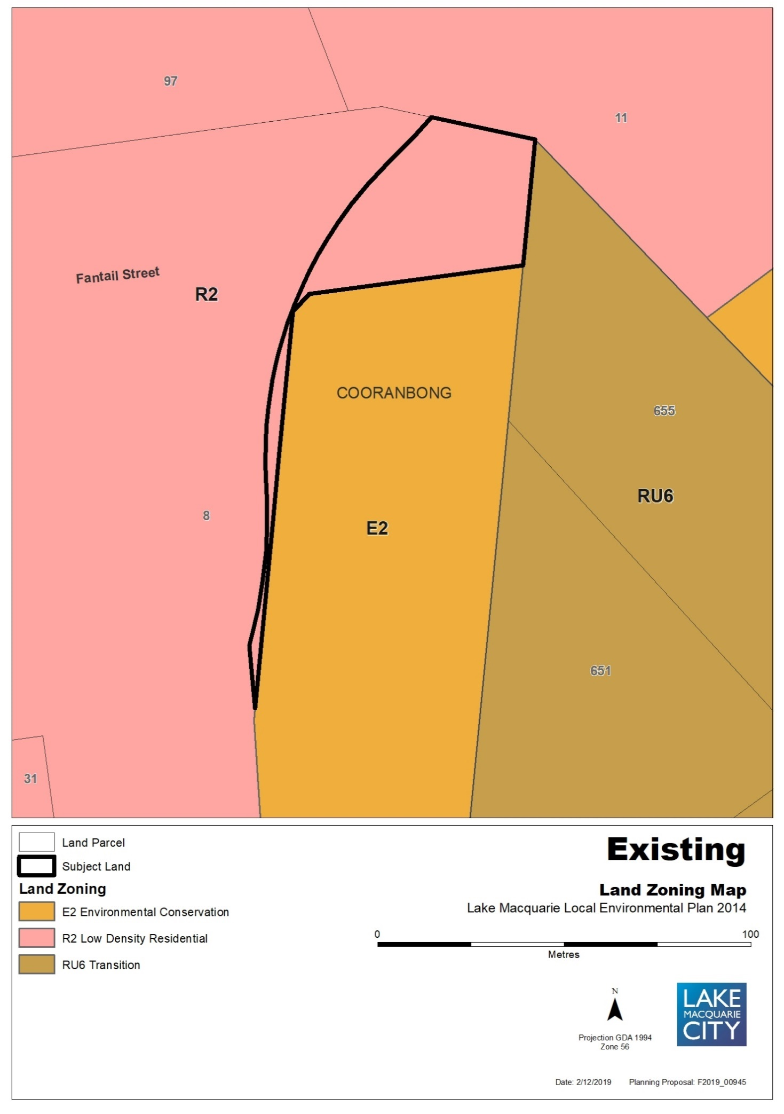

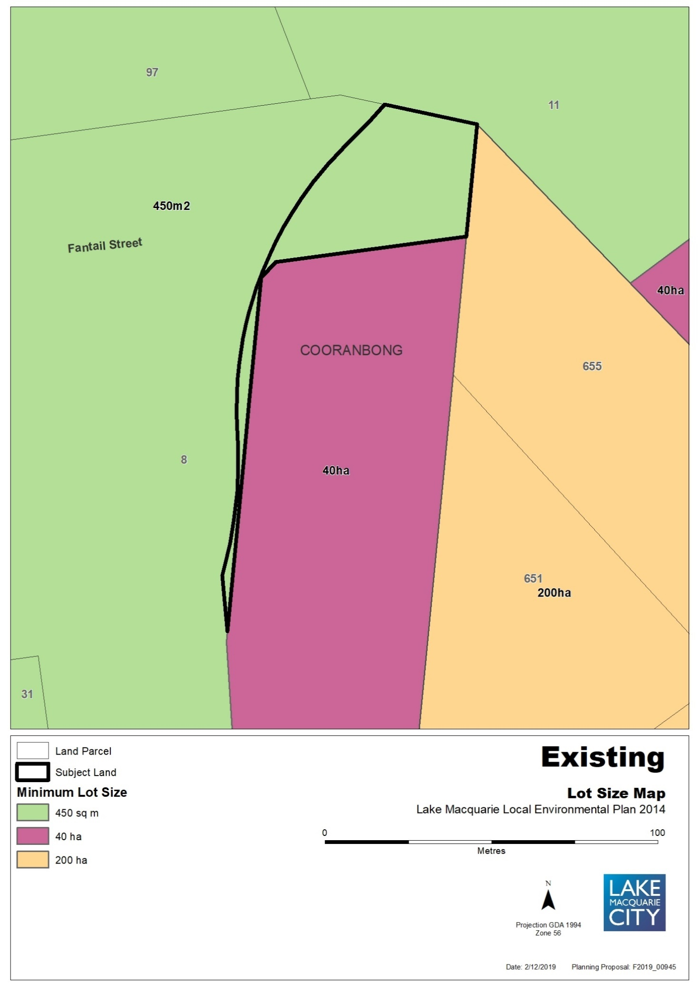

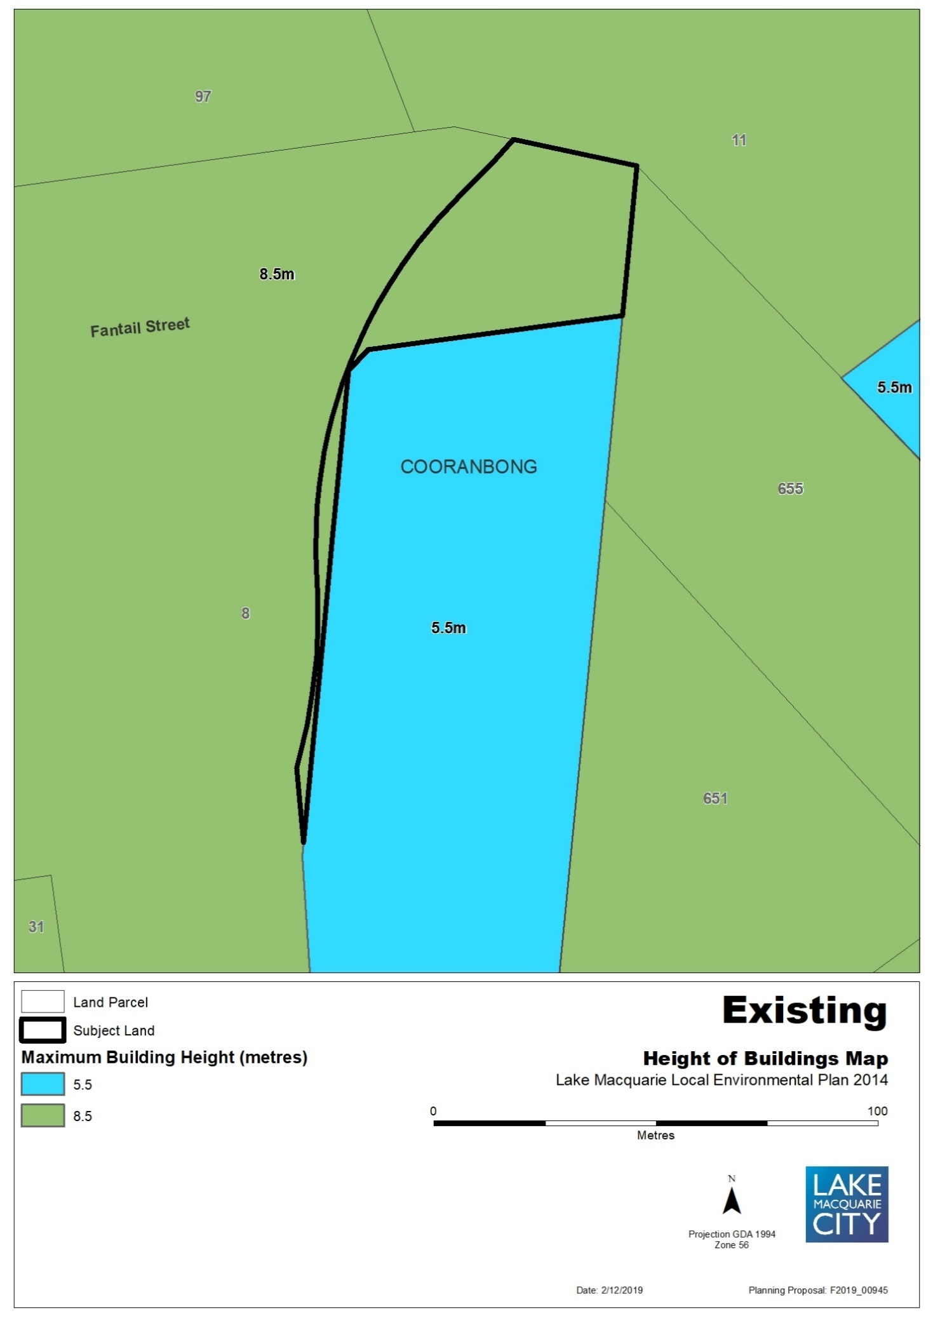

Map 3b – Item 2 – Proposed Zones, Minimum lot size, Height of building
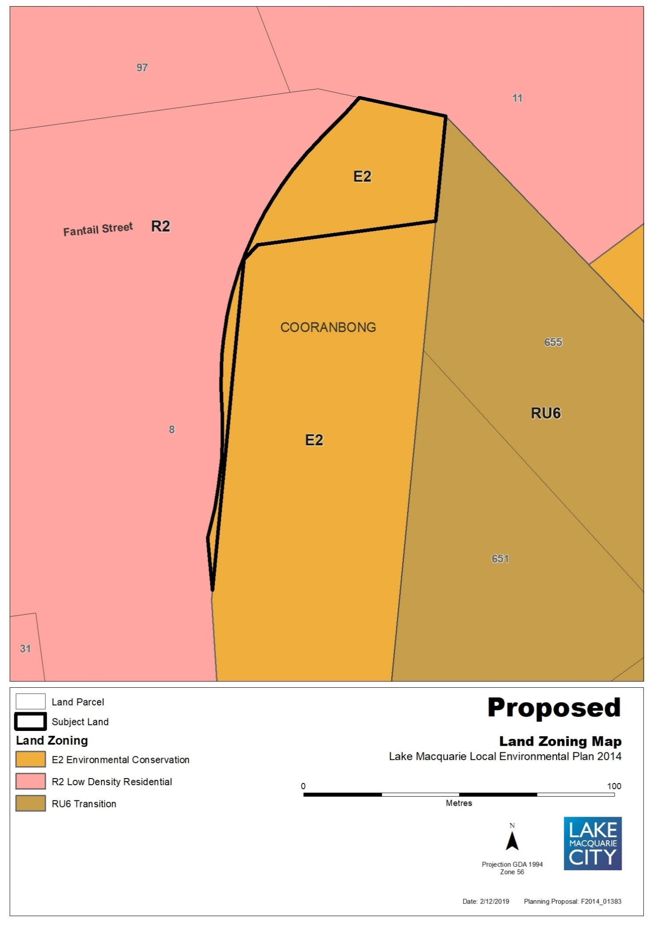
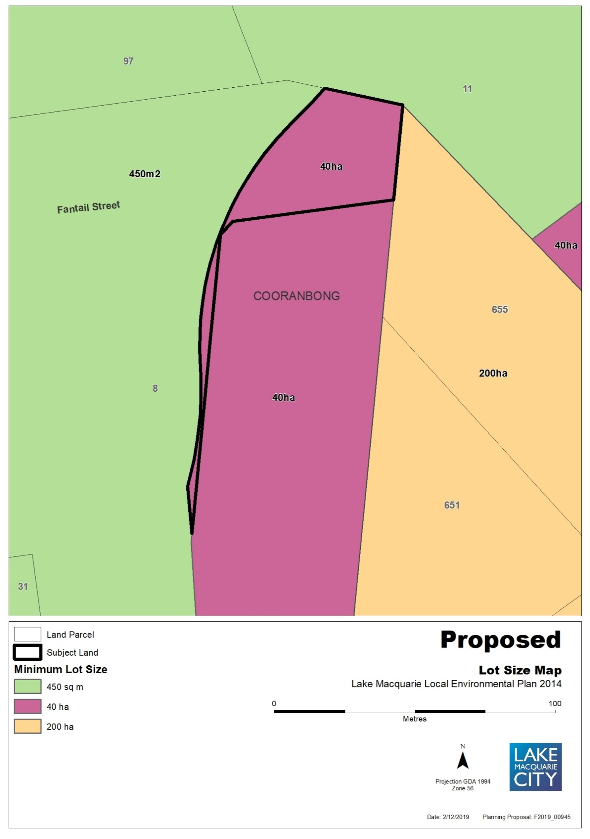

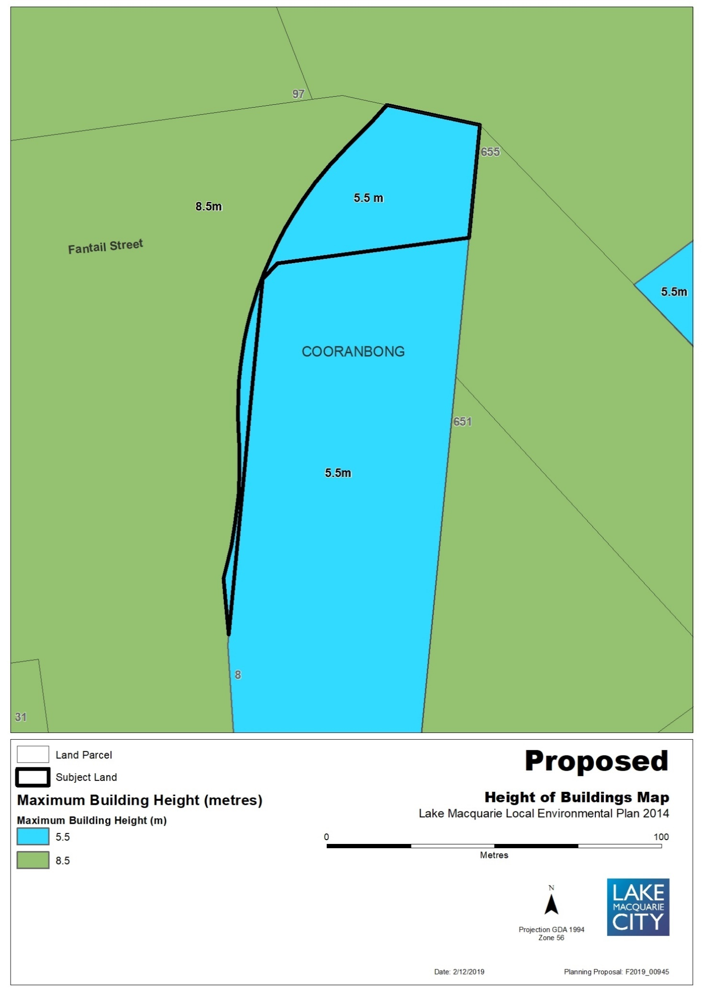

Map 4a – Item 3 – Aerial, Existing Zones, Minimum lot size, Land Reservation Acquisition
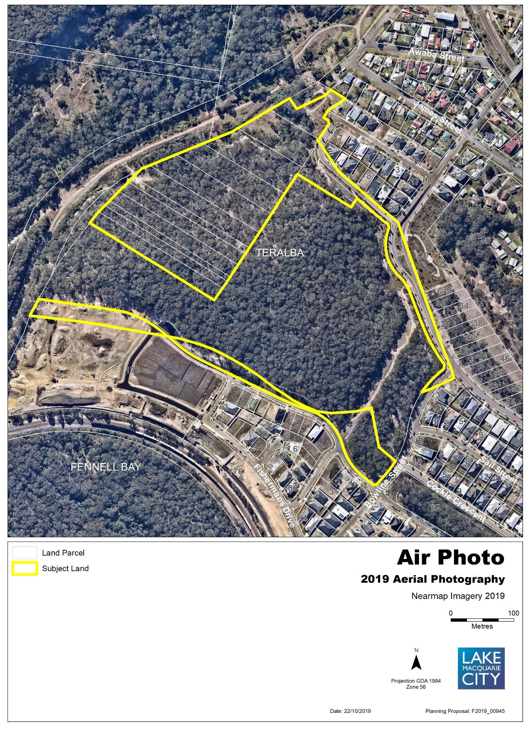
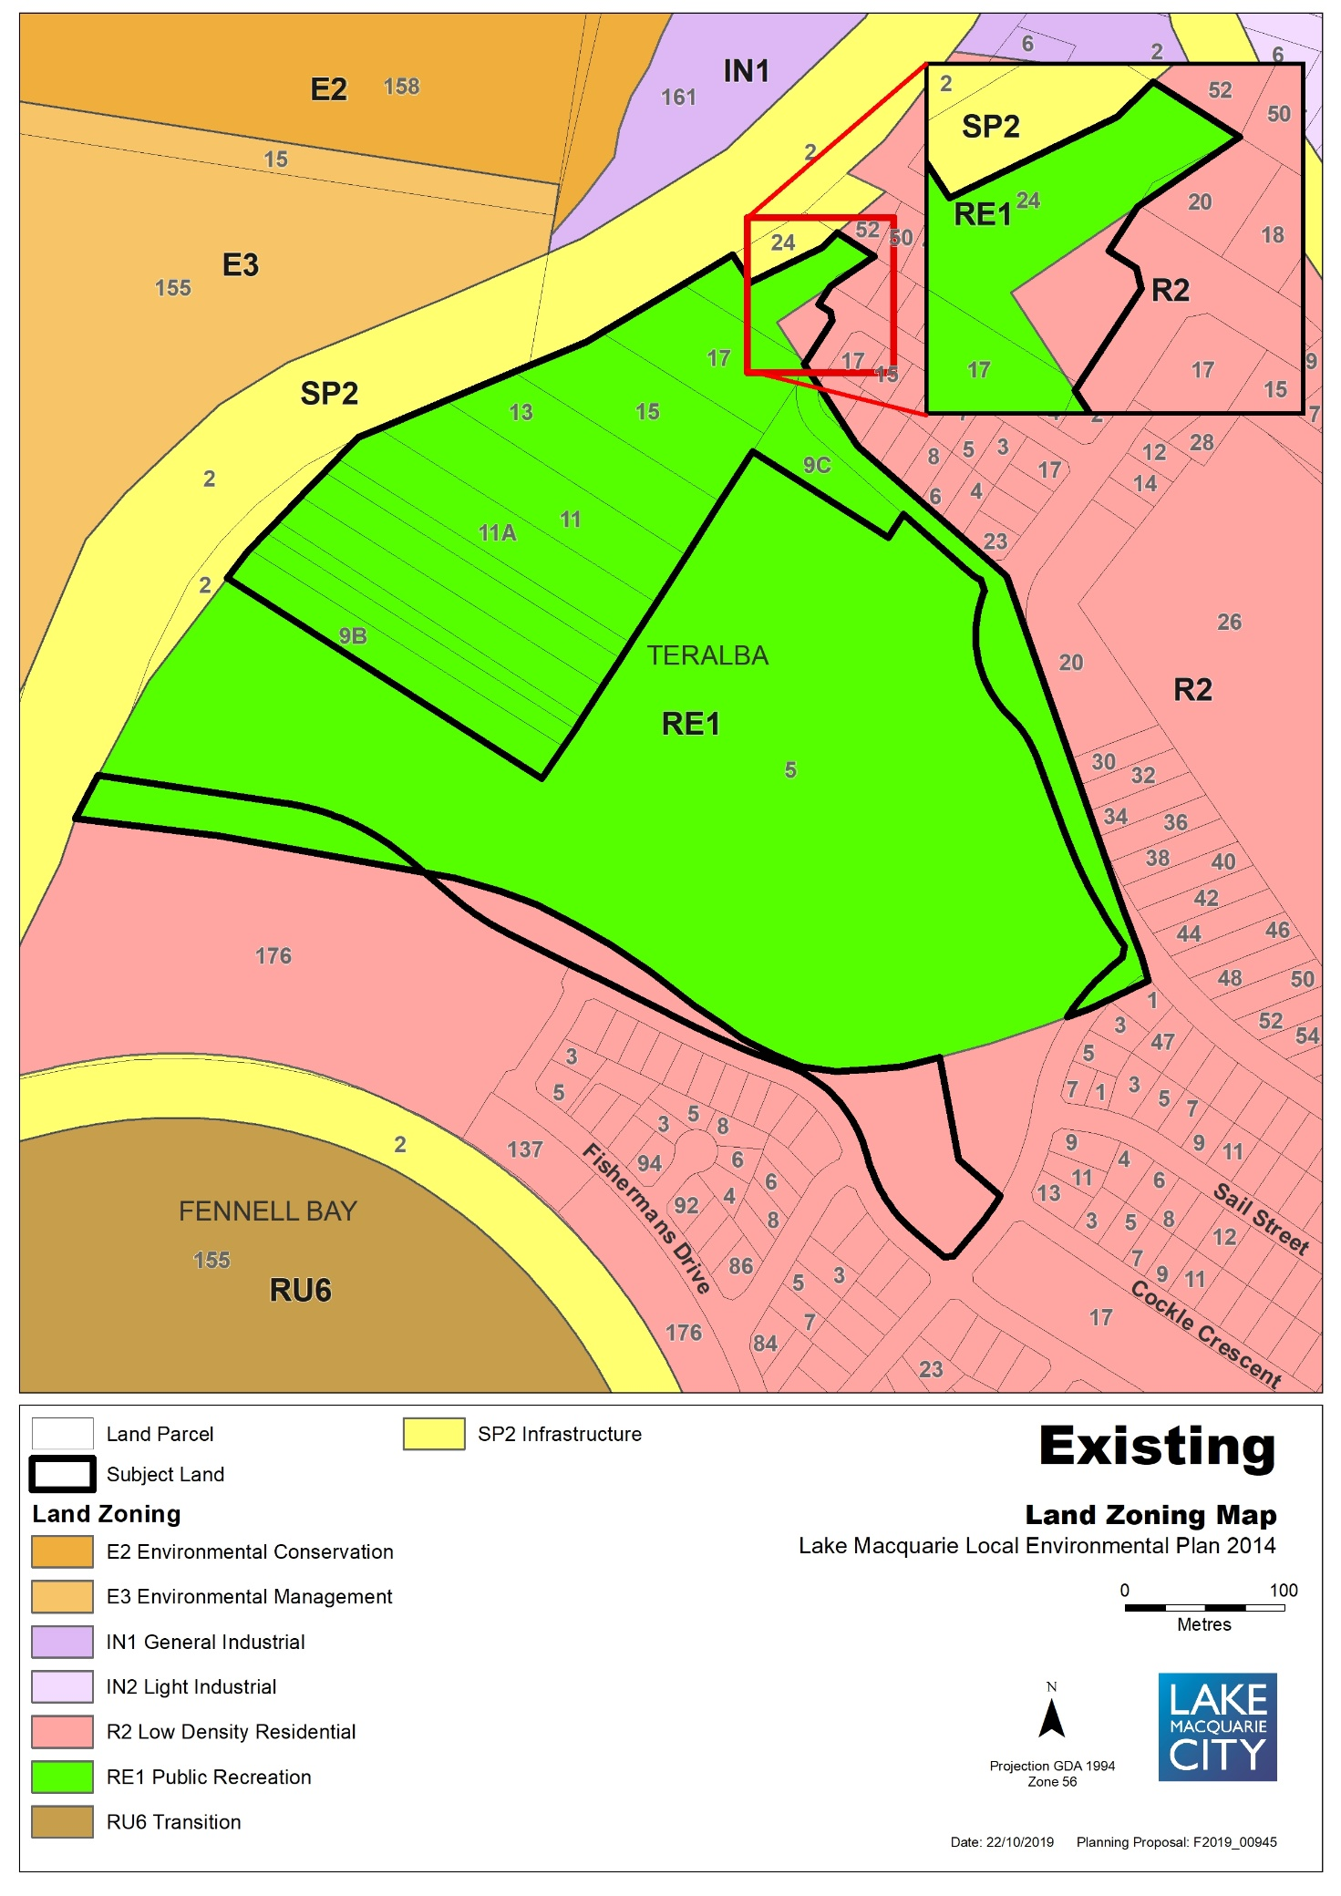

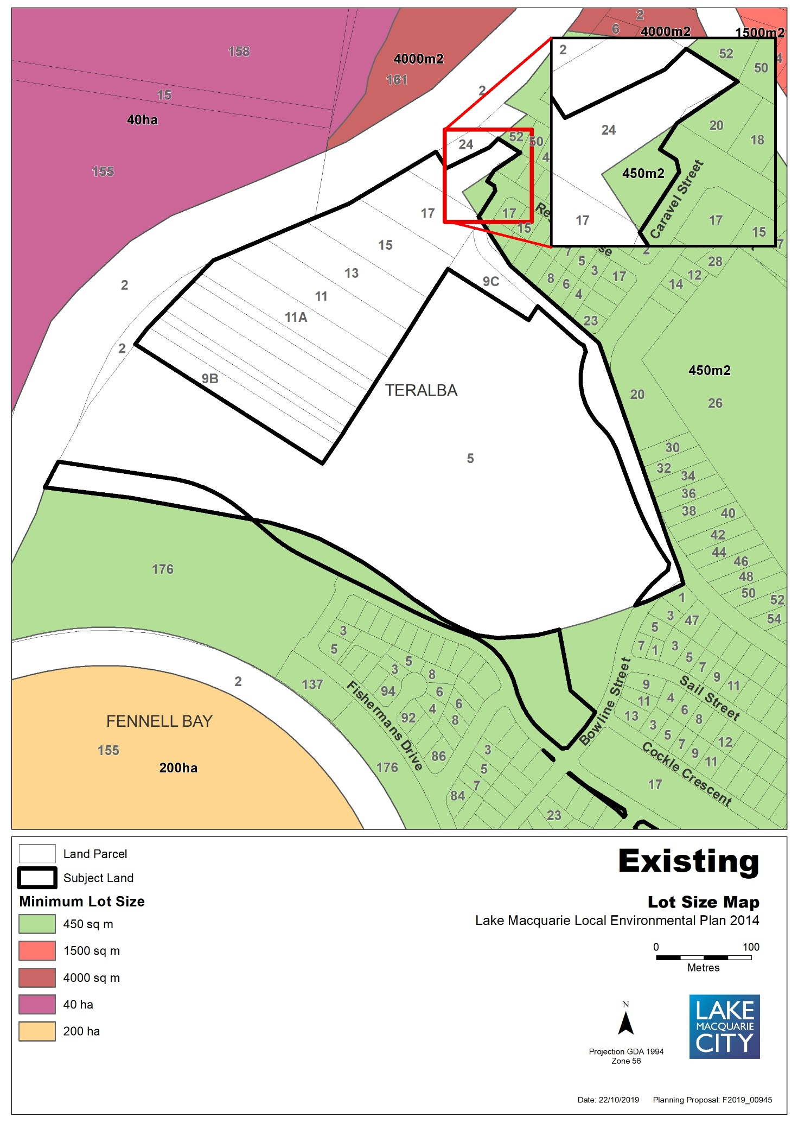

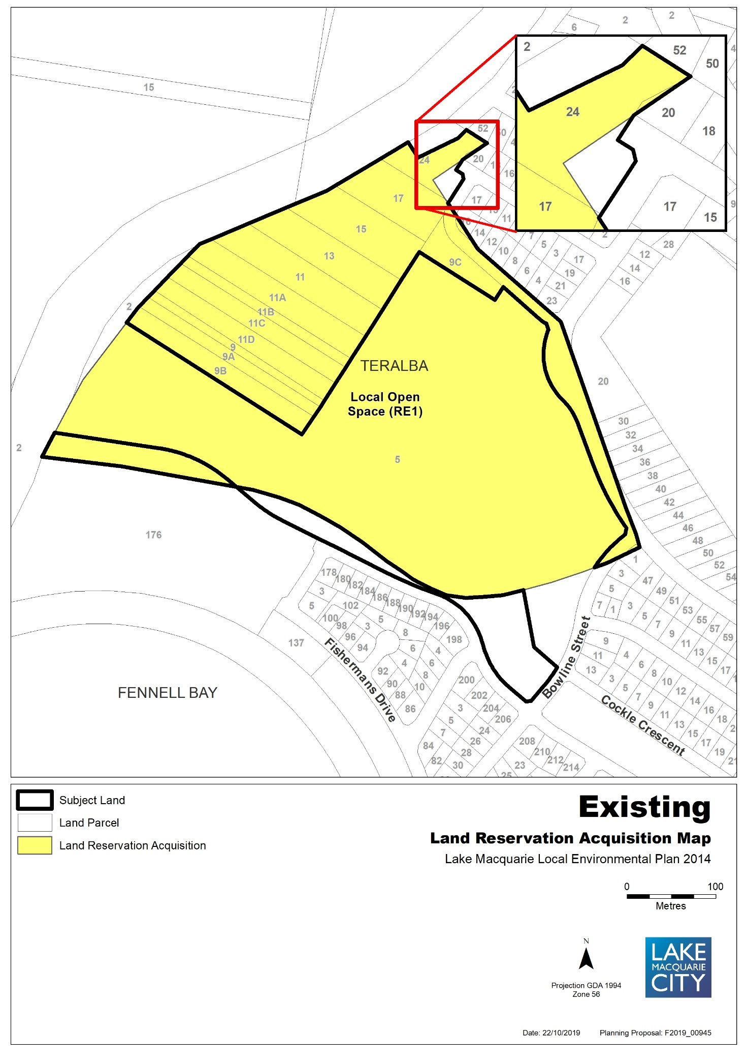

Map 4b – Item 3 – Proposed Zones, Minimum lot size, Land Reservation Acquisition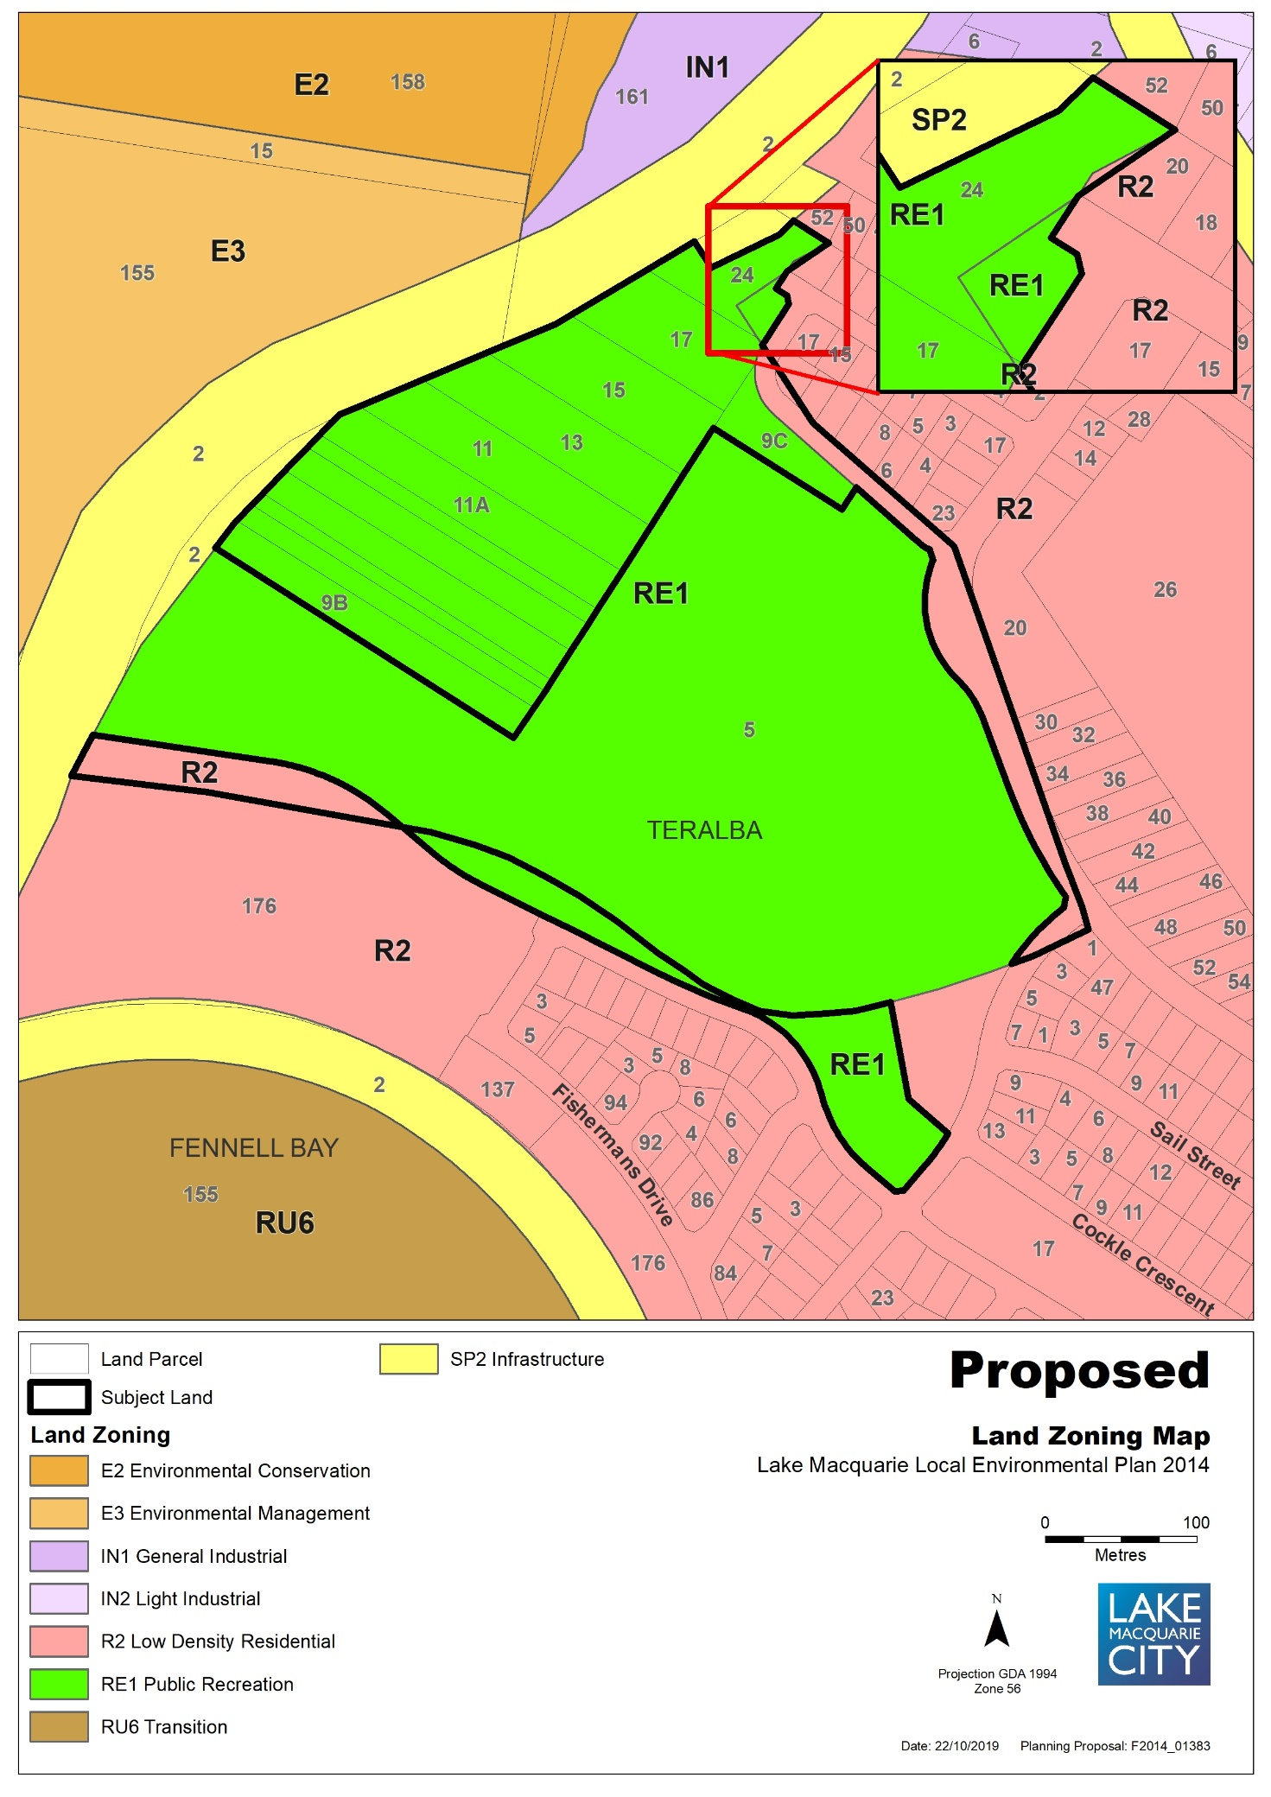
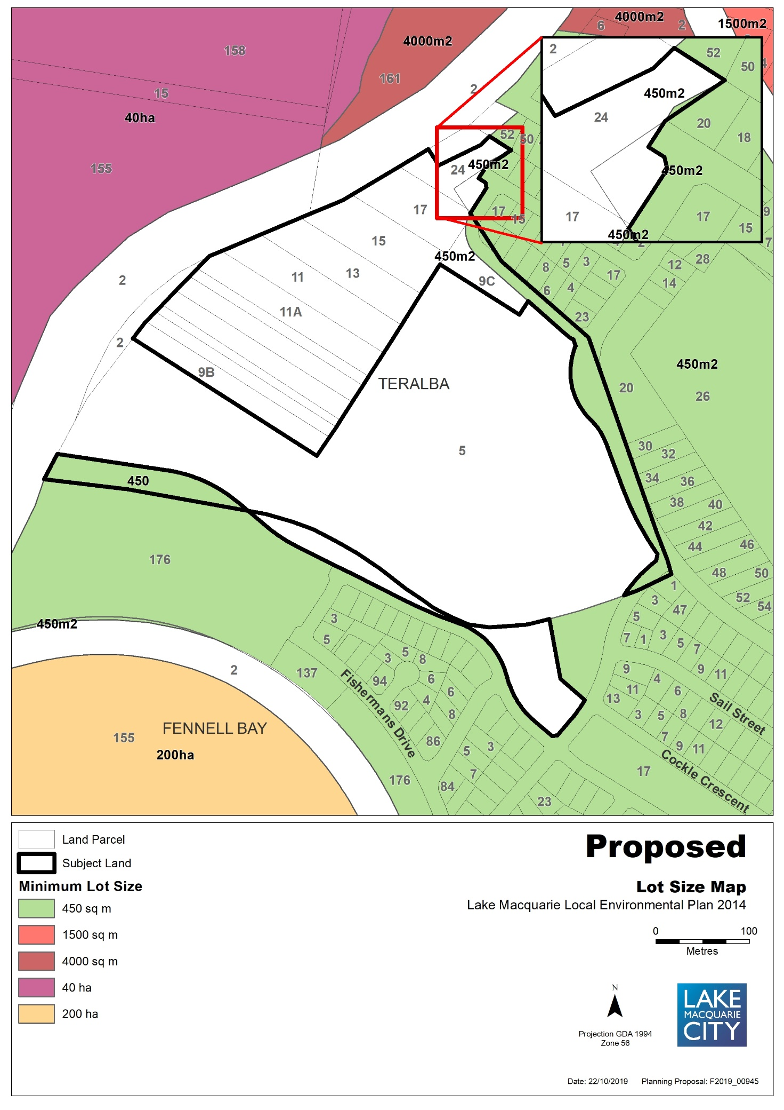
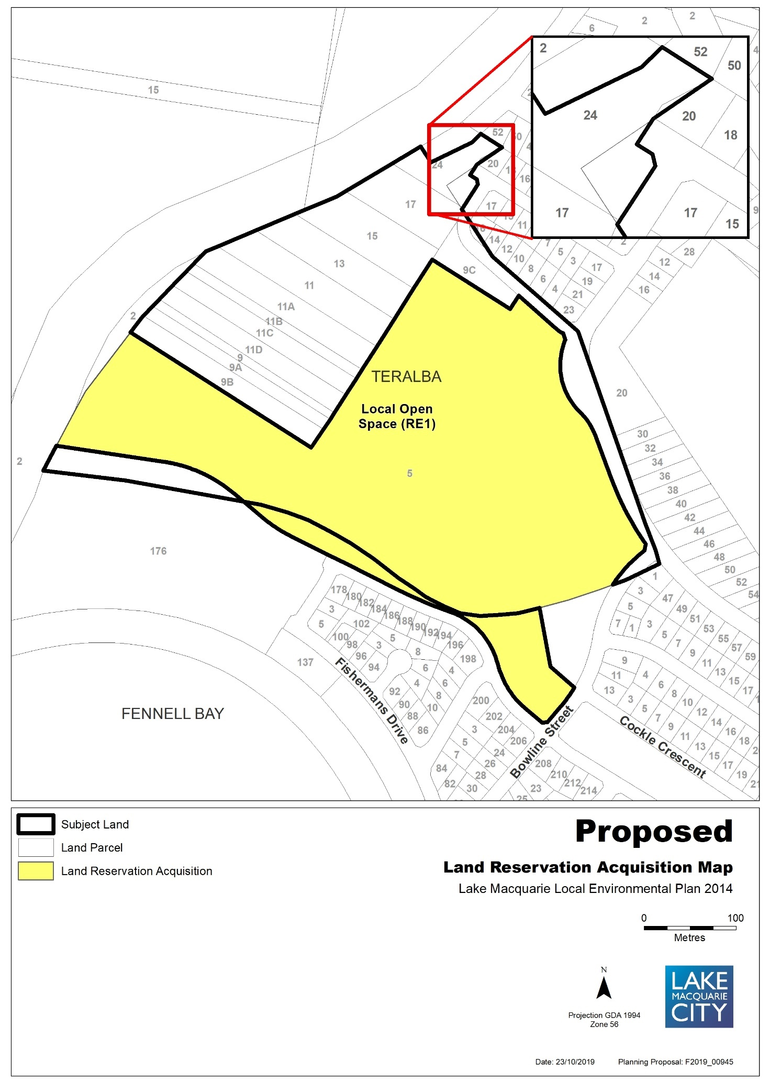

Map 5a – Item 4 – Aerial, Existing Zones, Minimum lot size, Height of buildings
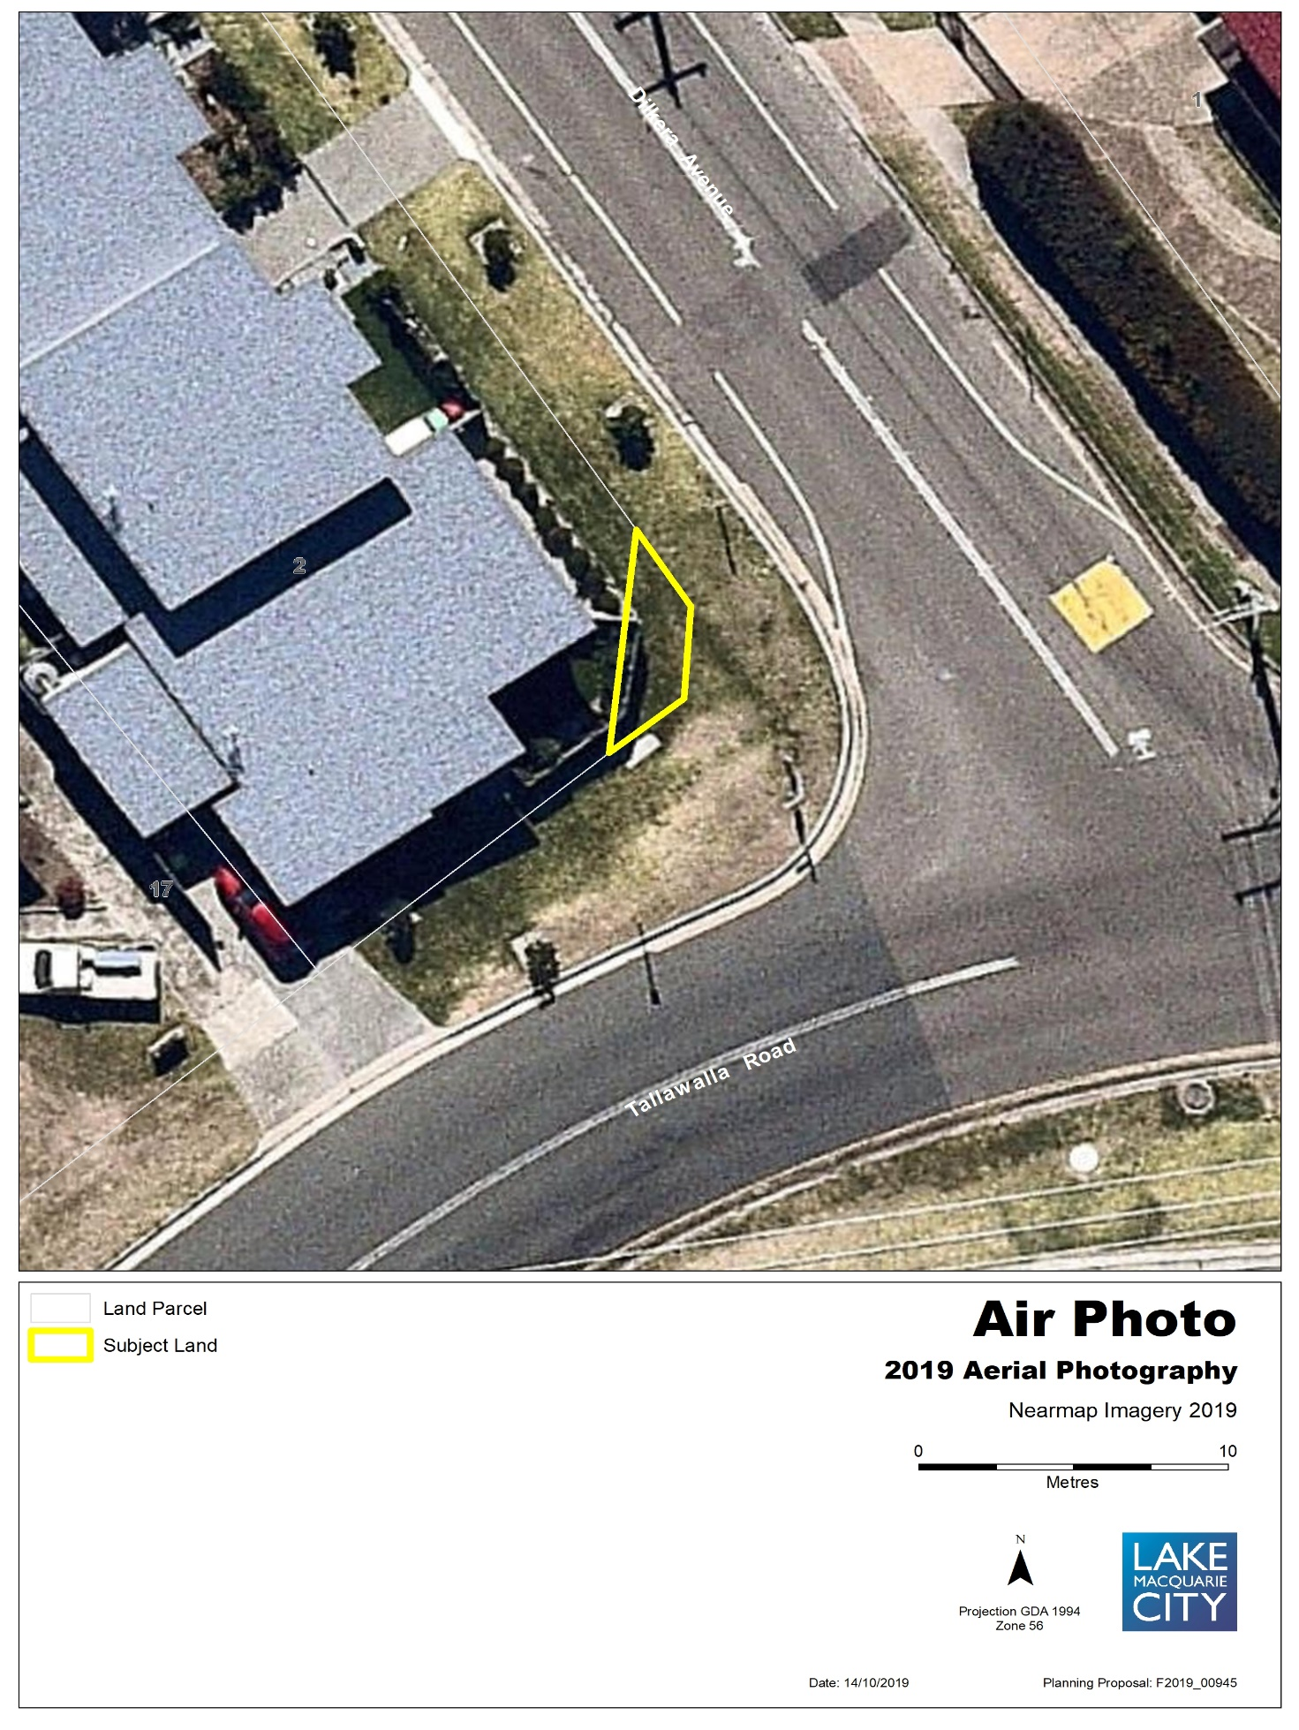

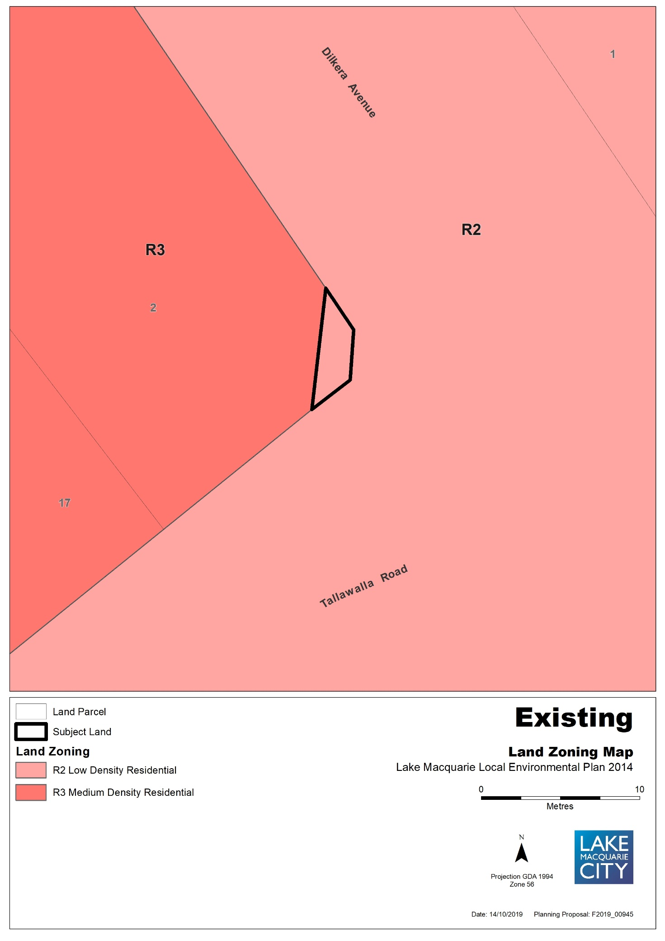

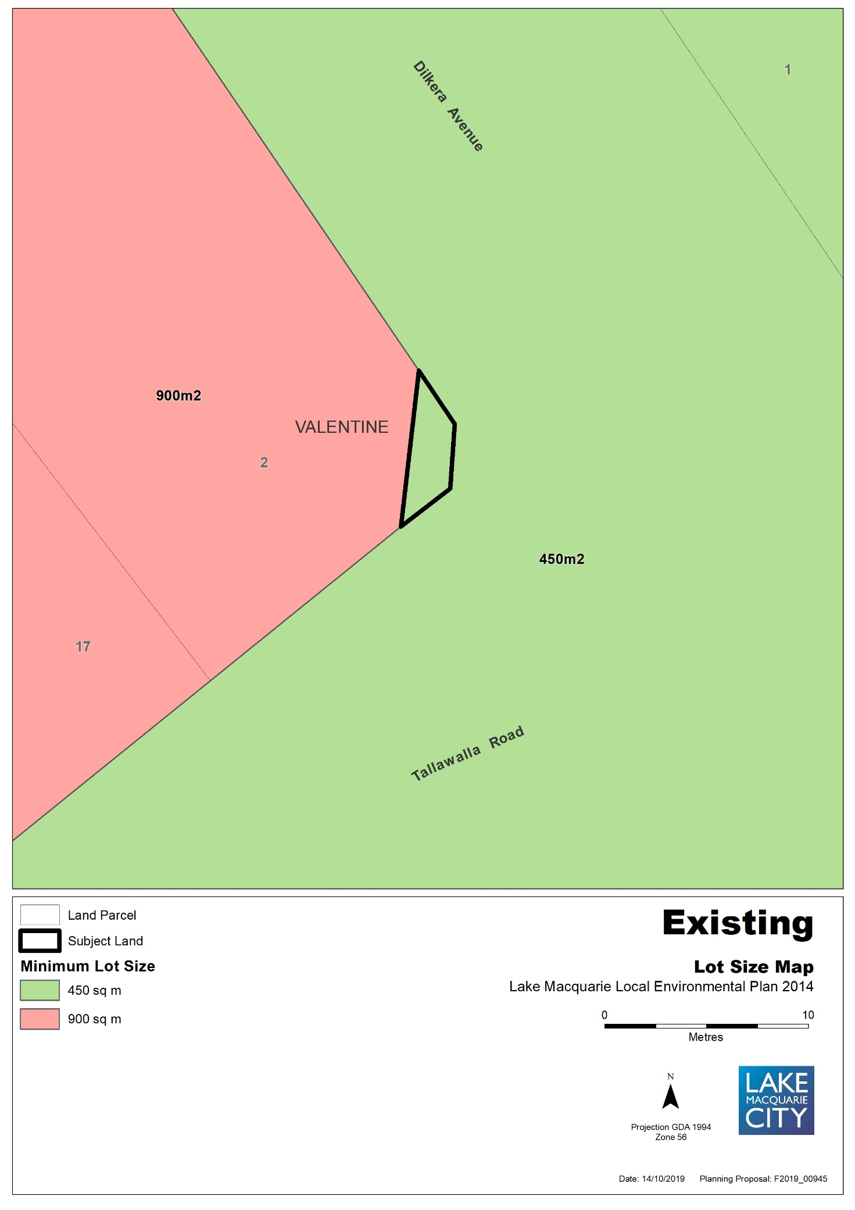

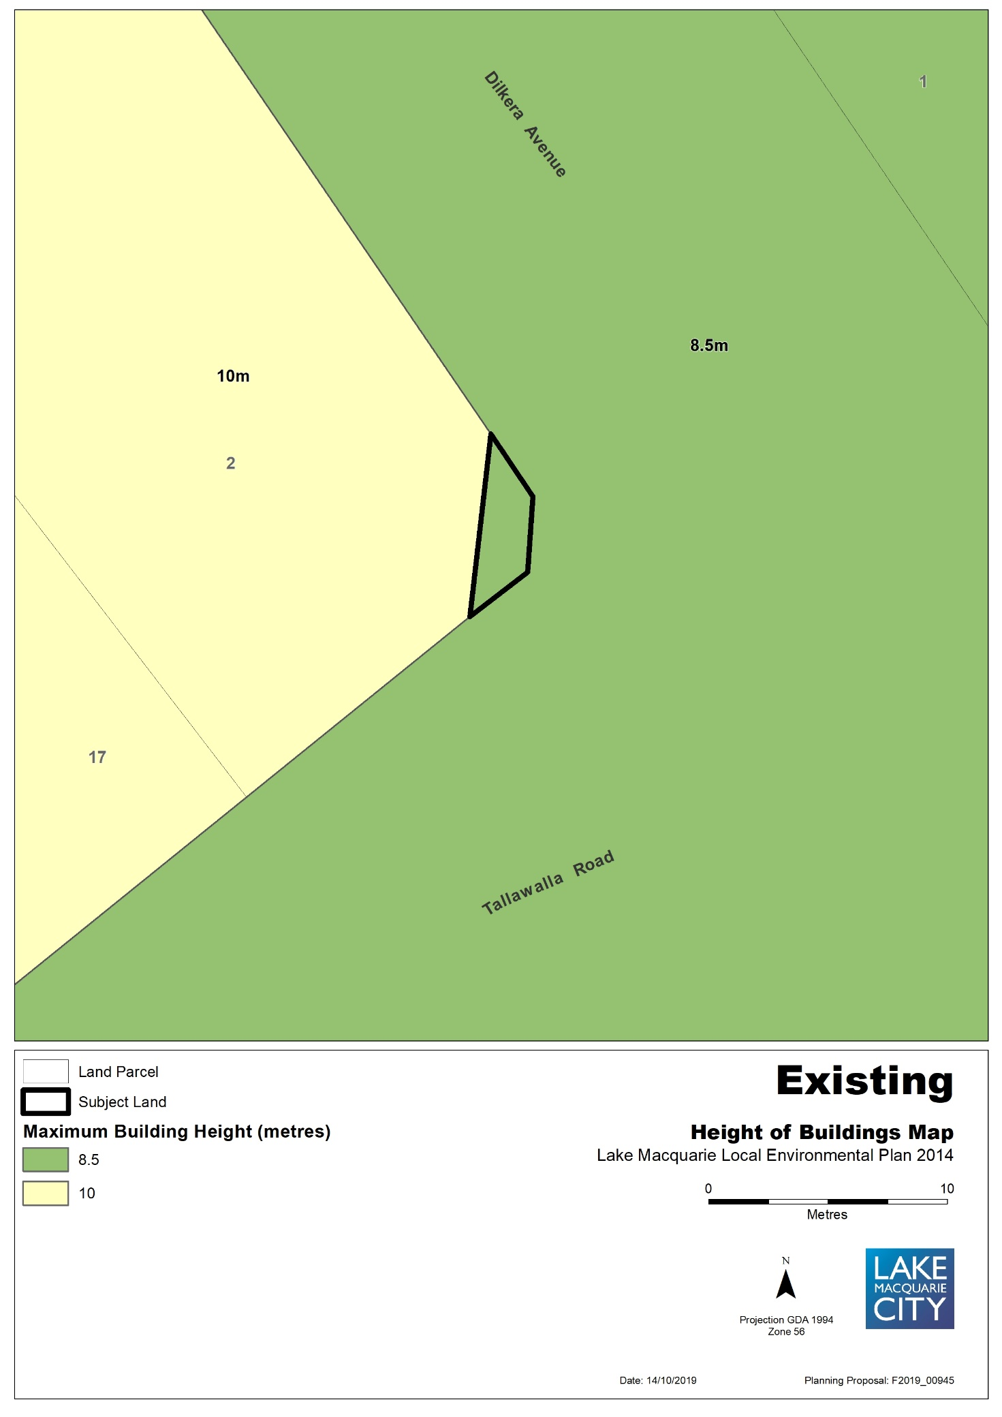

Map 5b – Item 4 – Proposed Zones, Minimum lot size, Height of building
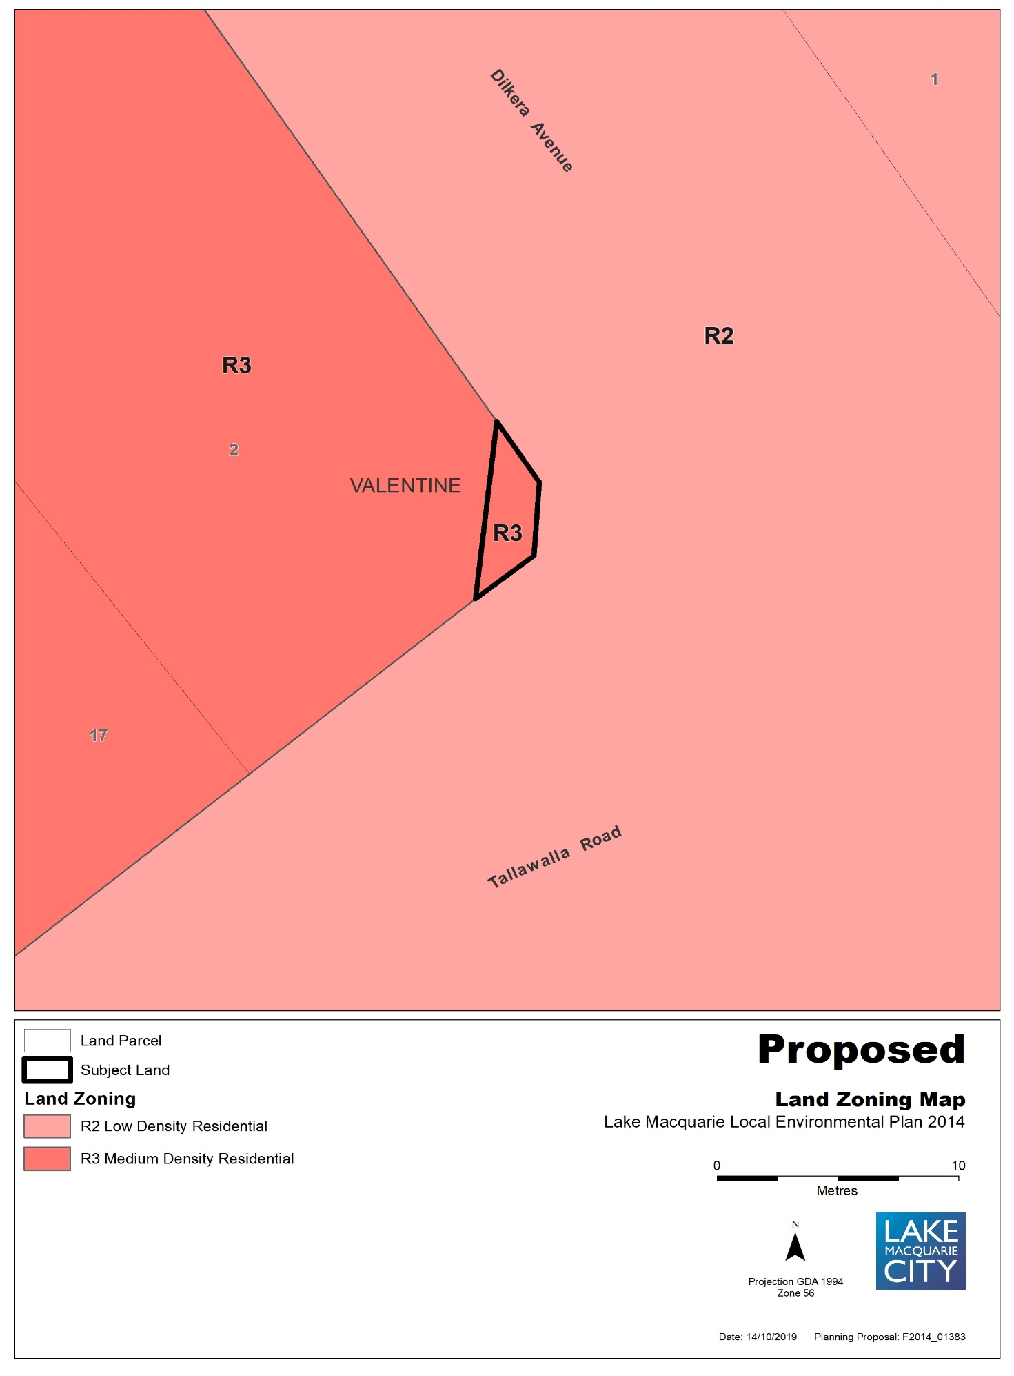

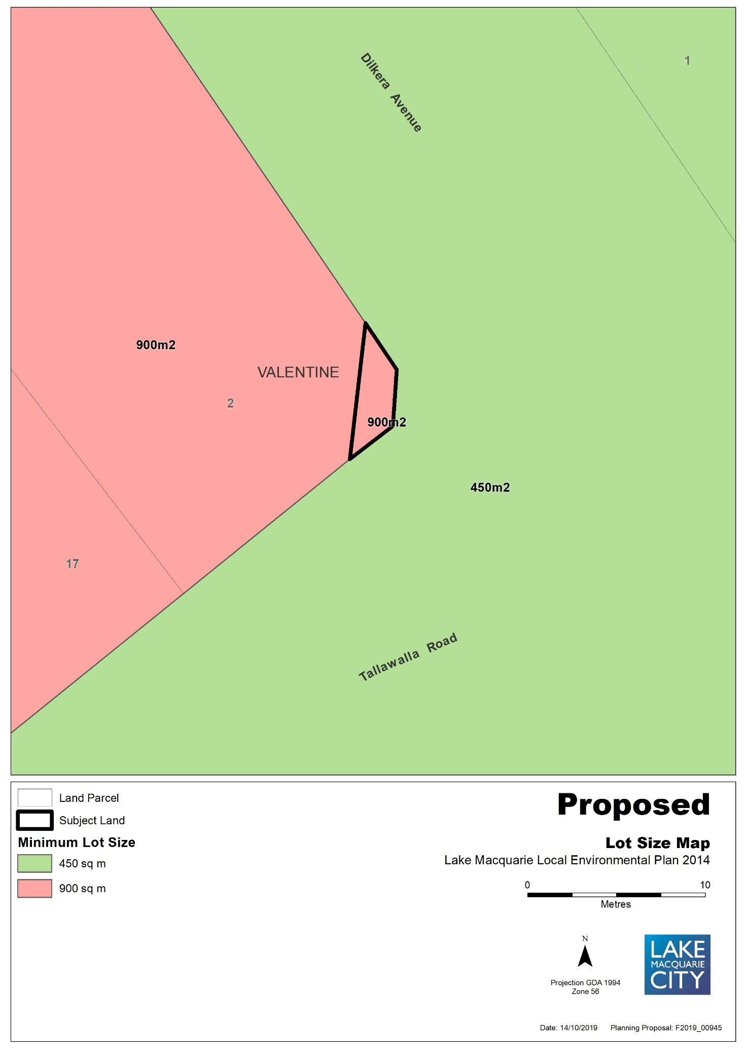

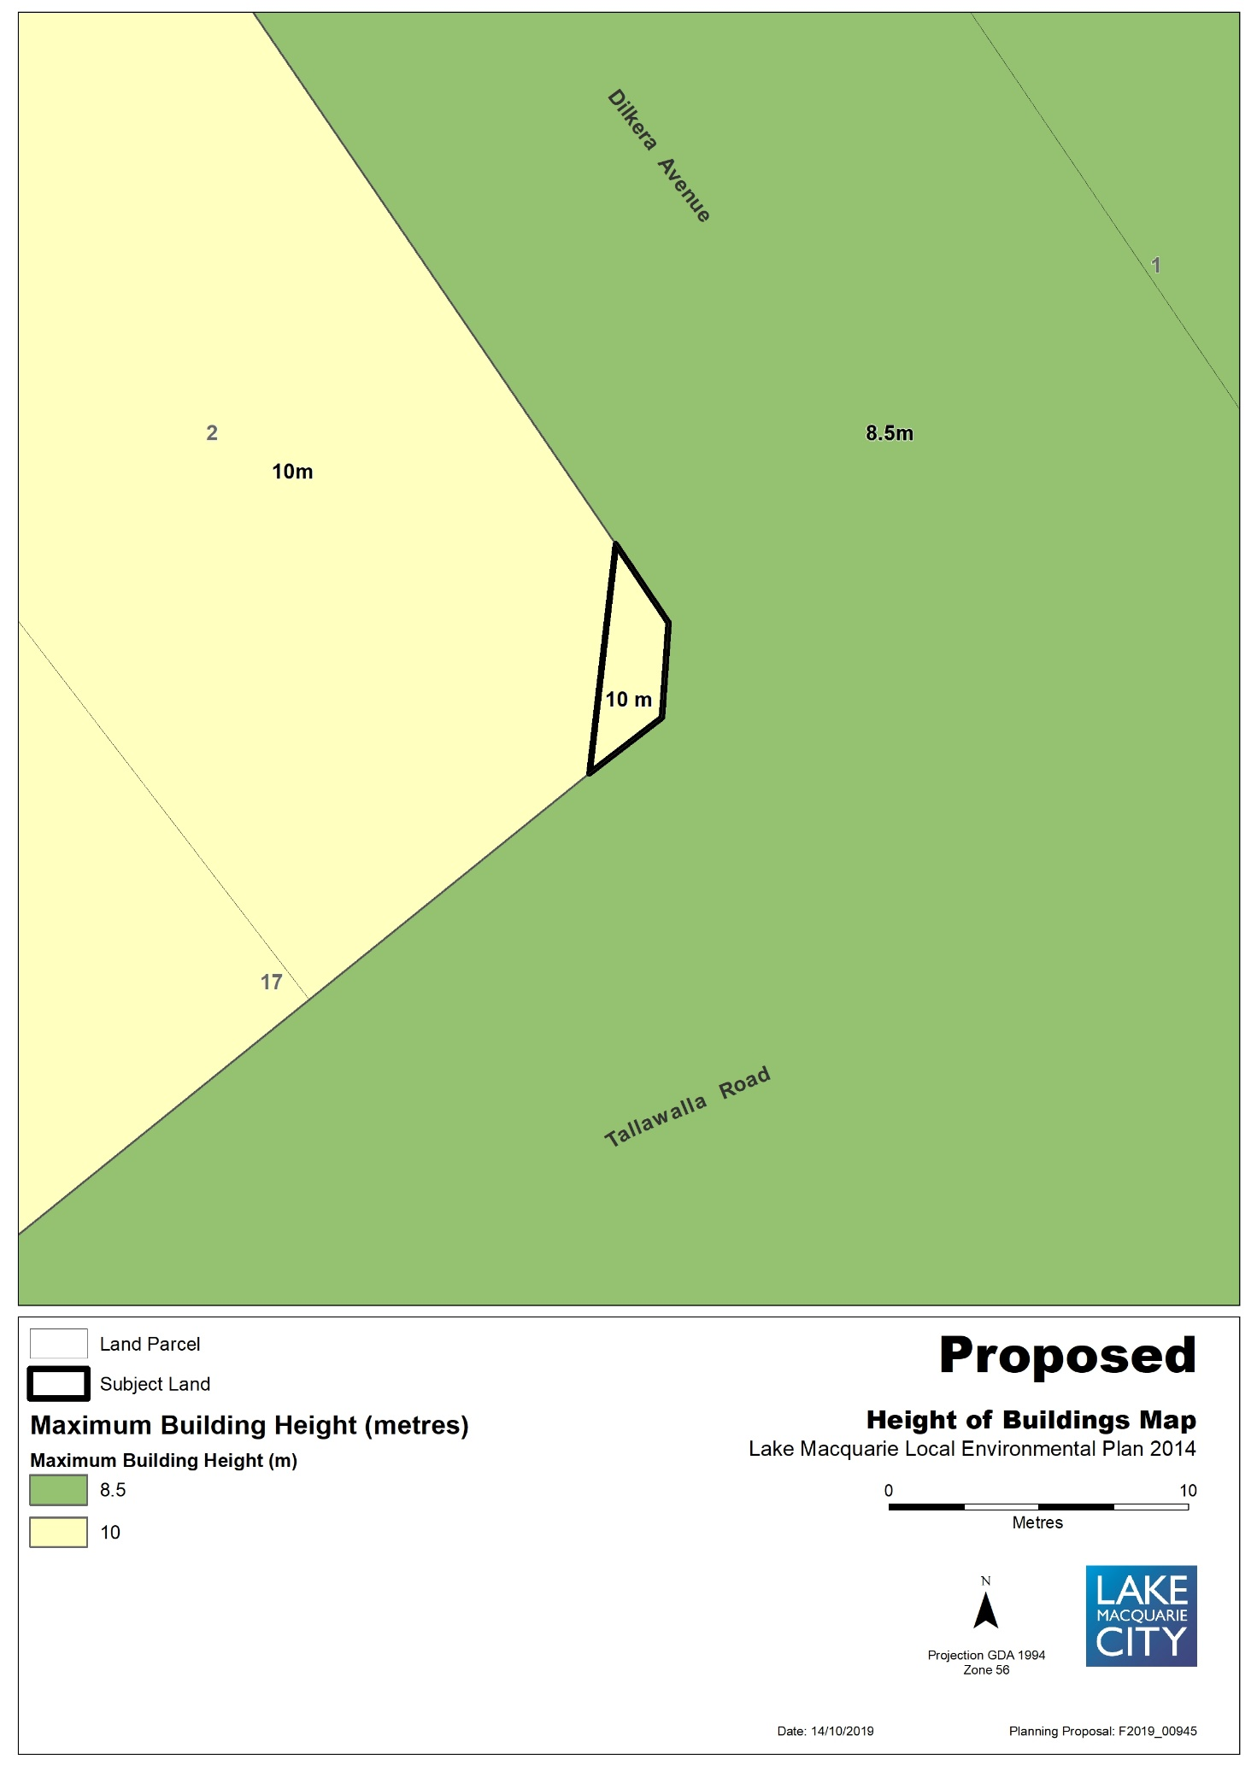

Map 6a – Item 5 – Aerial, Existing Zones, Minimum lot size, Height of buildings
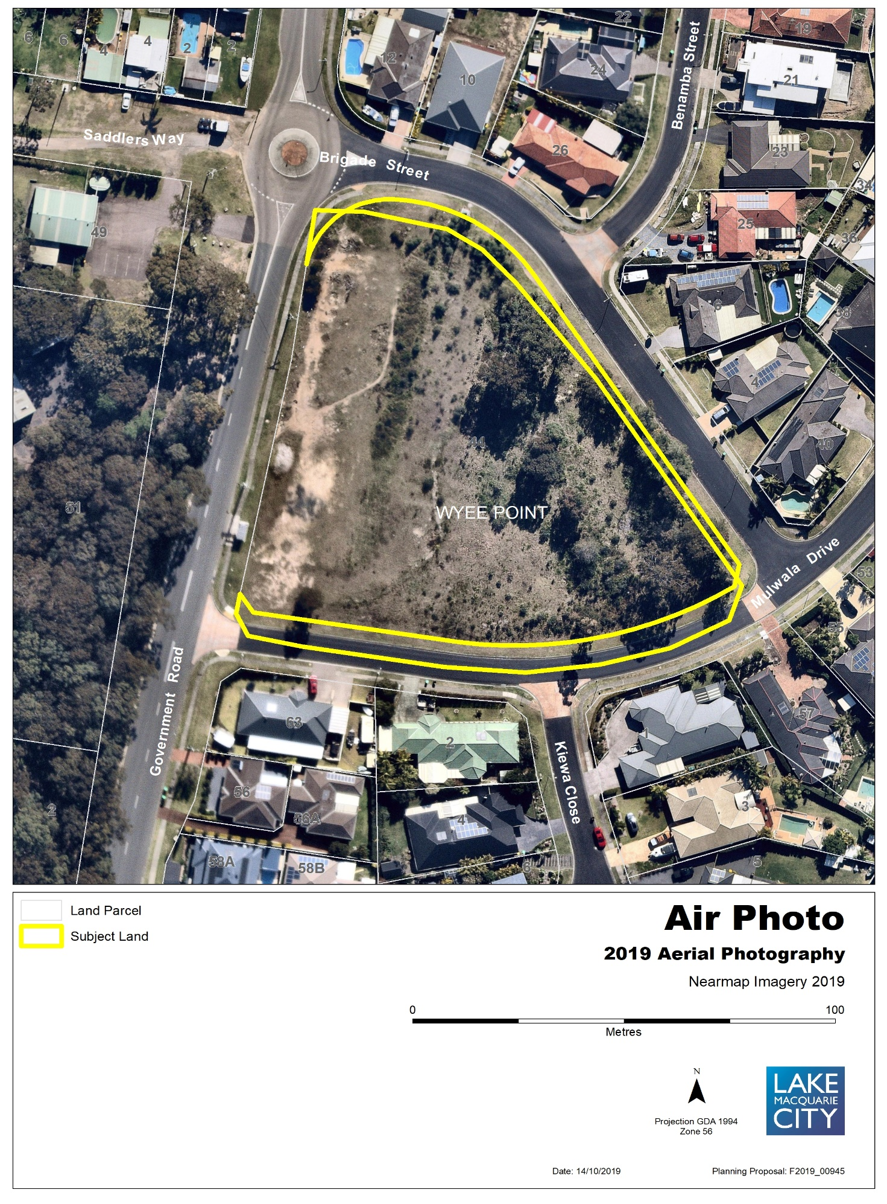

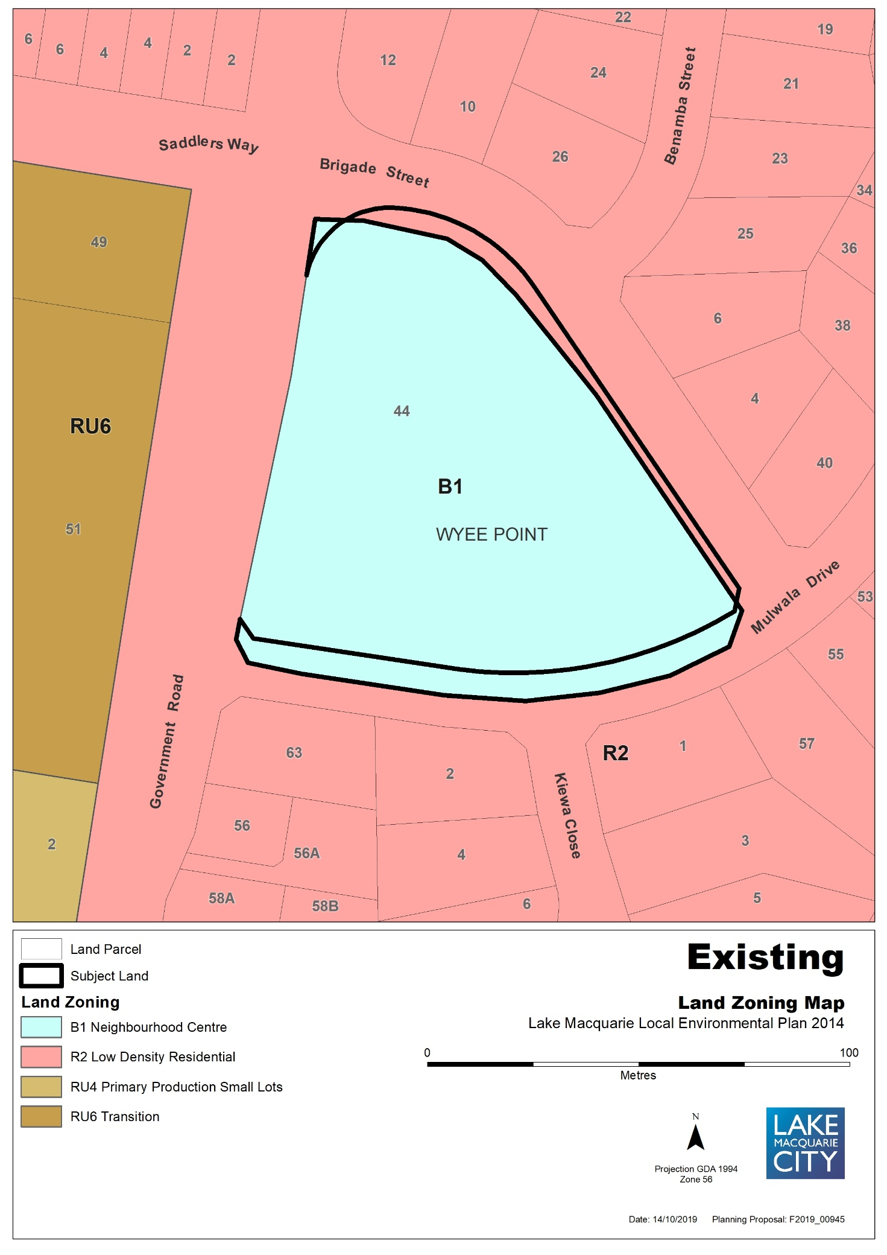

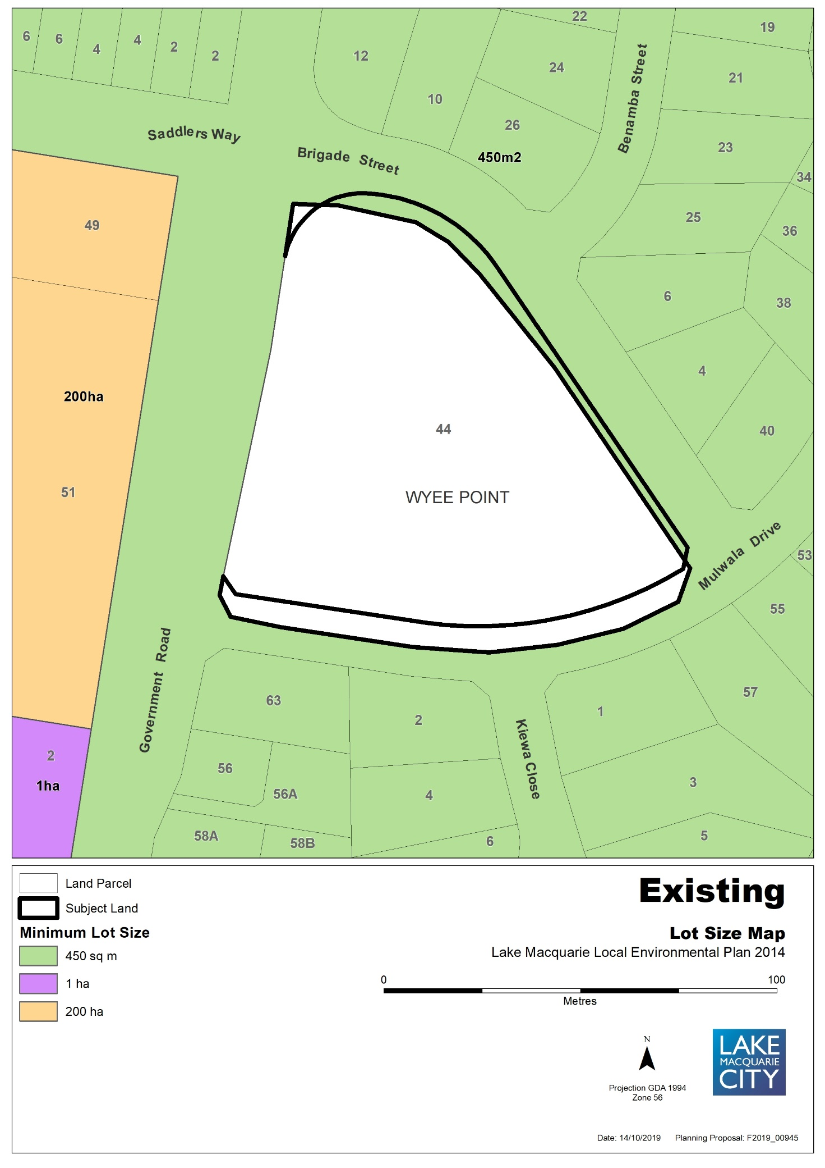

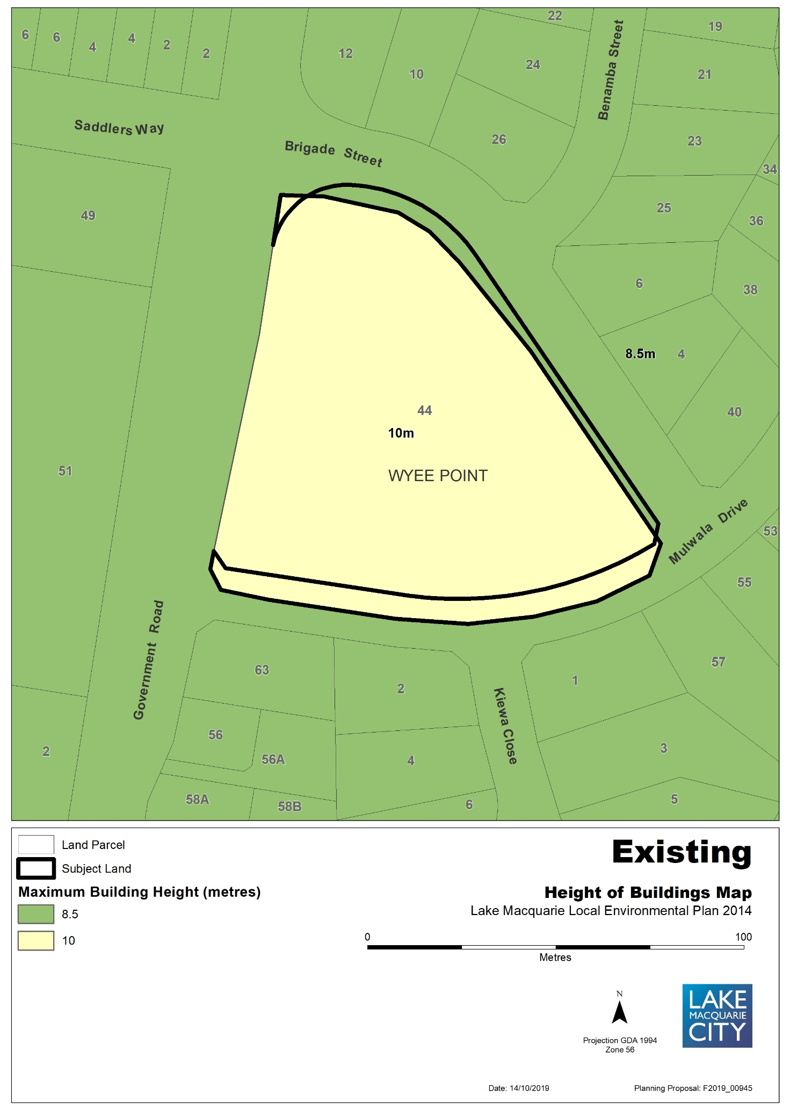

Map 6b – Item 5 – Proposed Zones, Minimum lot size, Height of buildings
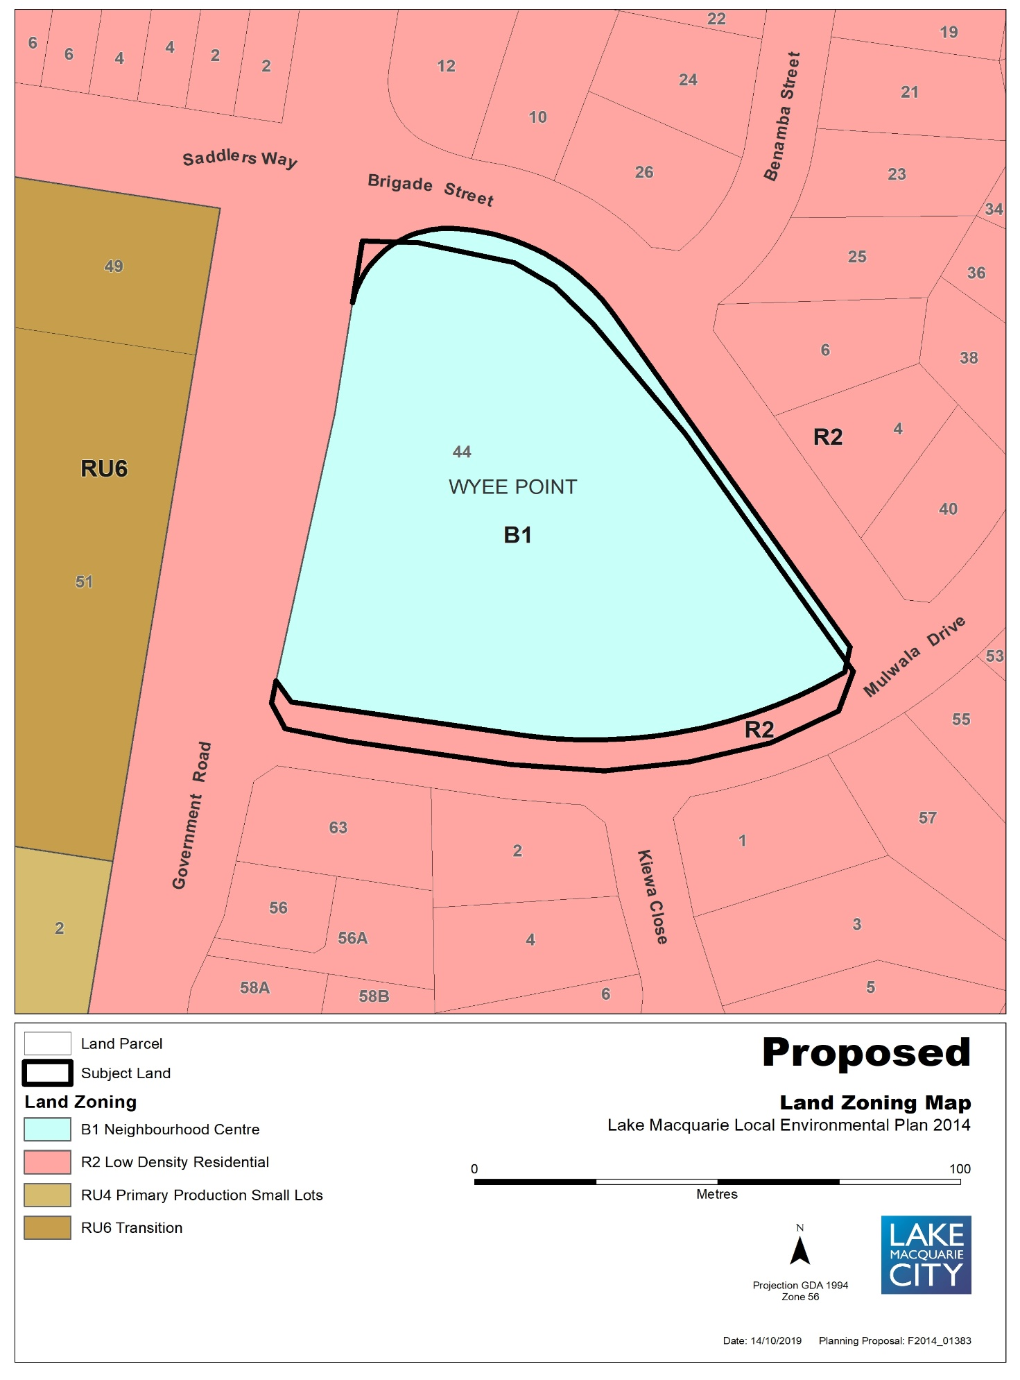

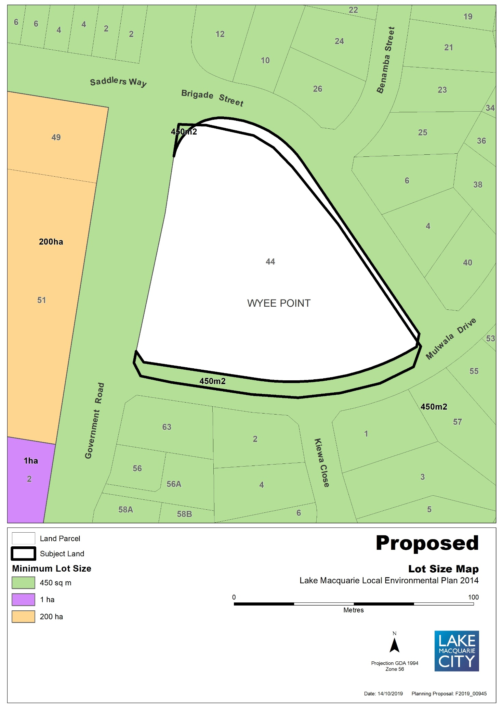

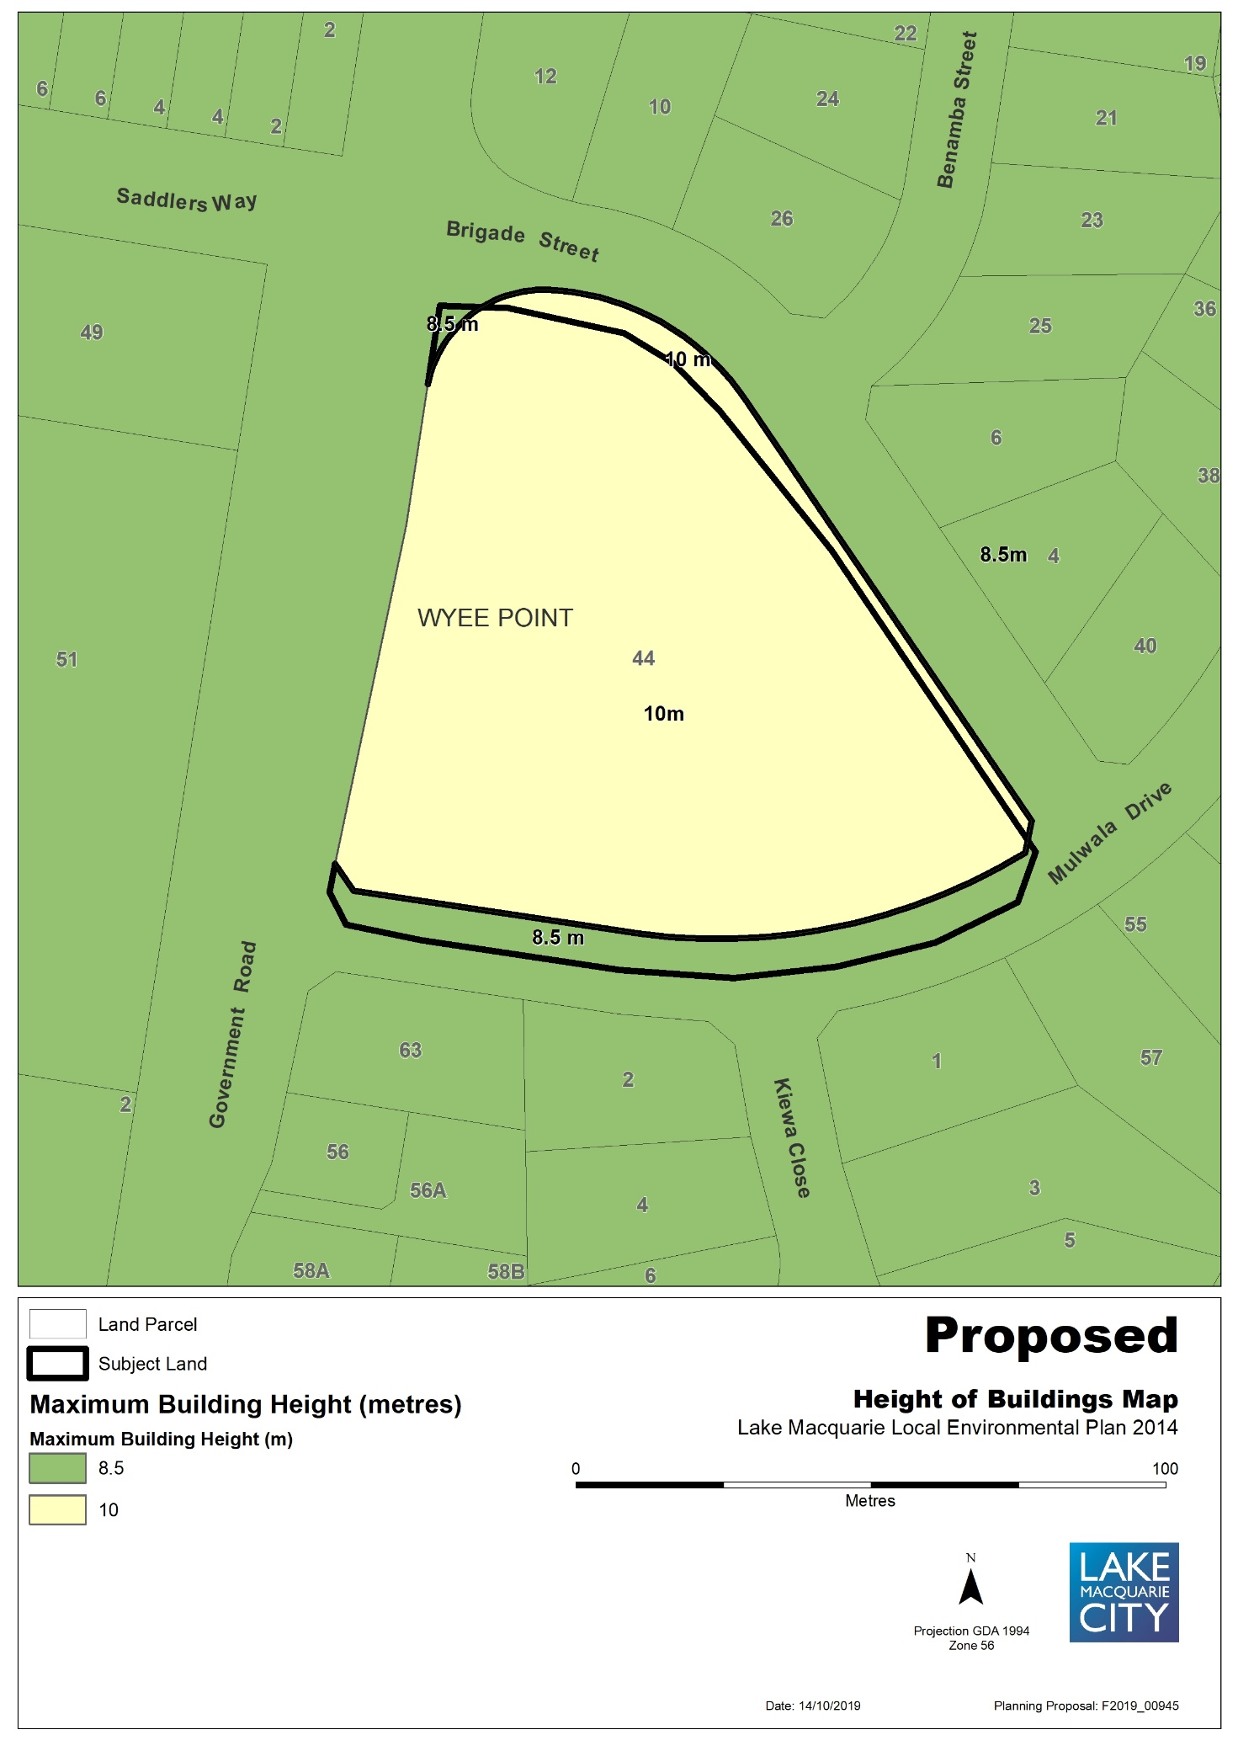

Map 7a – Item 6 – Aerial, Existing Land Acquisition Reservation
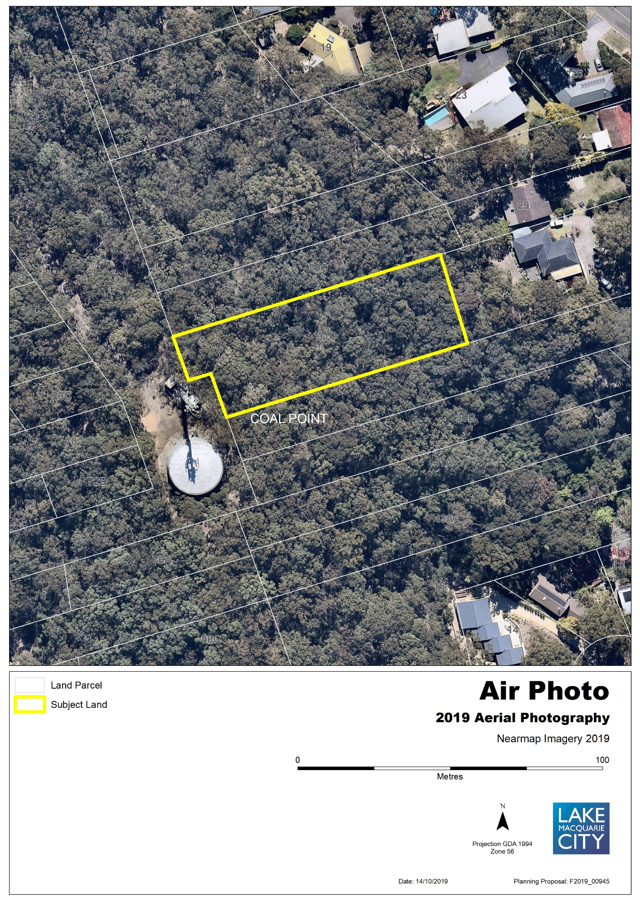
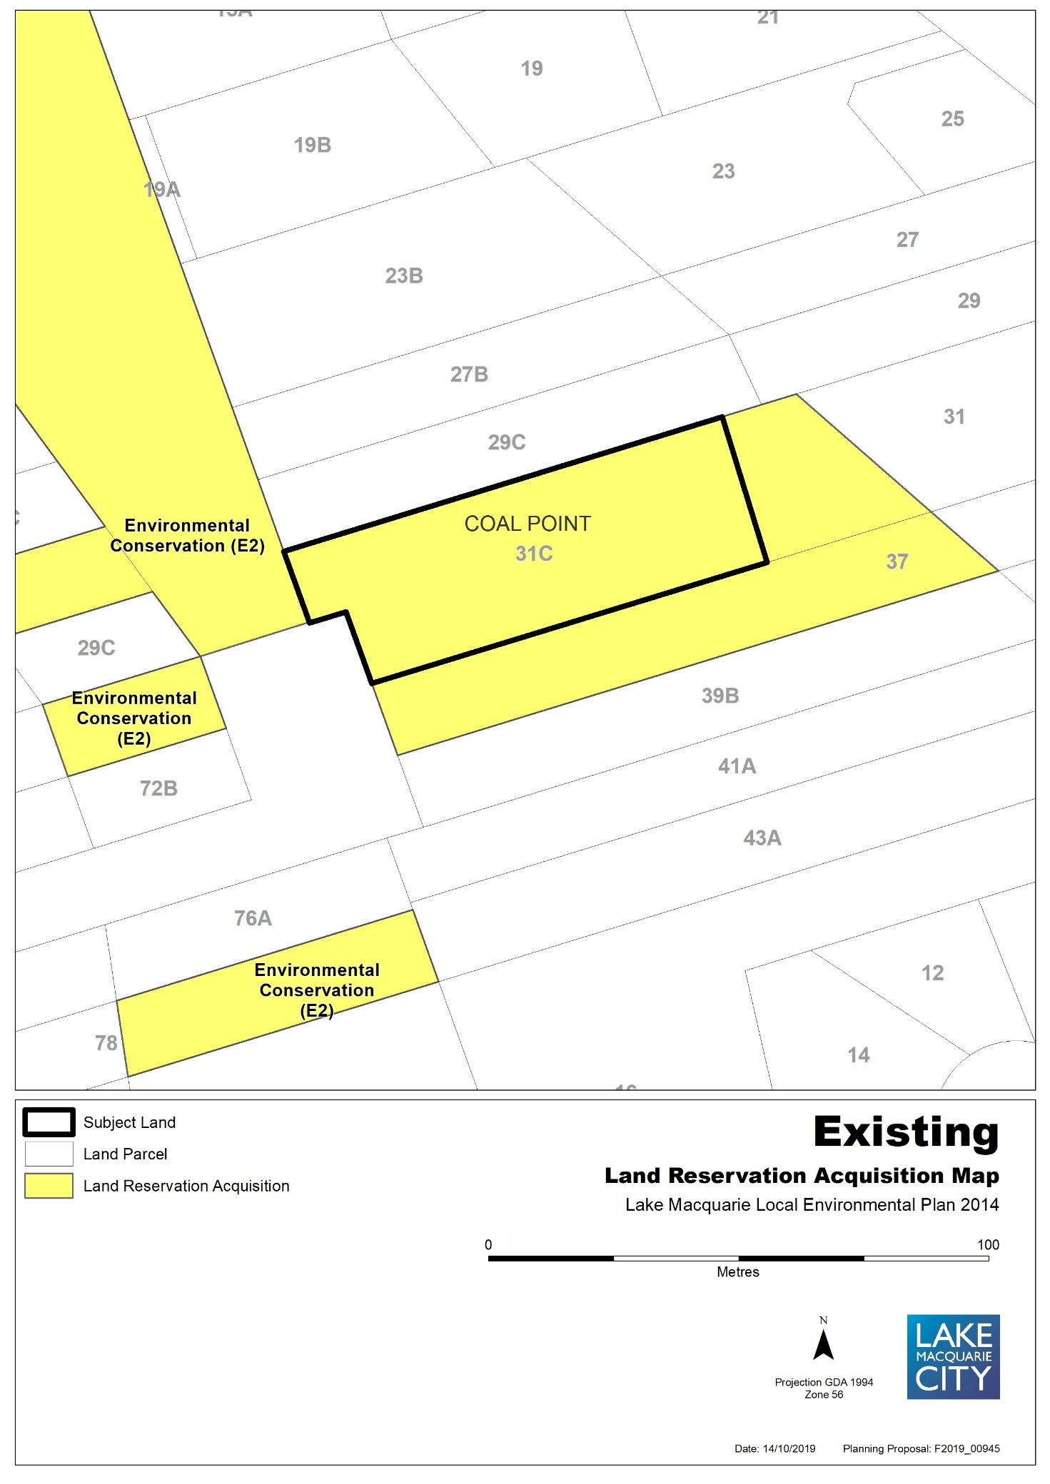

Map 7b – Item 6 – Proposed Land Acquisition Reservation
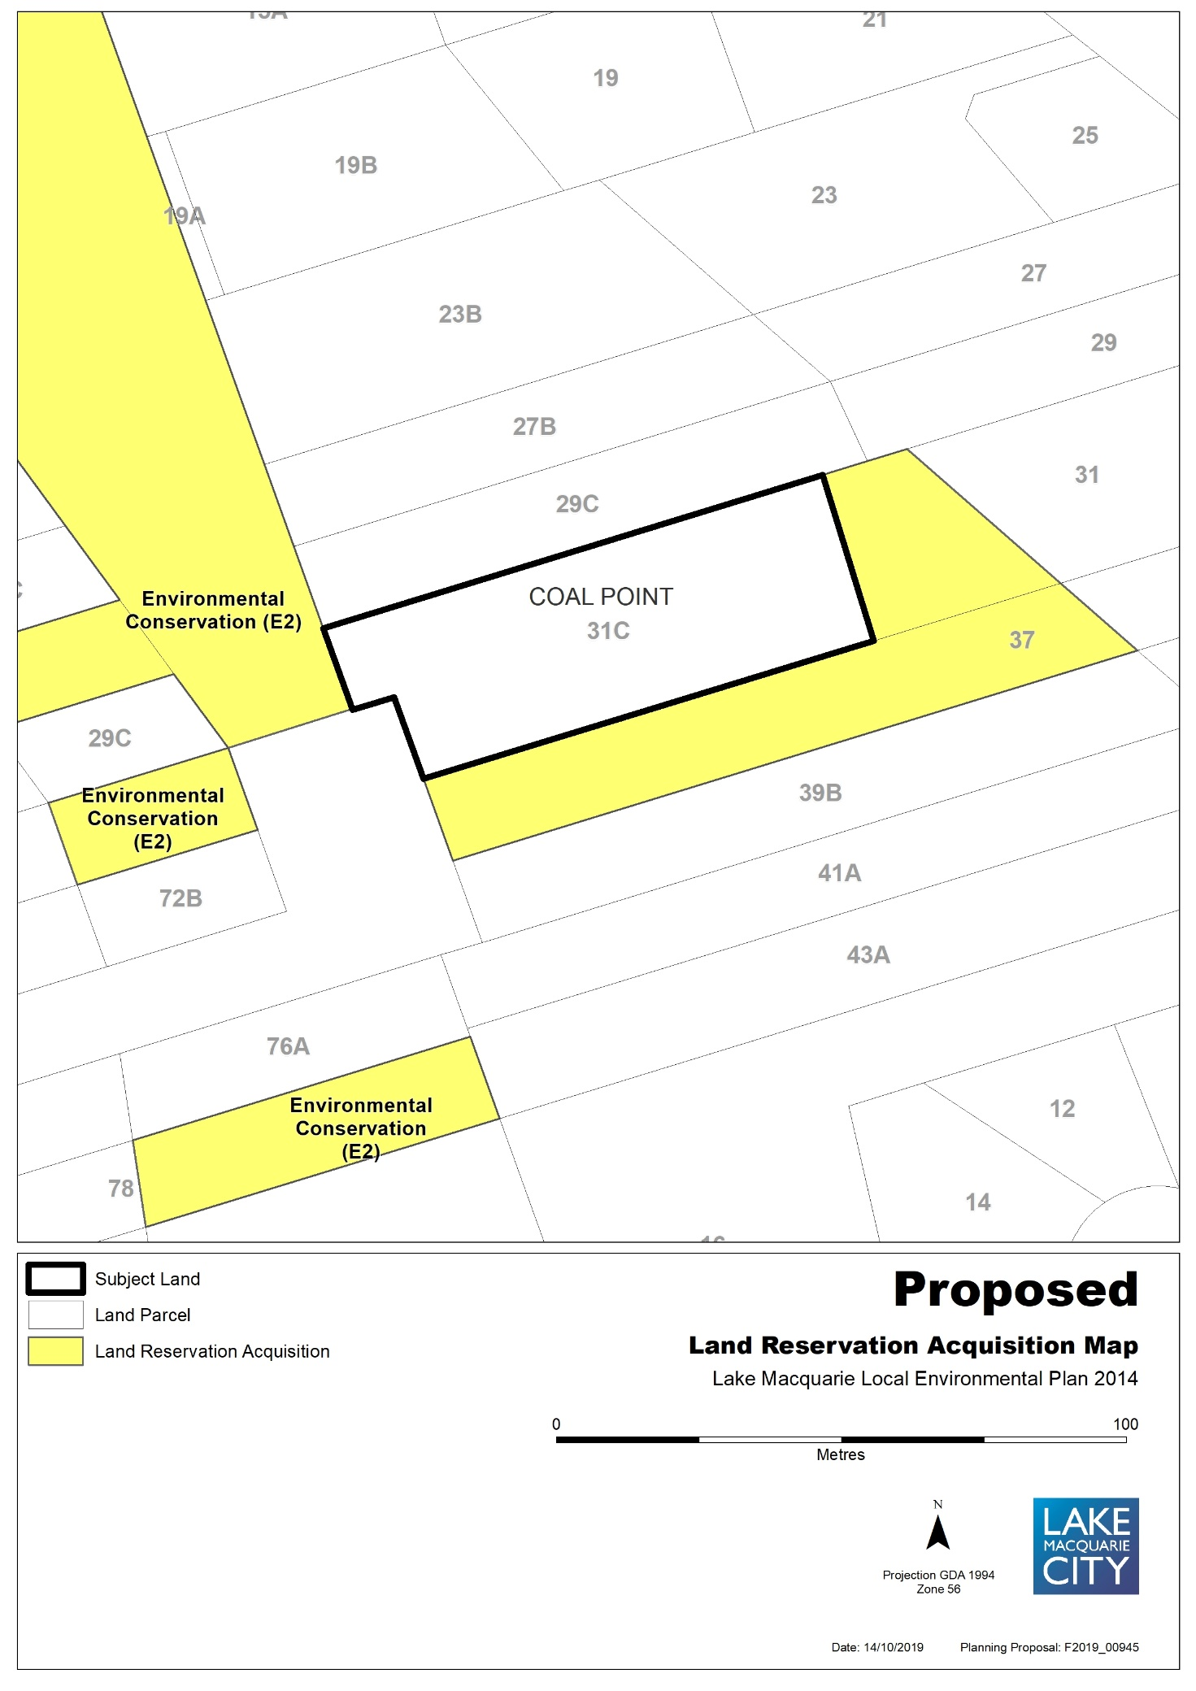
Map 8a – Item 7 – Aerial, Existing Land Acquisition Reservation
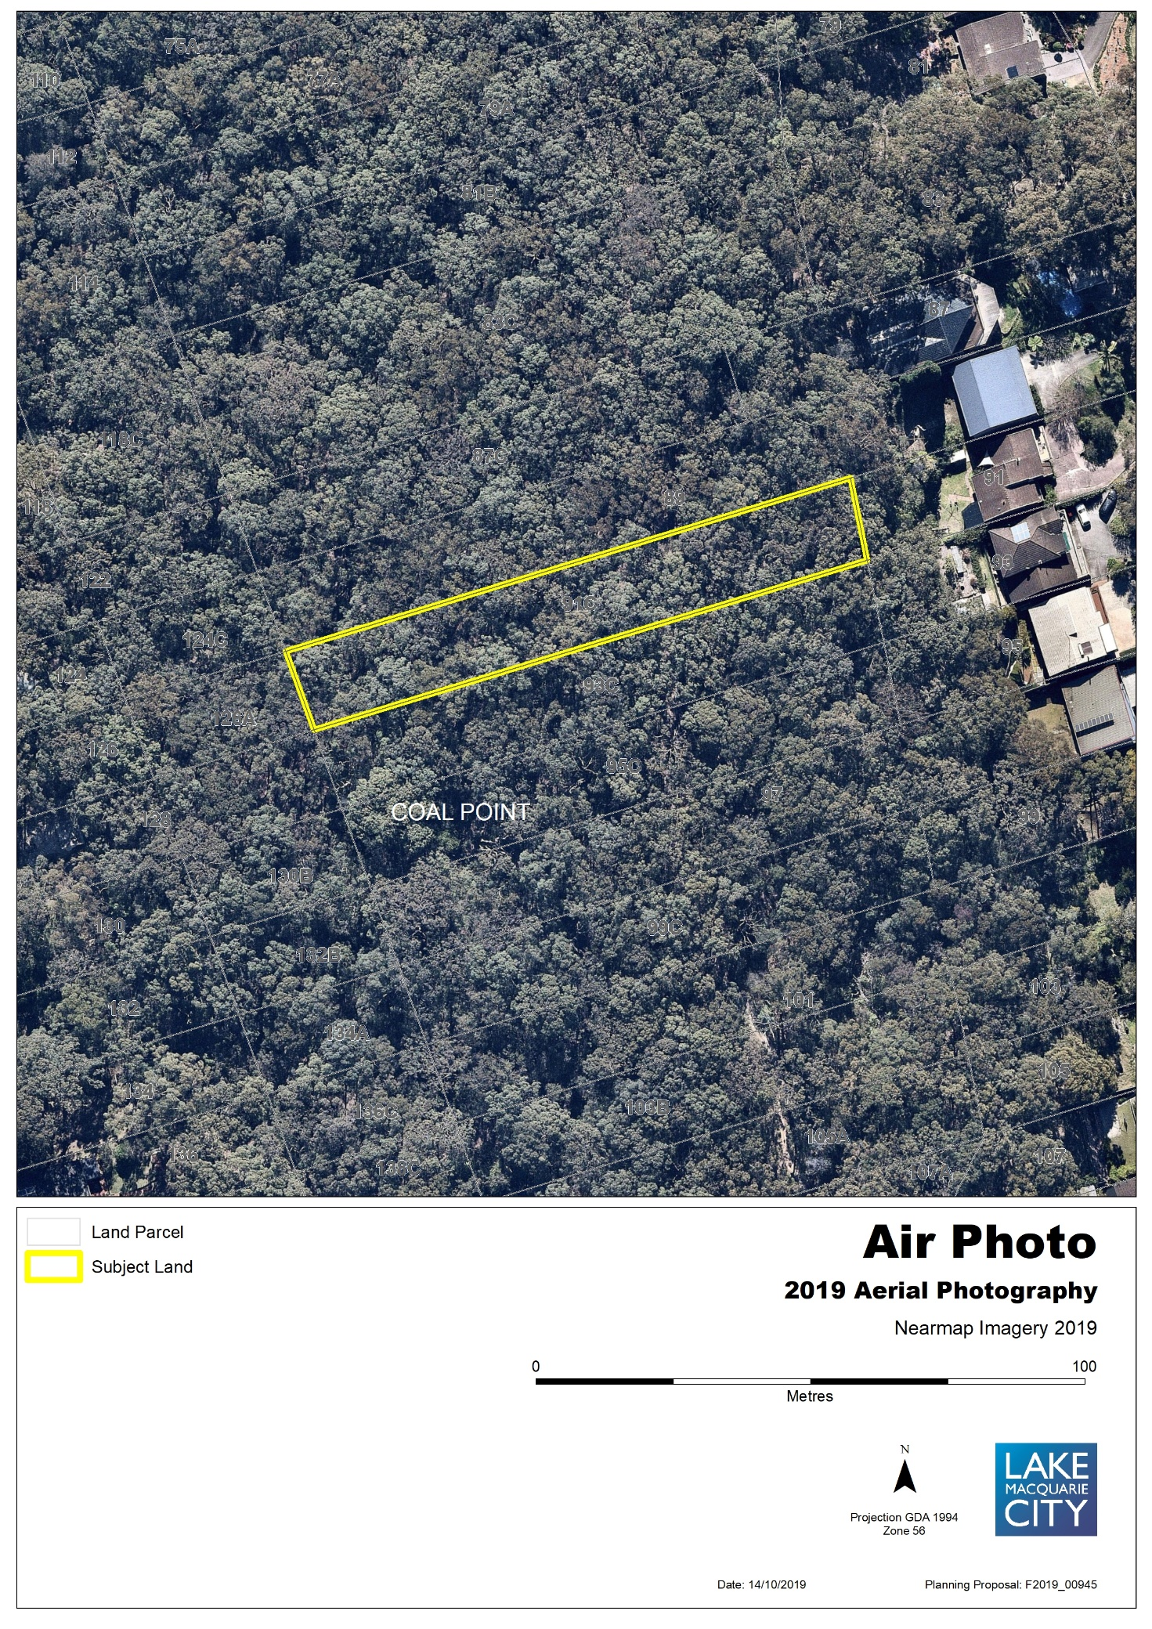
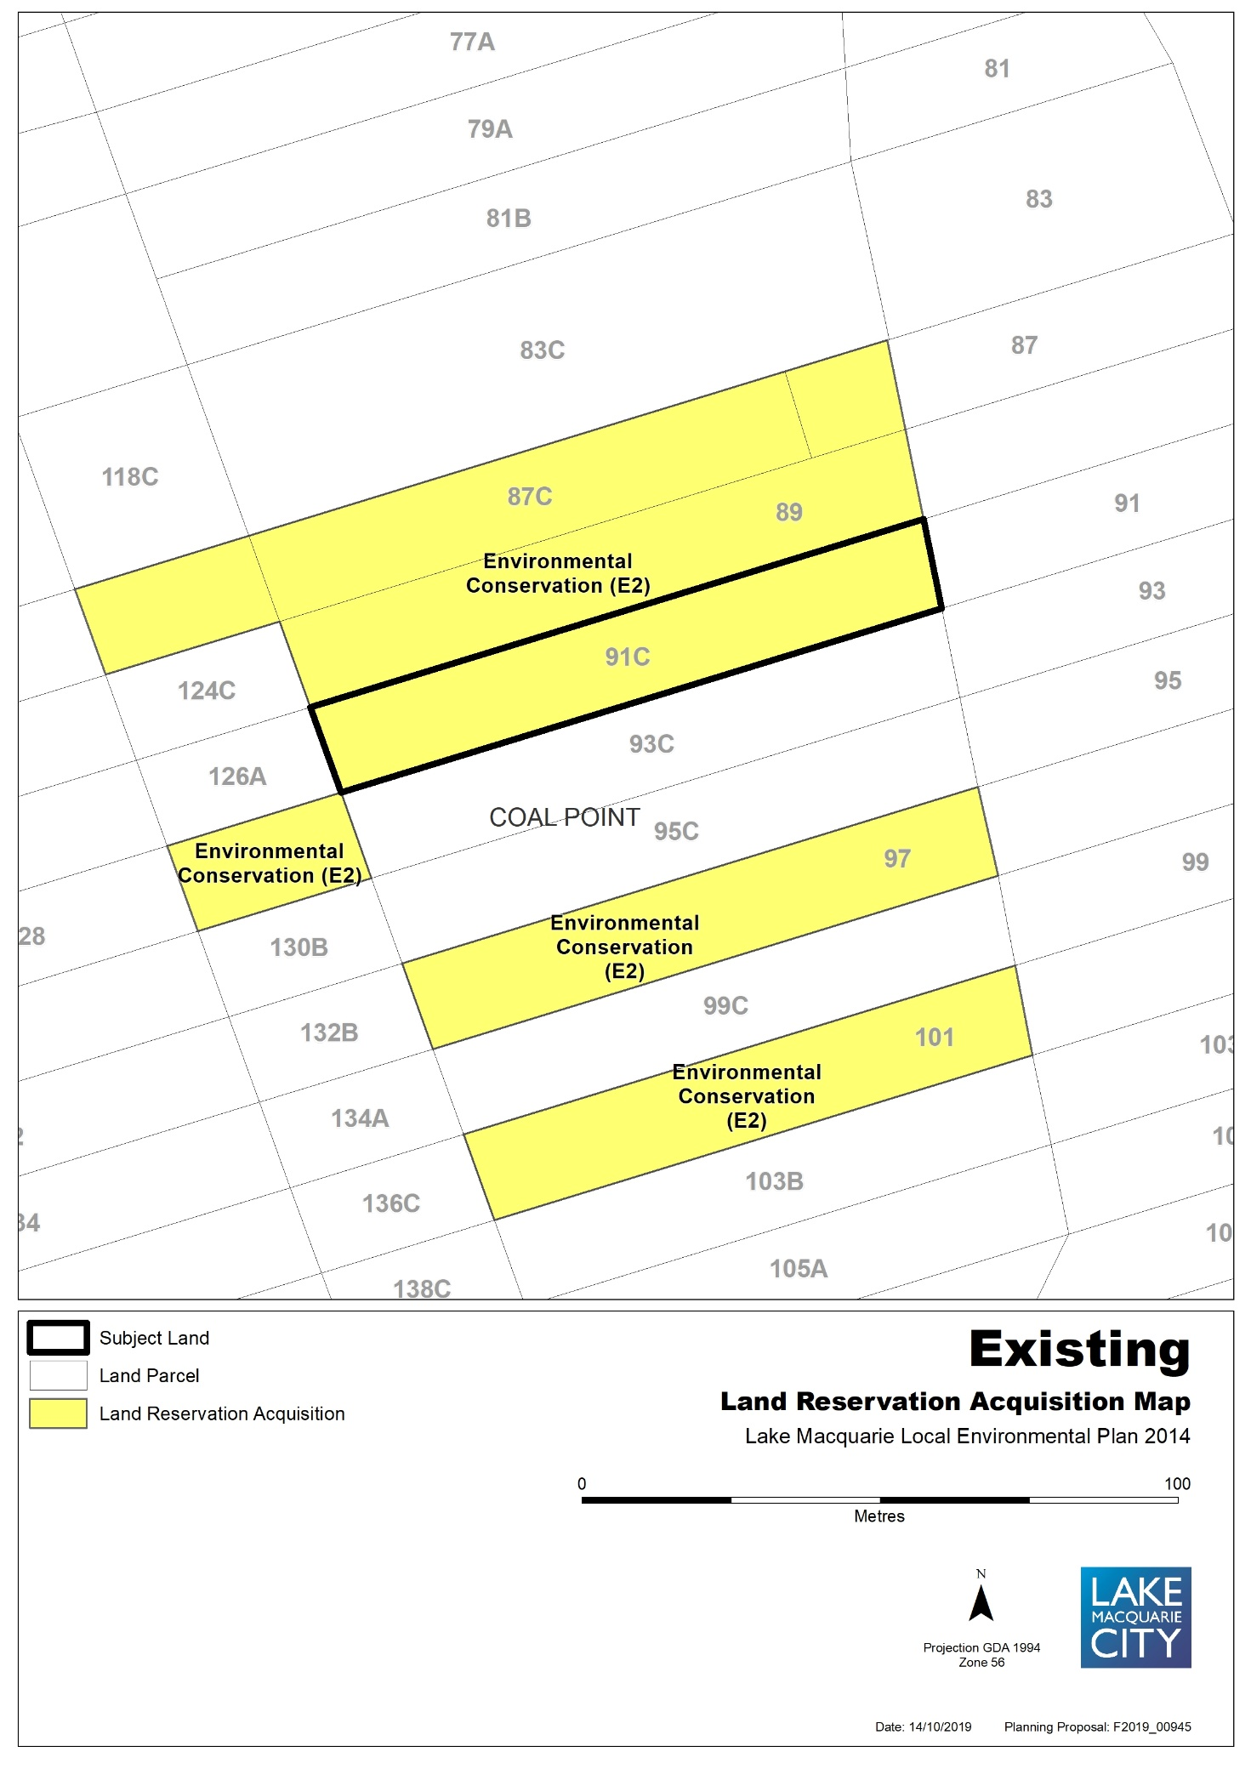

Map 8b – Item 7 – Proposed Land Acquisition Reservation
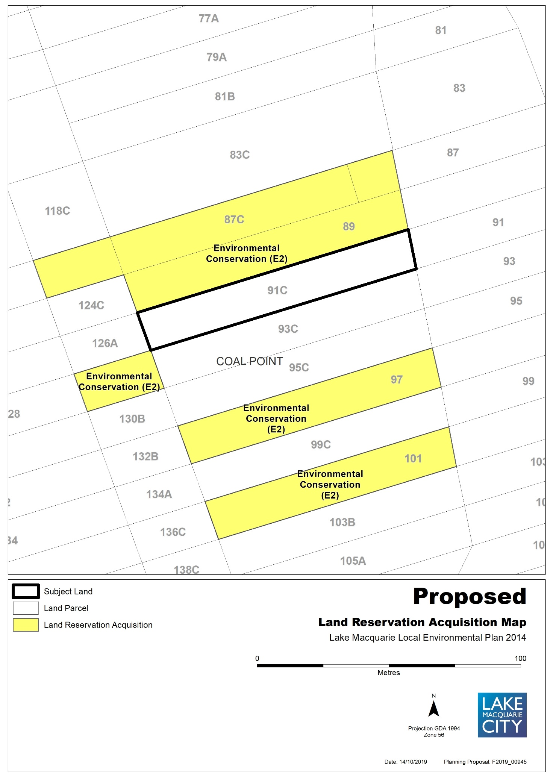
Map 9a – Item 8 – Aerial, Existing Land Acquisition Reservation
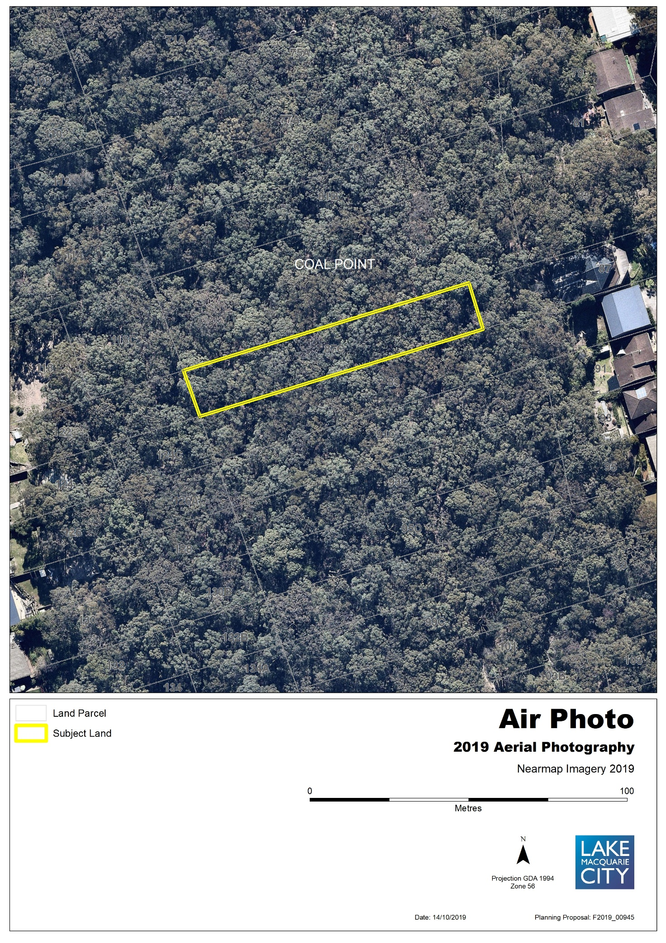
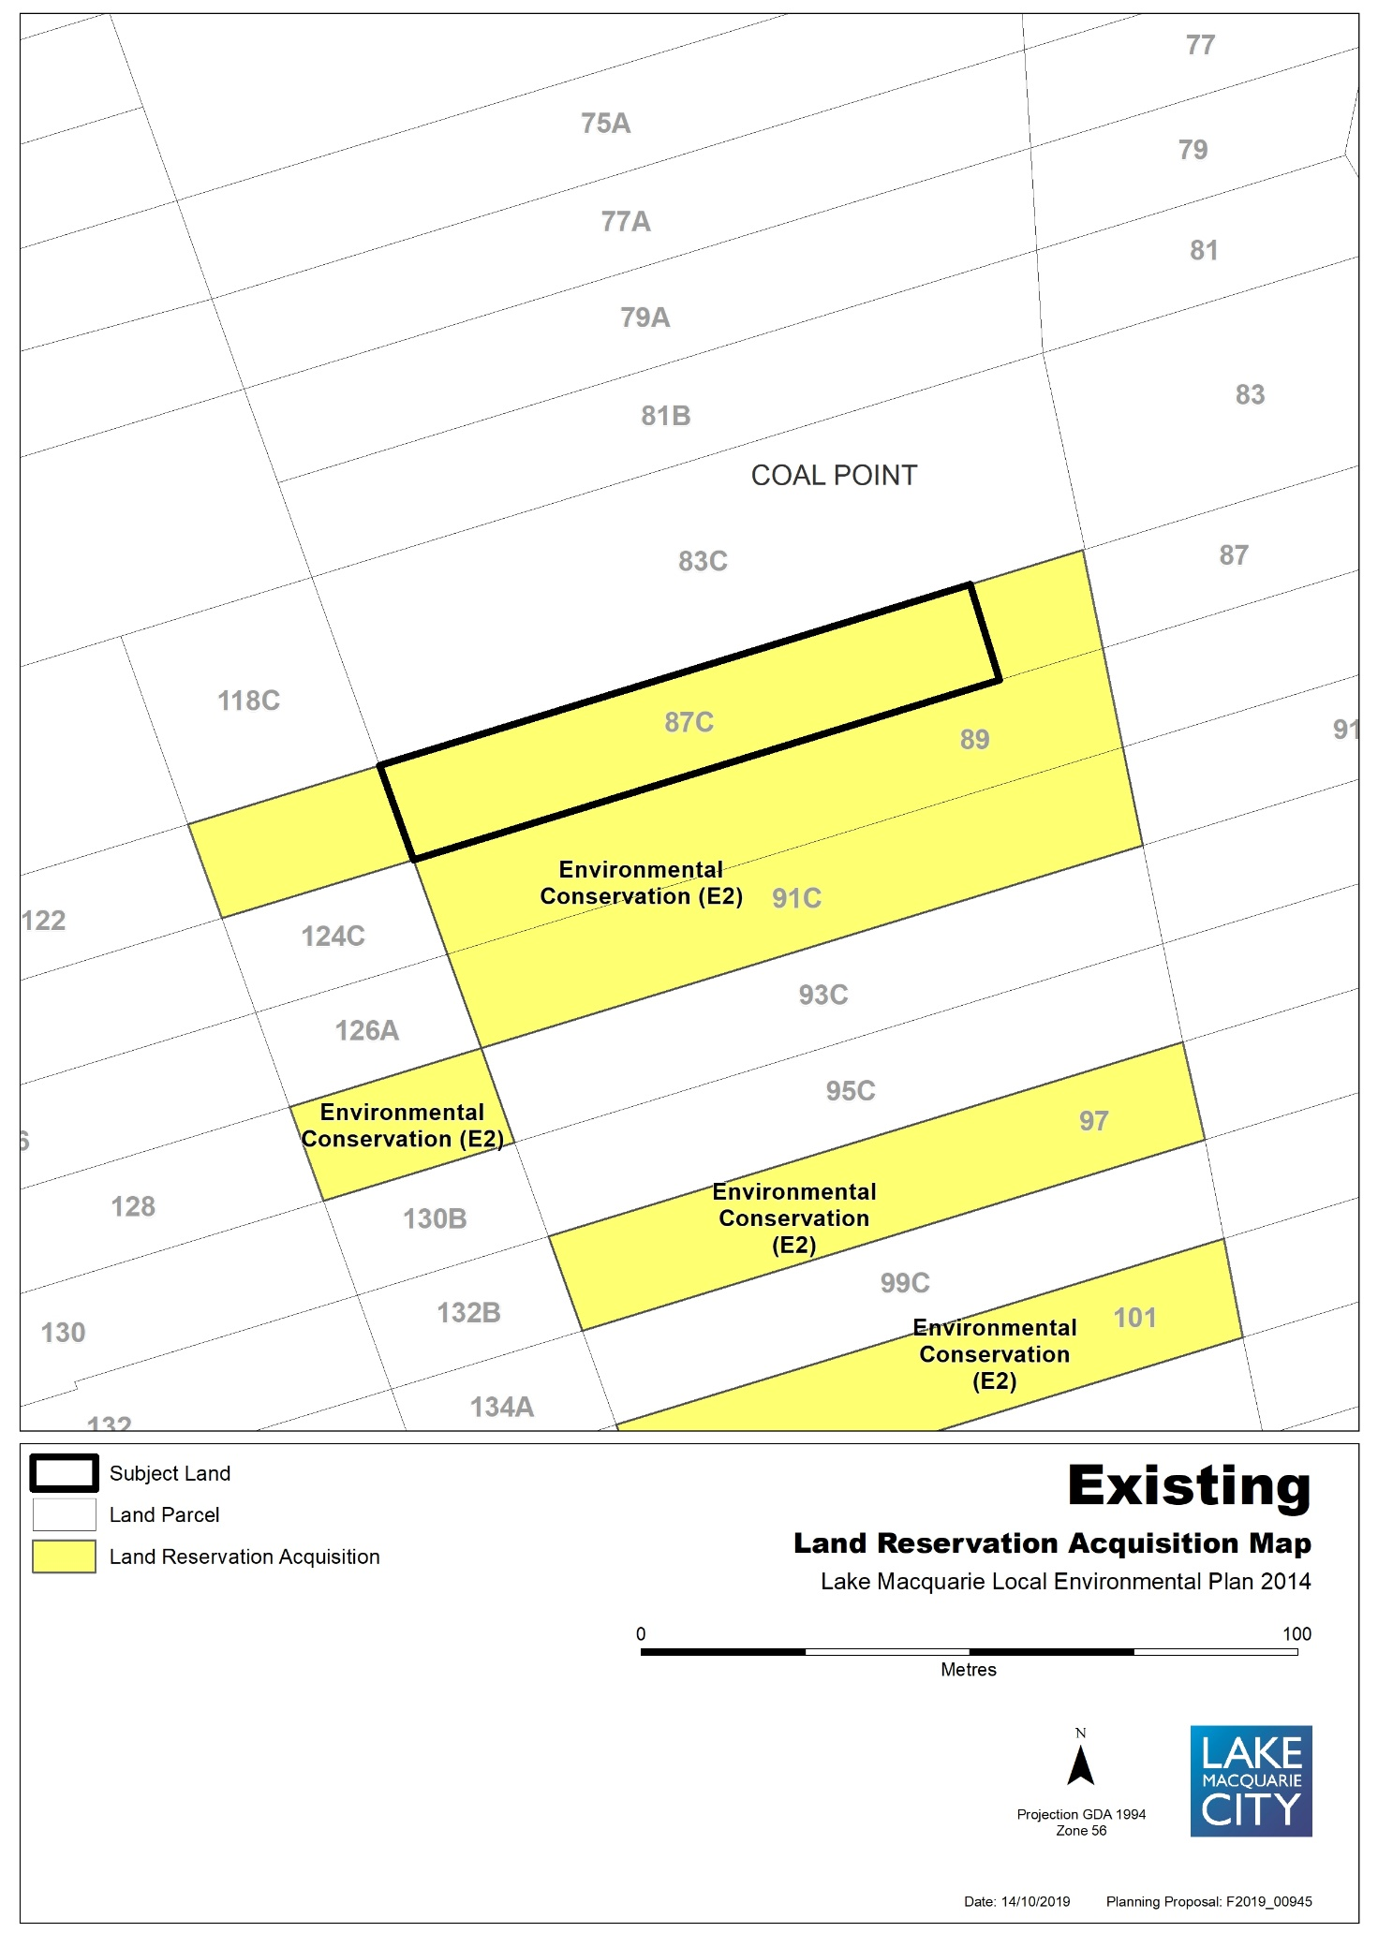

Map 9b – Item 8 – Proposed Land Acquisition Reservation
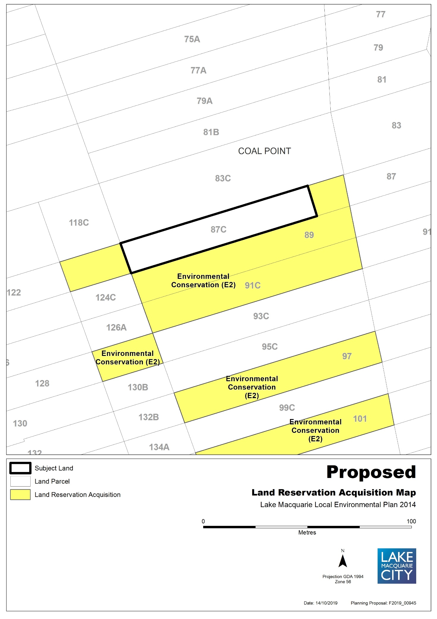
Map 10a – Item 9 – Aerial, Existing Land Acquisition Reservation
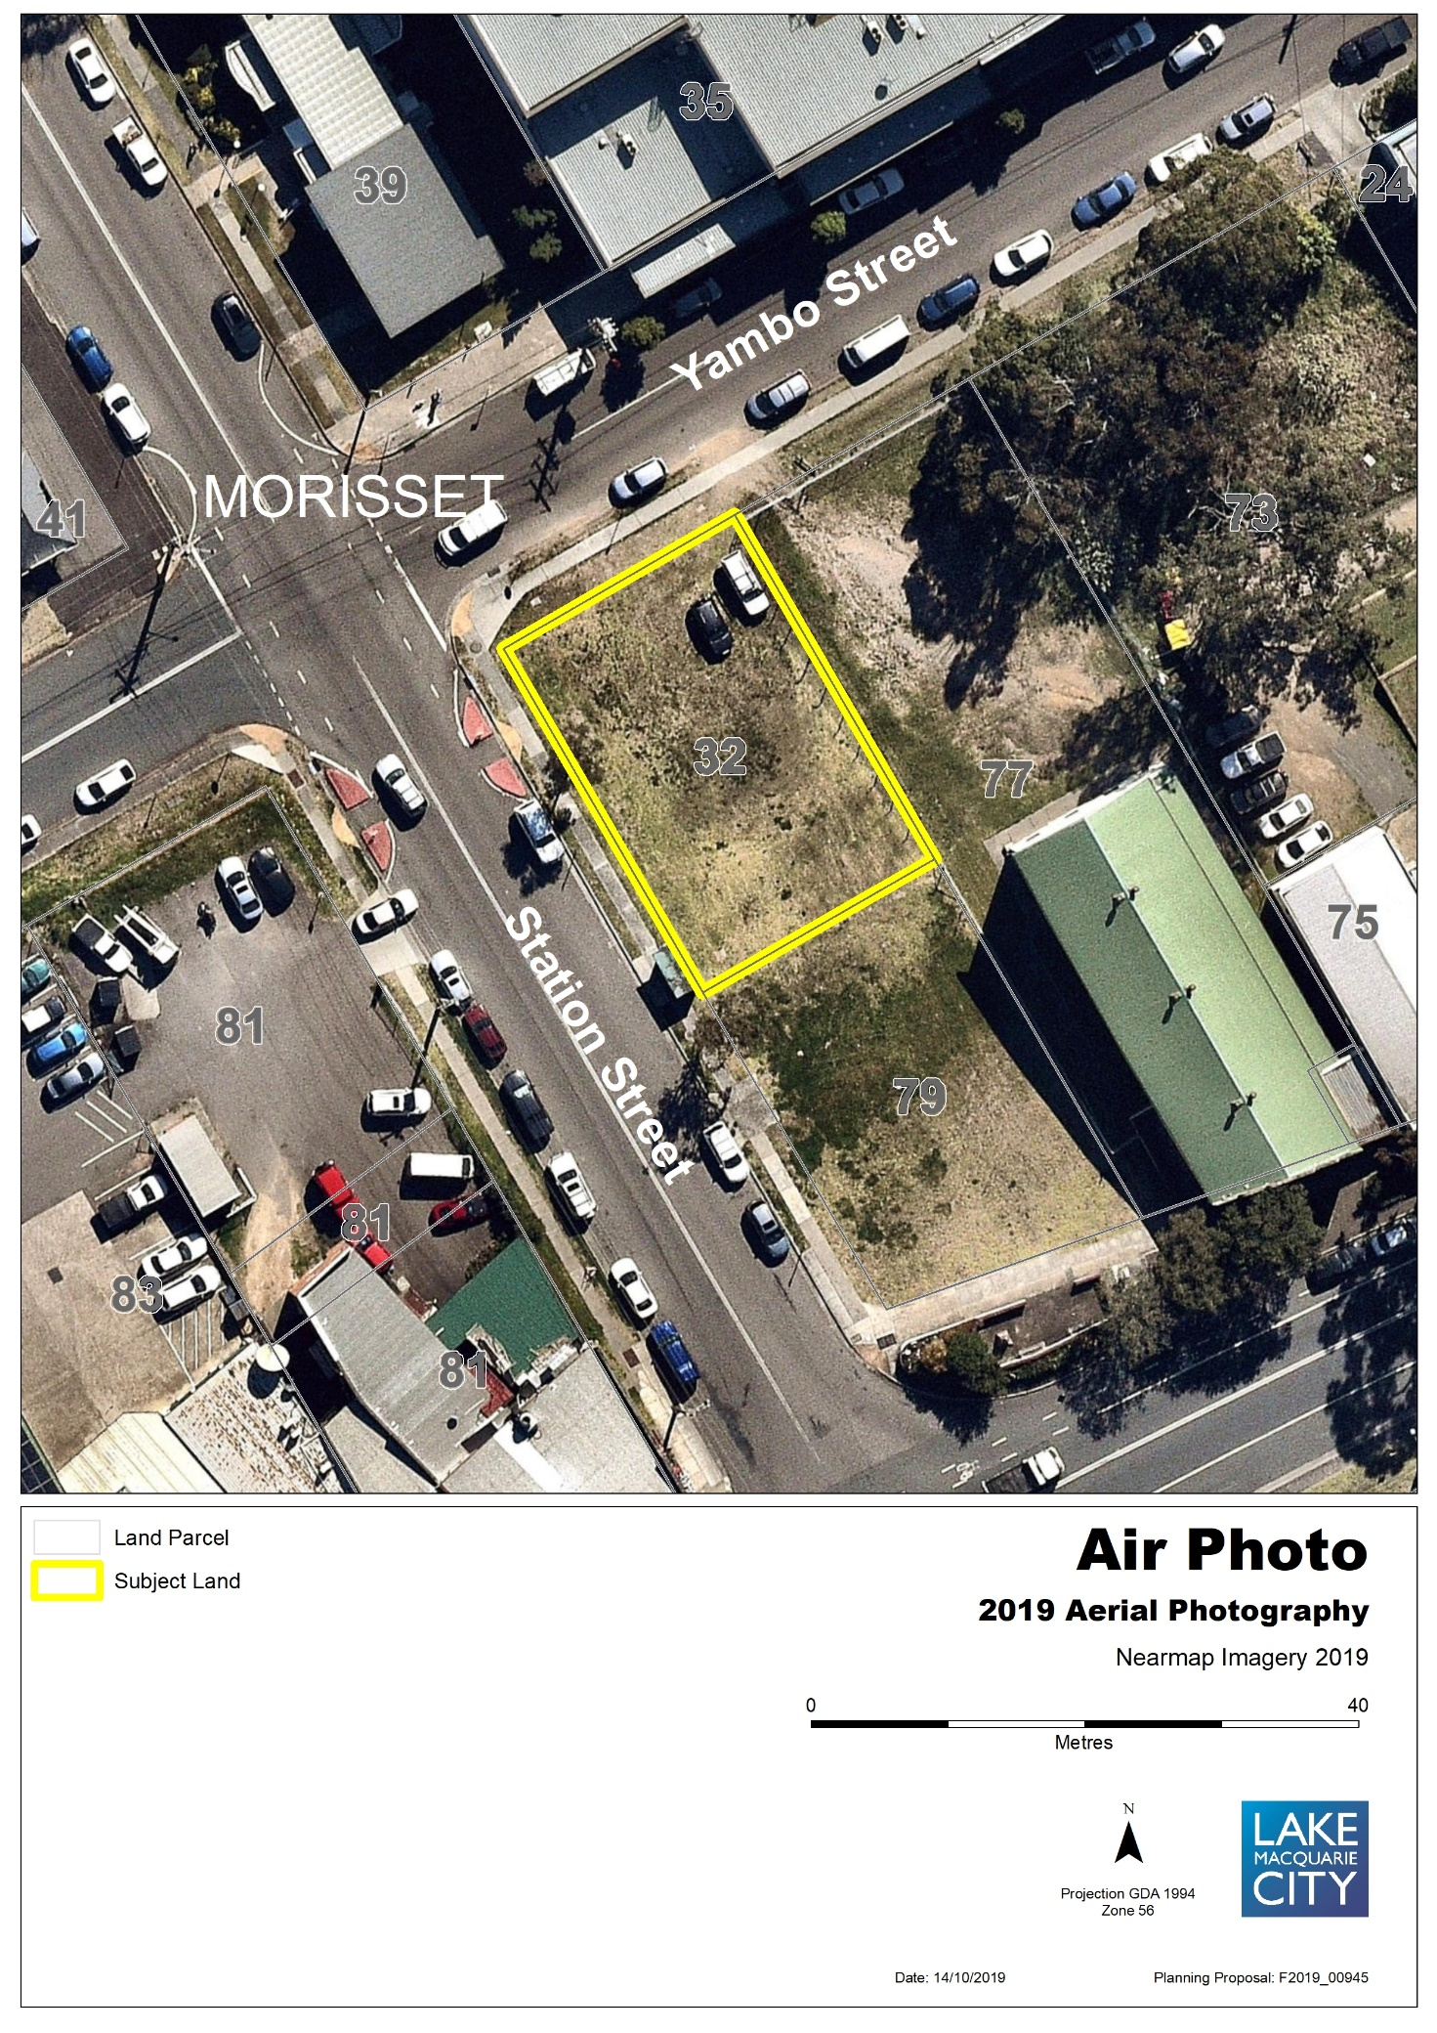
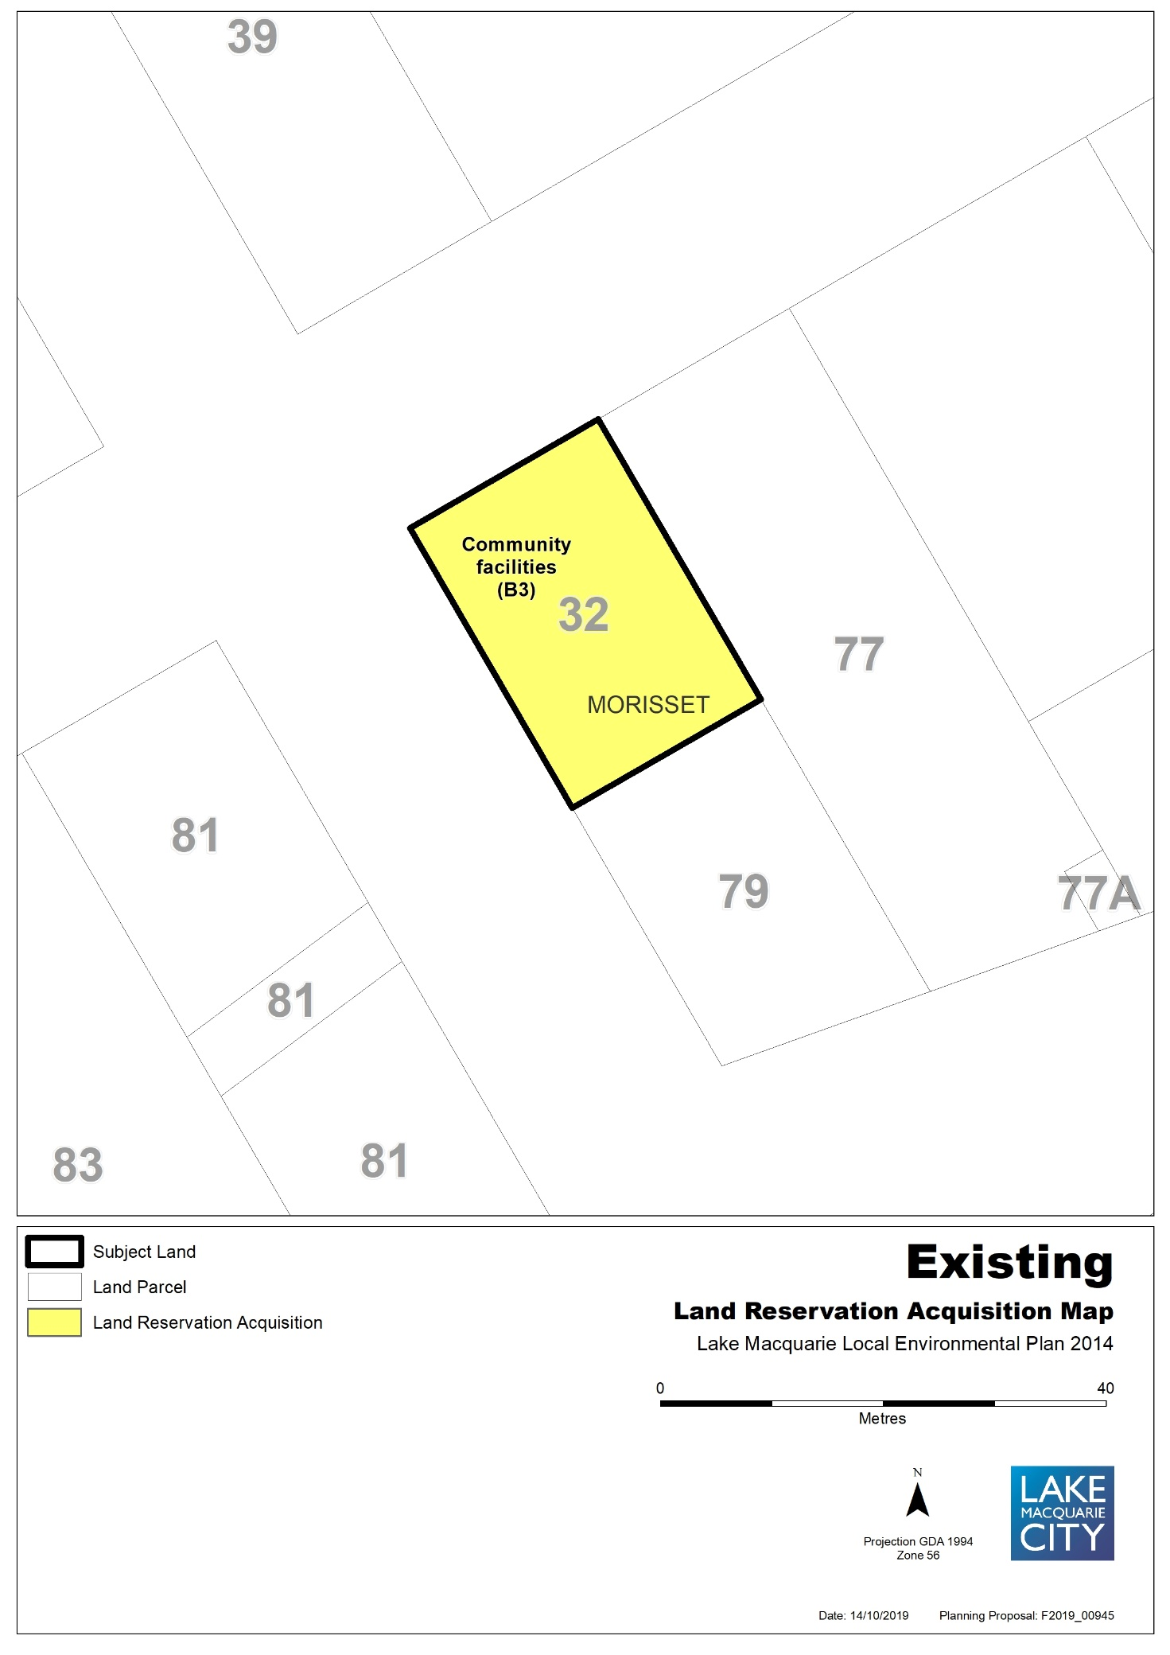

Map 10b – Item 9 – Proposed Land Acquisition Reservation
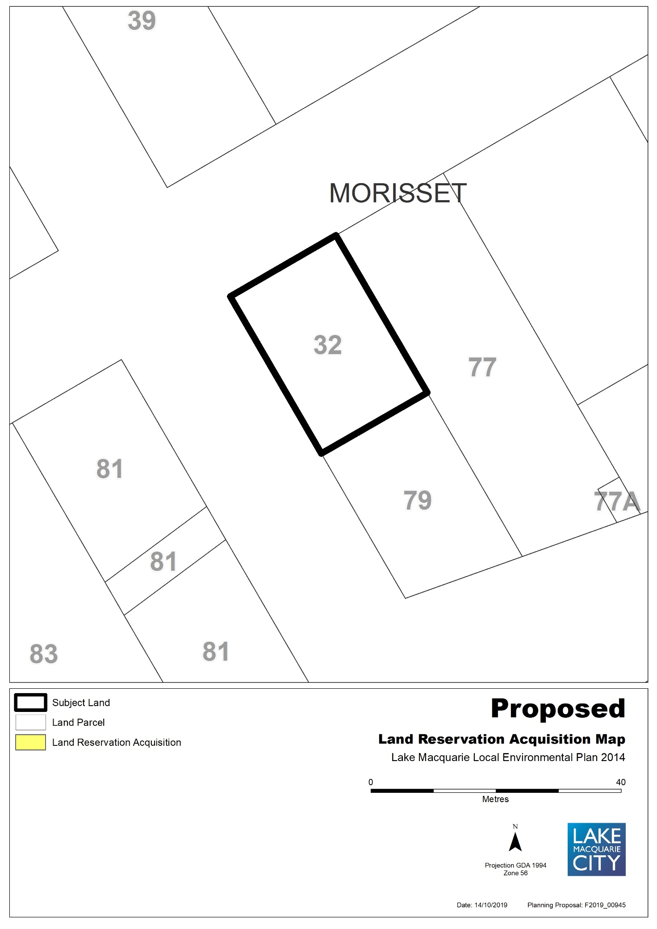
Map 11a – Item 10 – Aerial, Existing Land Acquisition Reservation
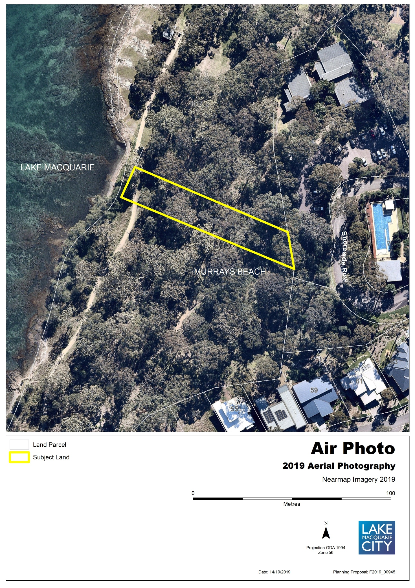
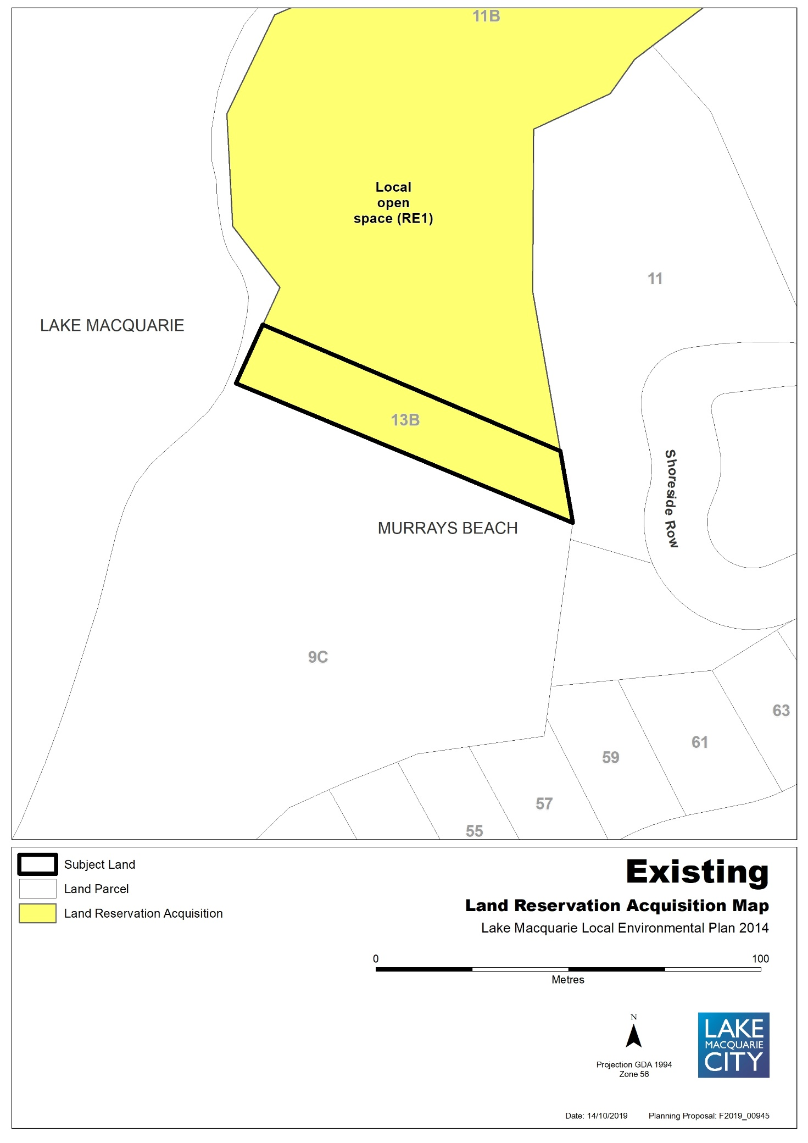

Map 11b – Item 10 – Proposed Land Acquisition Reservation
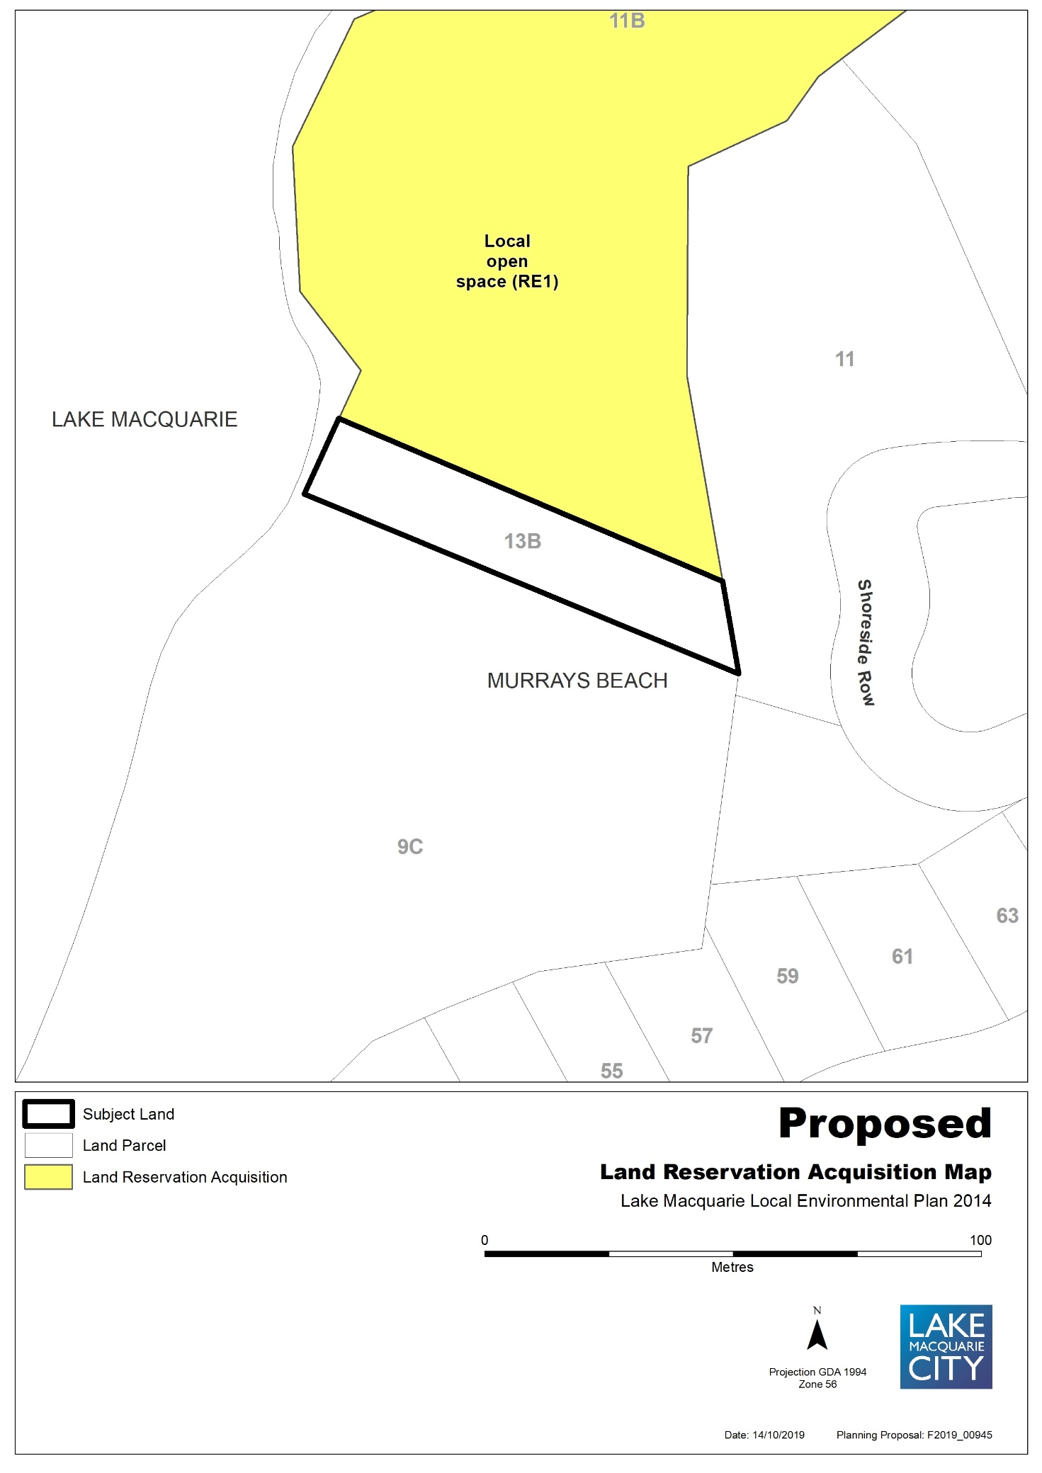
Map 12a – Item 11 – Aerial, Existing Land Acquisition Reservation
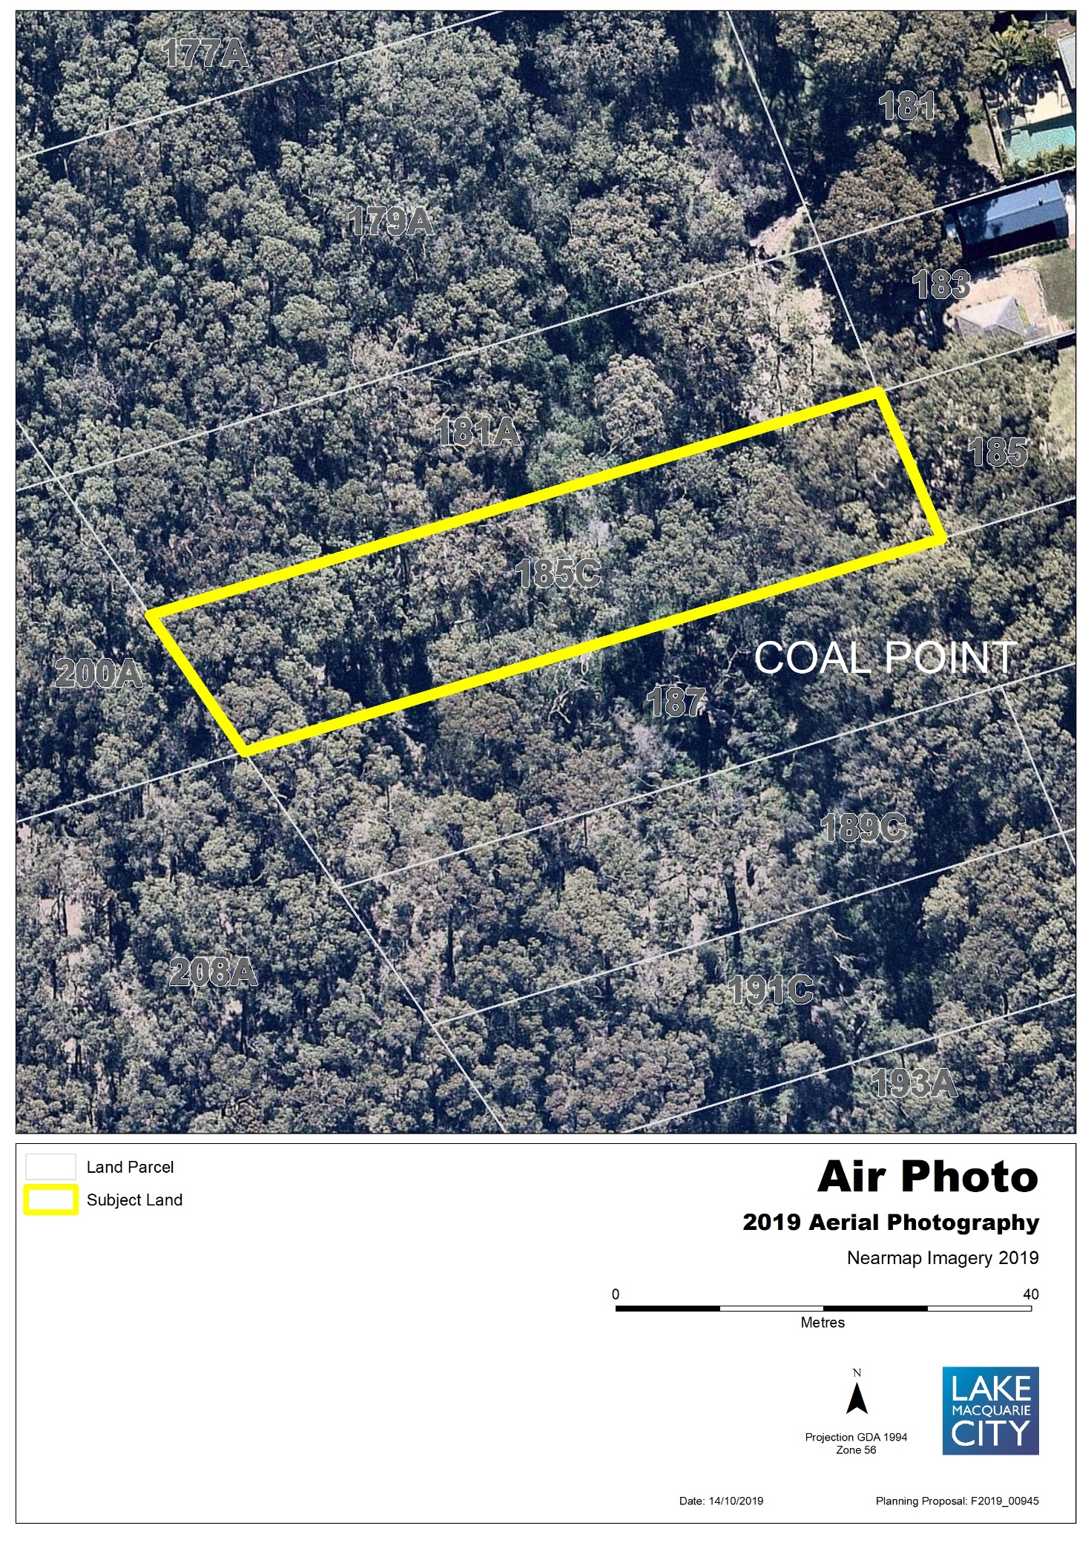
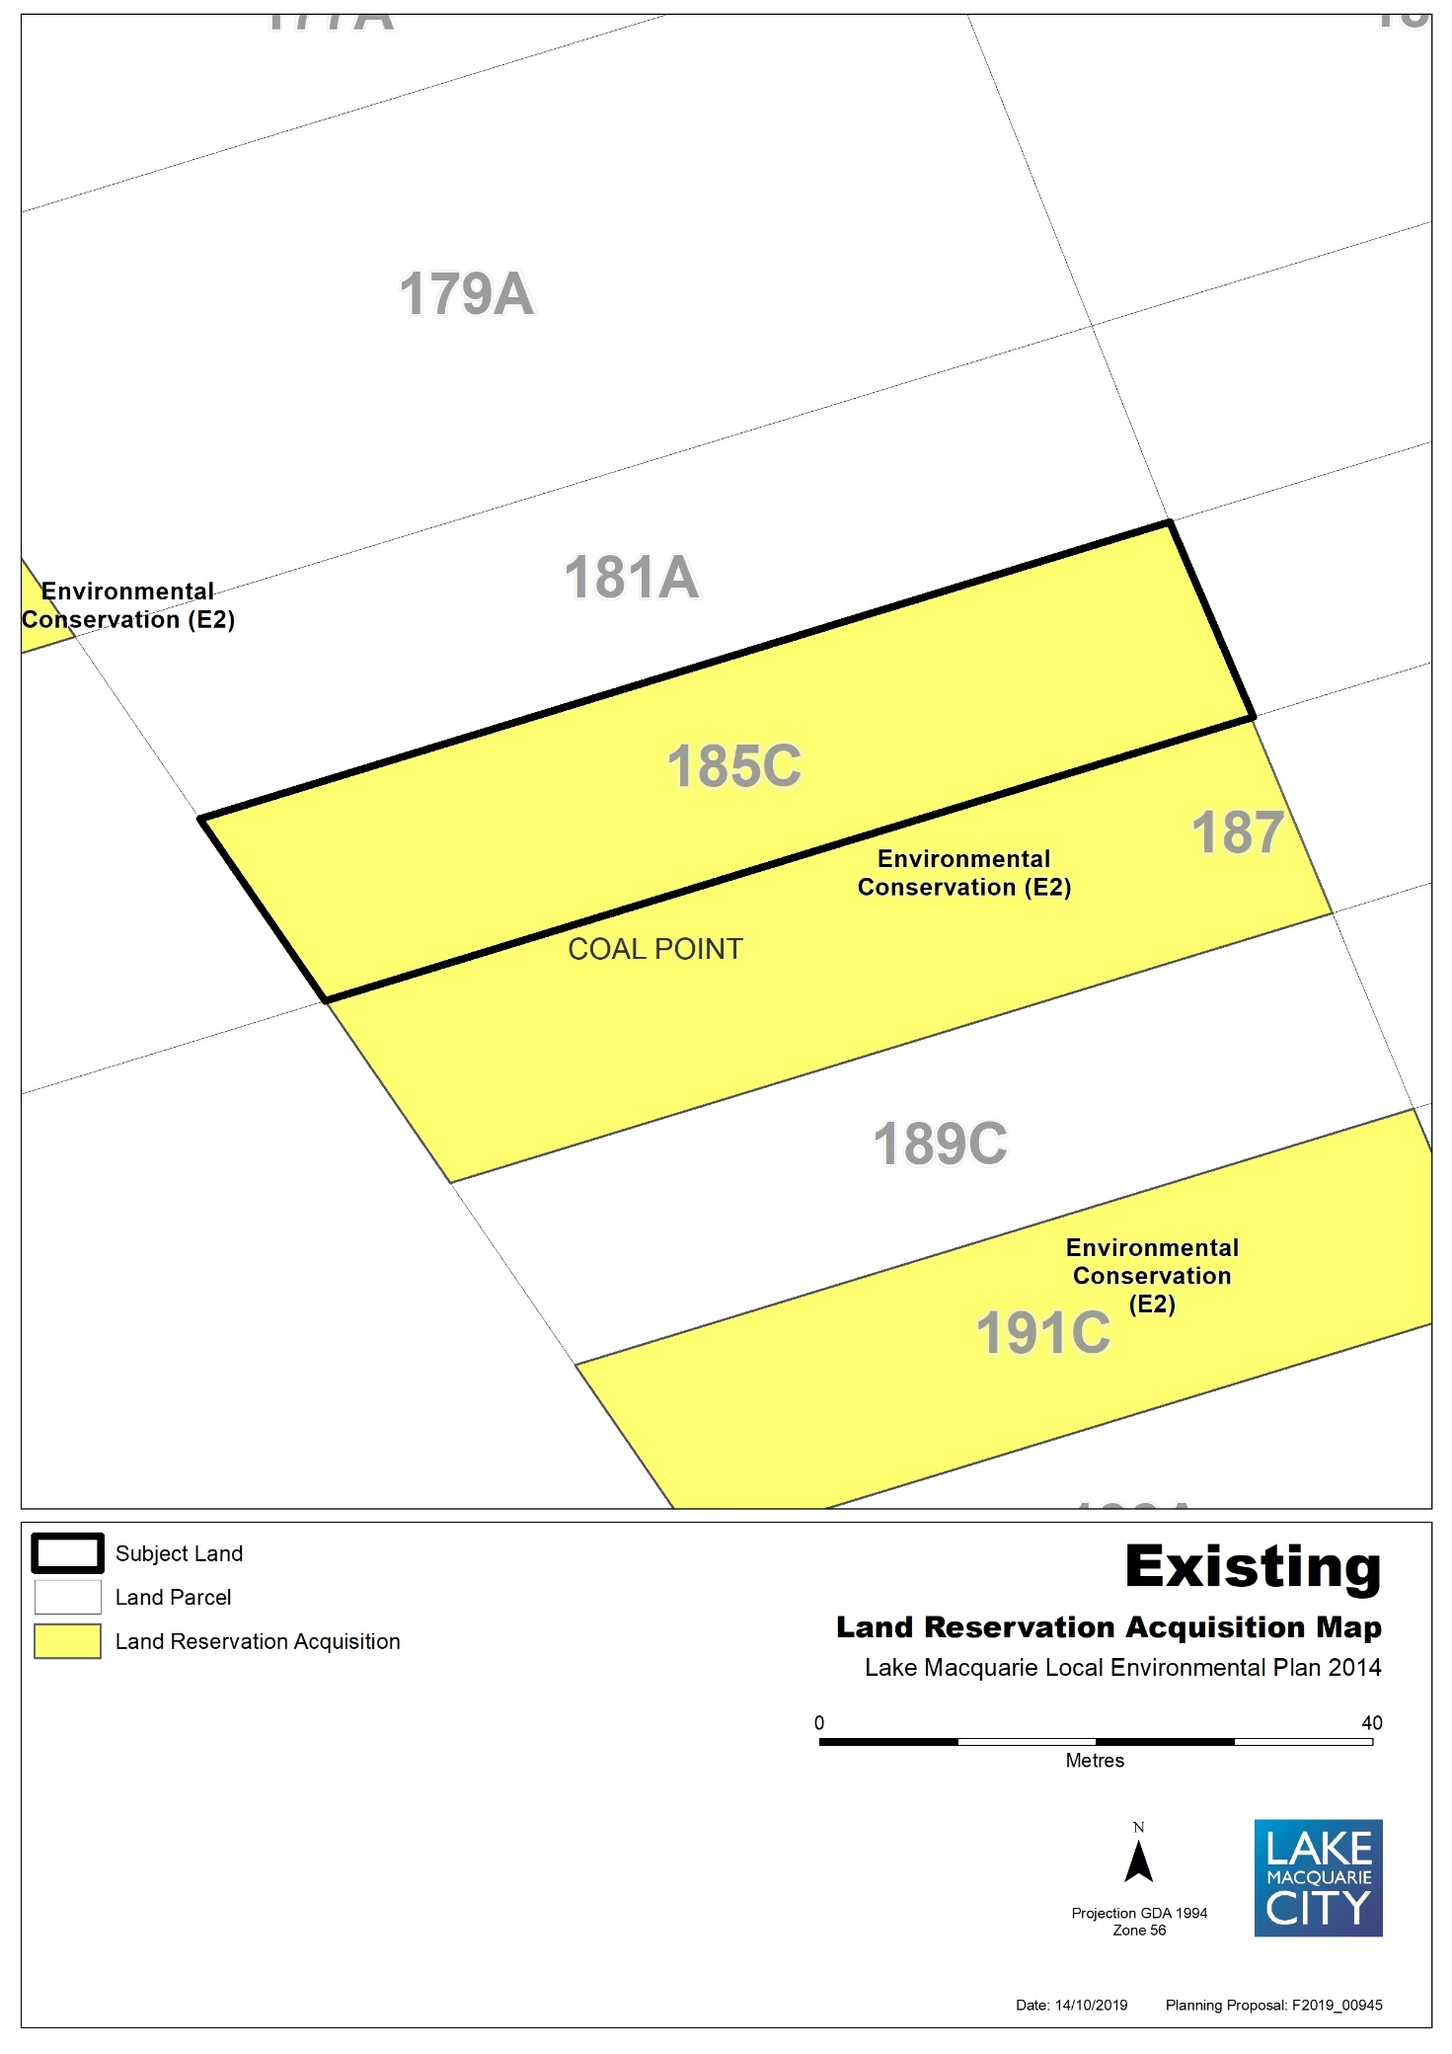

Map 12b – Item 11 – Proposed Land Acquisition Reservation
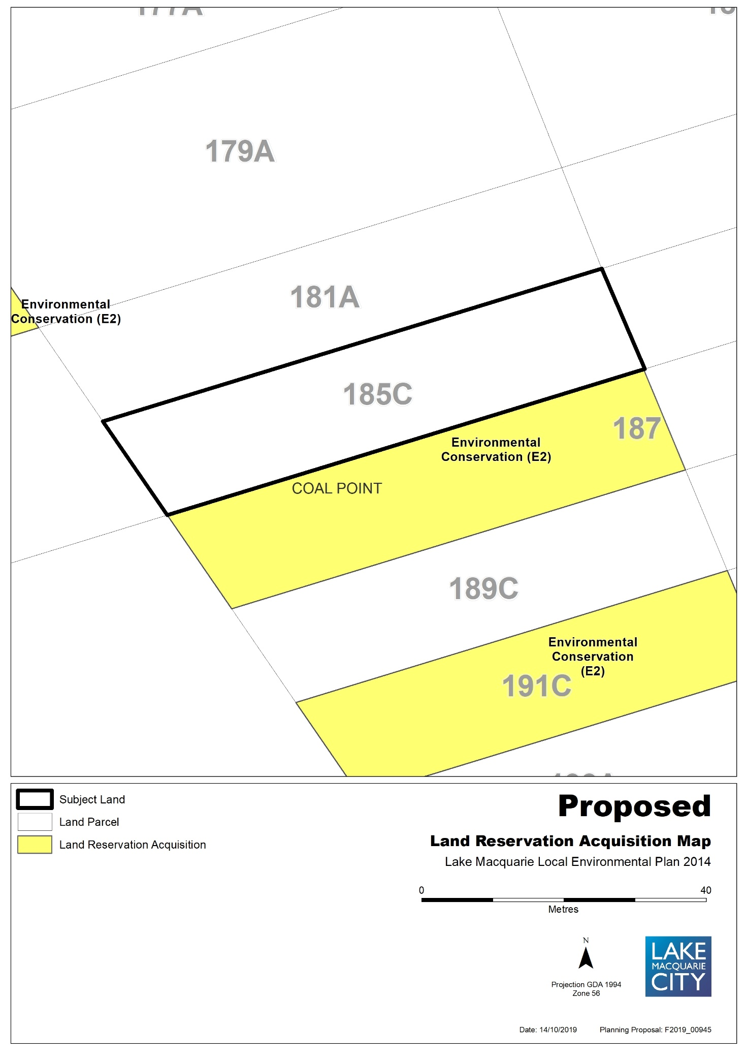
Map 13a – Item 12 – Aerial, Existing Land Acquisition Reservation
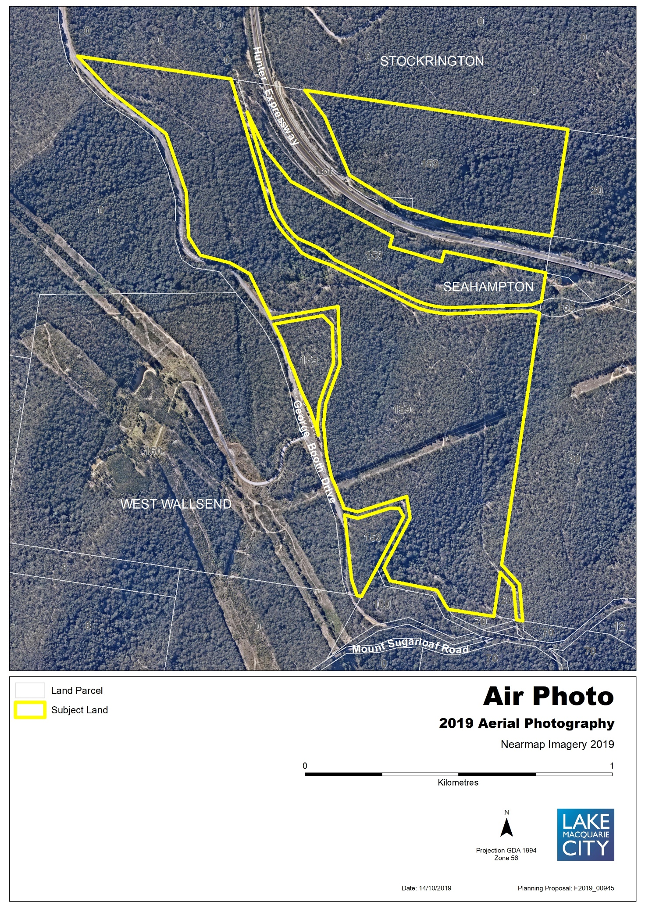
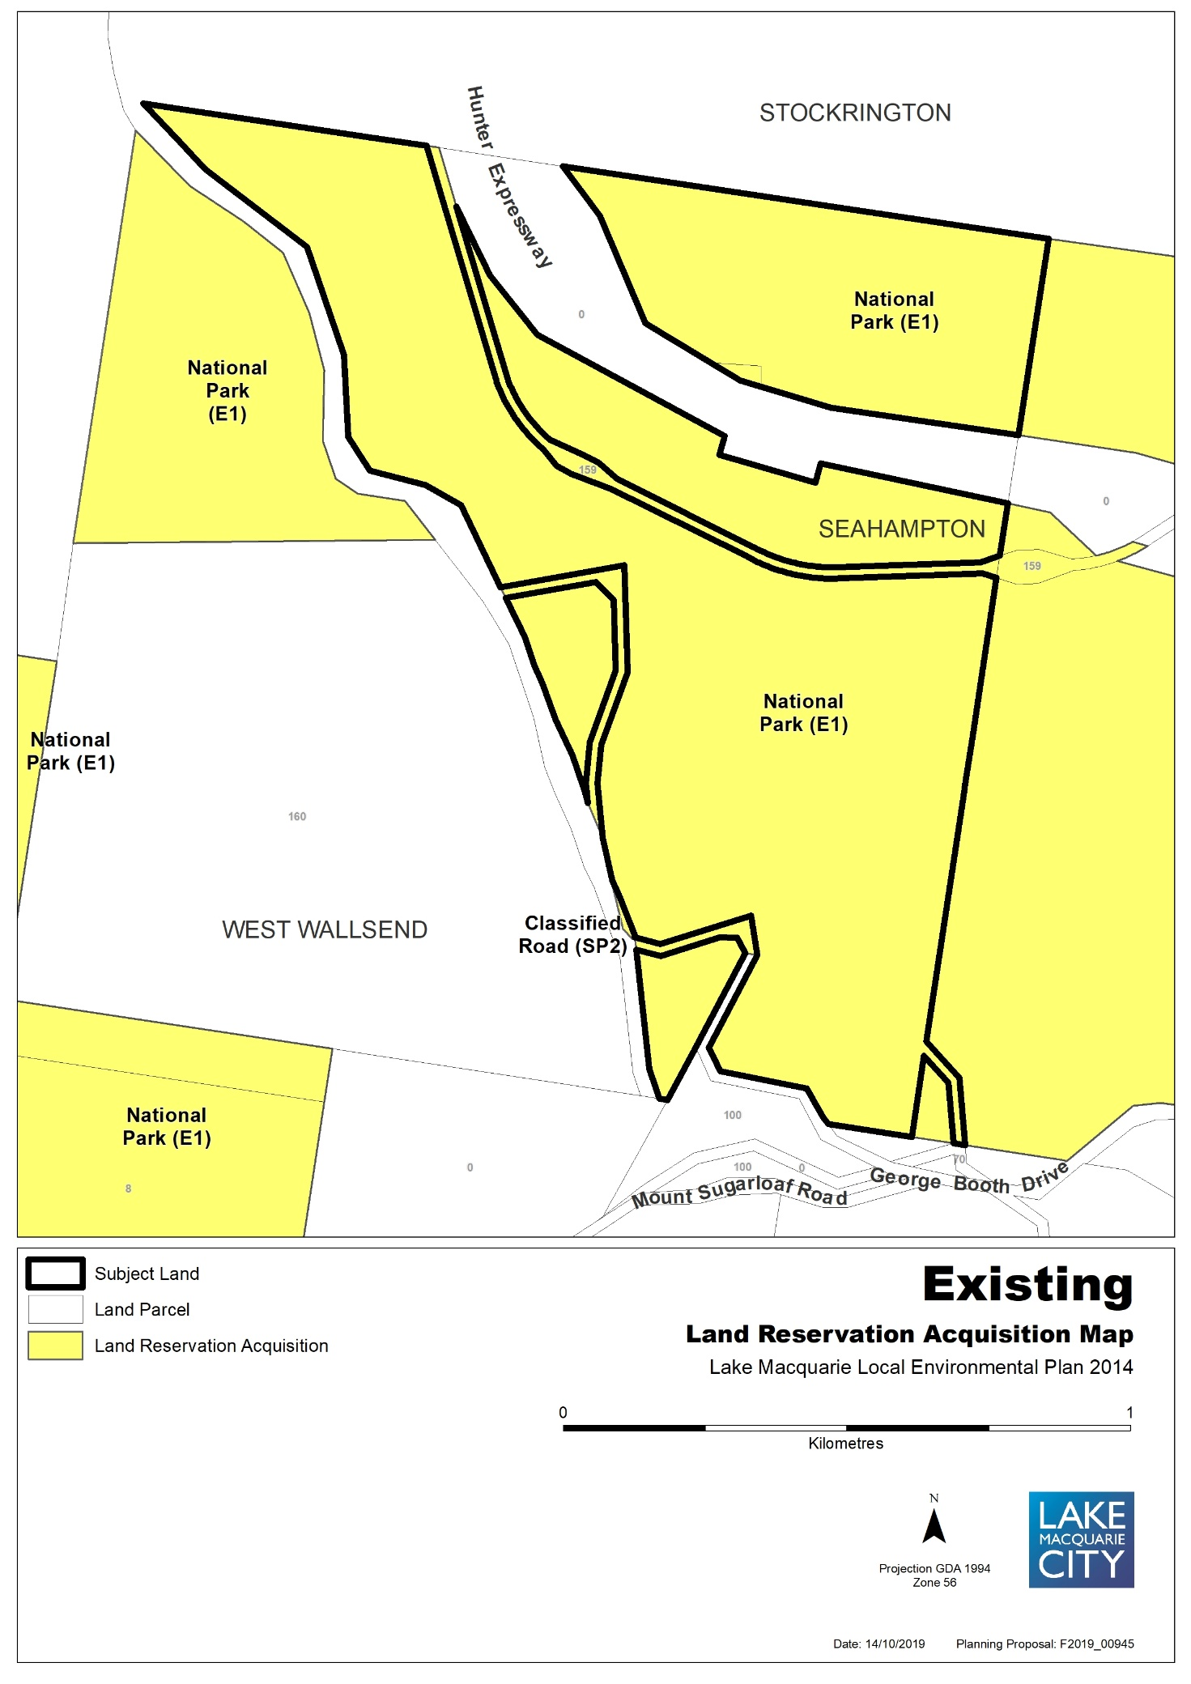

Map 13b – Item 12 – Proposed Land Acquisition Reservation
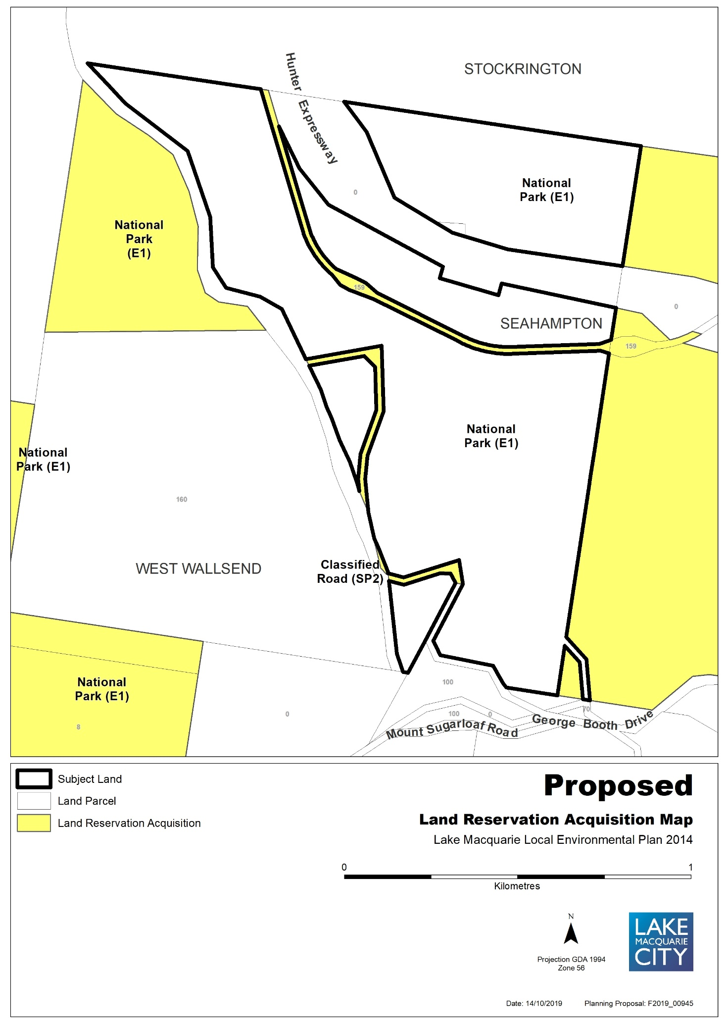
Map 14a – Item 13 – Aerial, Existing Land Acquisition Reservation
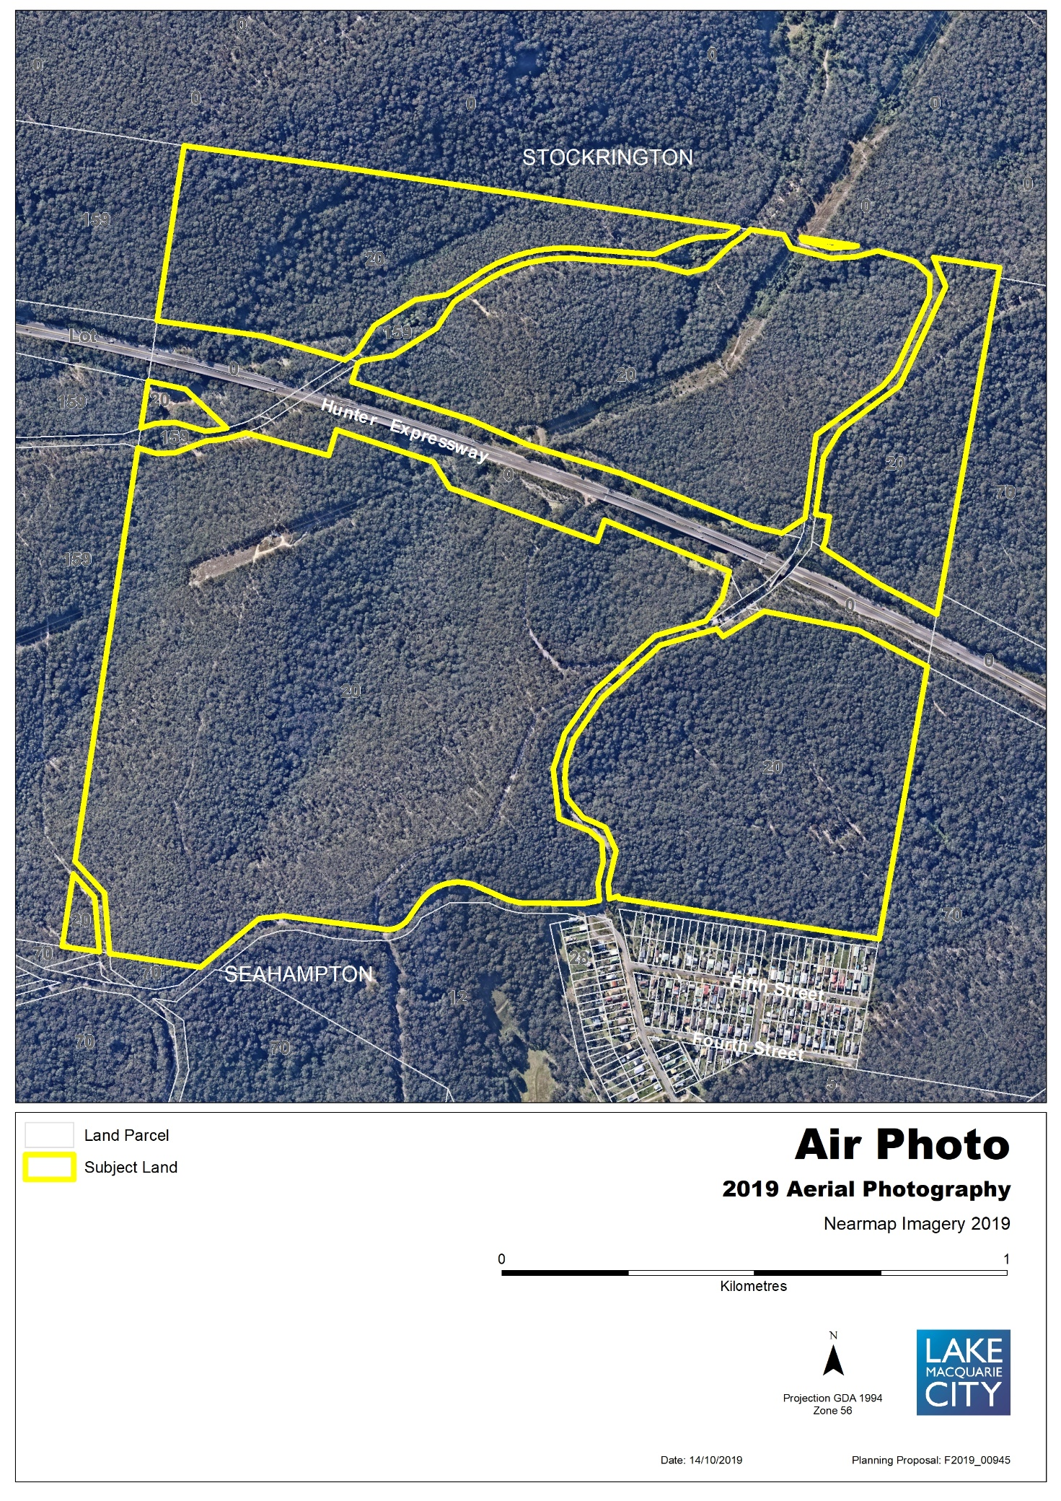
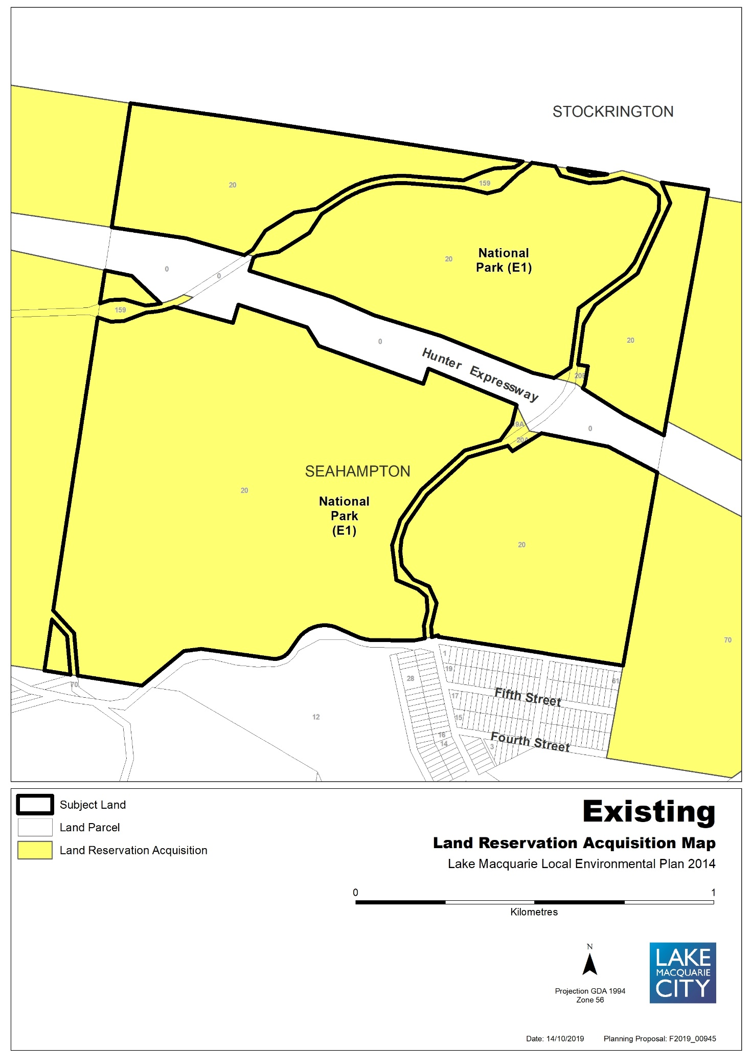

Map 14b – Item 13 – Proposed Land Acquisition Reservation
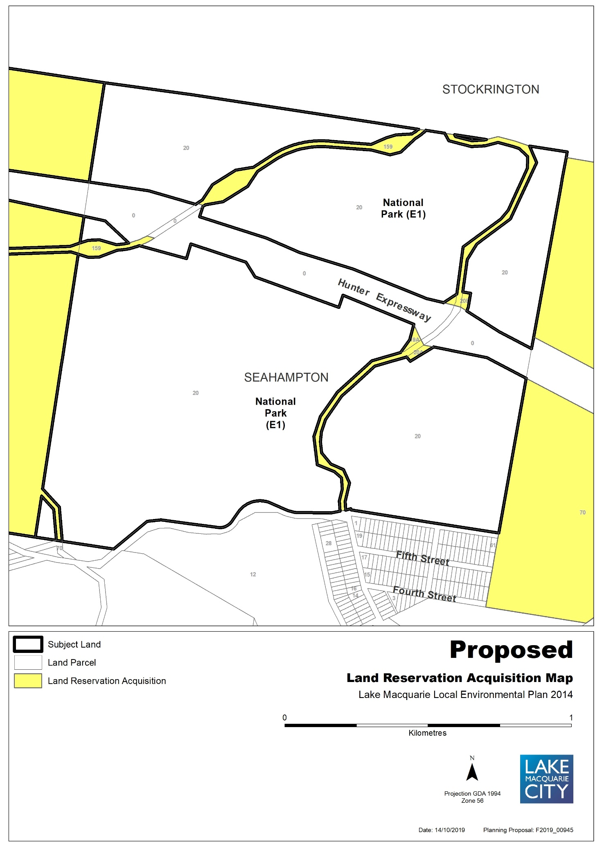
Map 15a – Item 14 – Aerial, Existing Foreshore Building Line
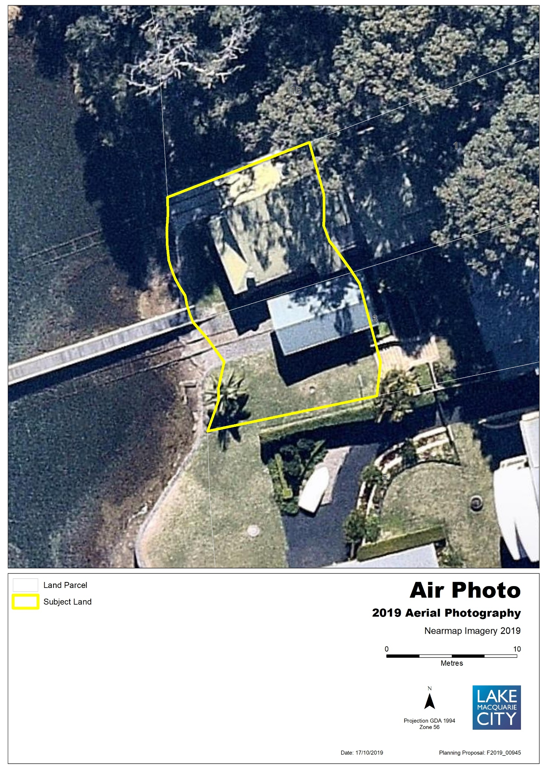
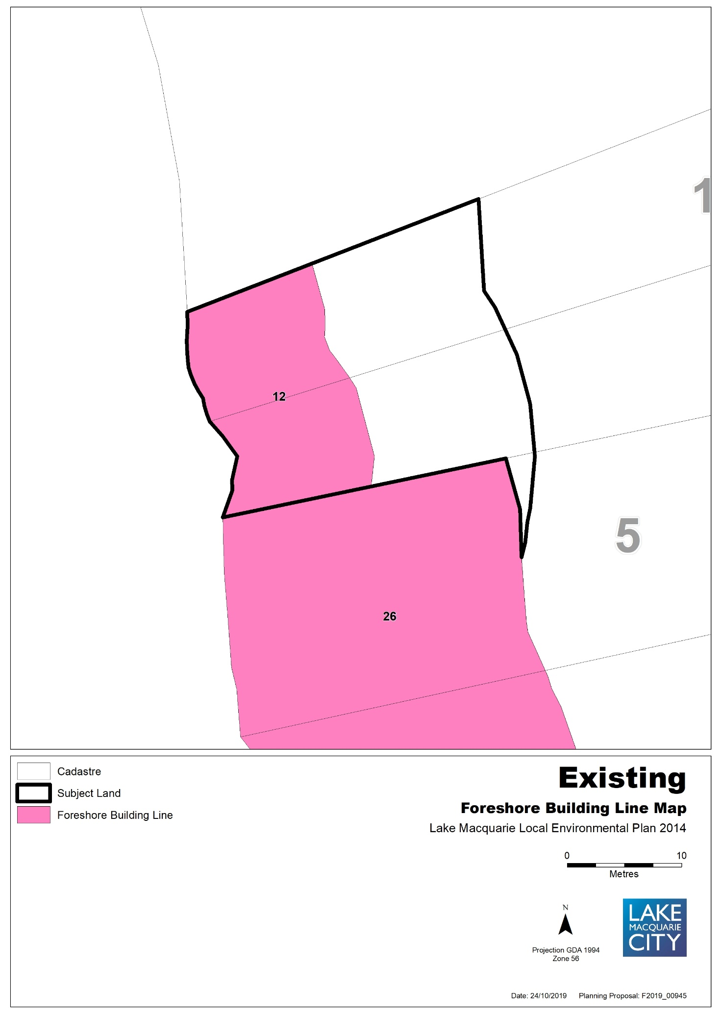

Map 15b – Item 14 – Proposed Foreshore Building Line
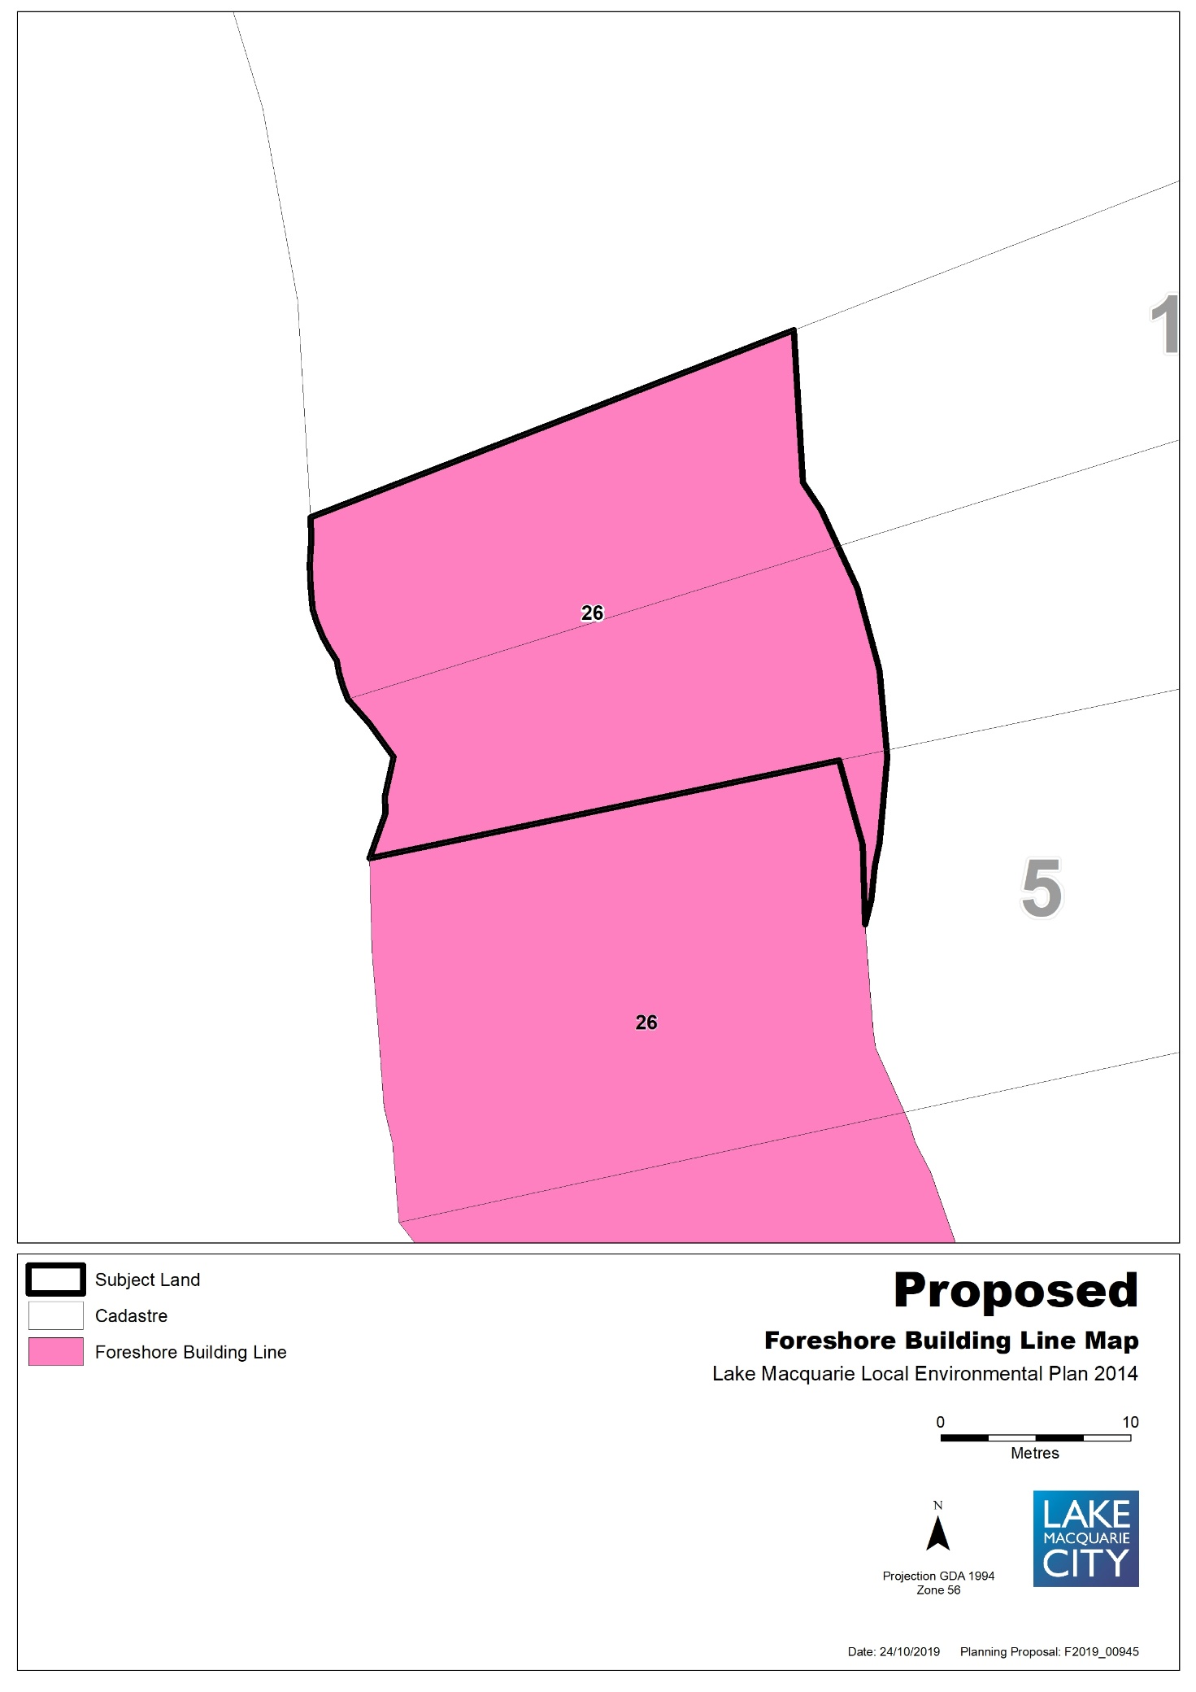
Map 16a - Item 16 - Aerial, Existing Heritage Map
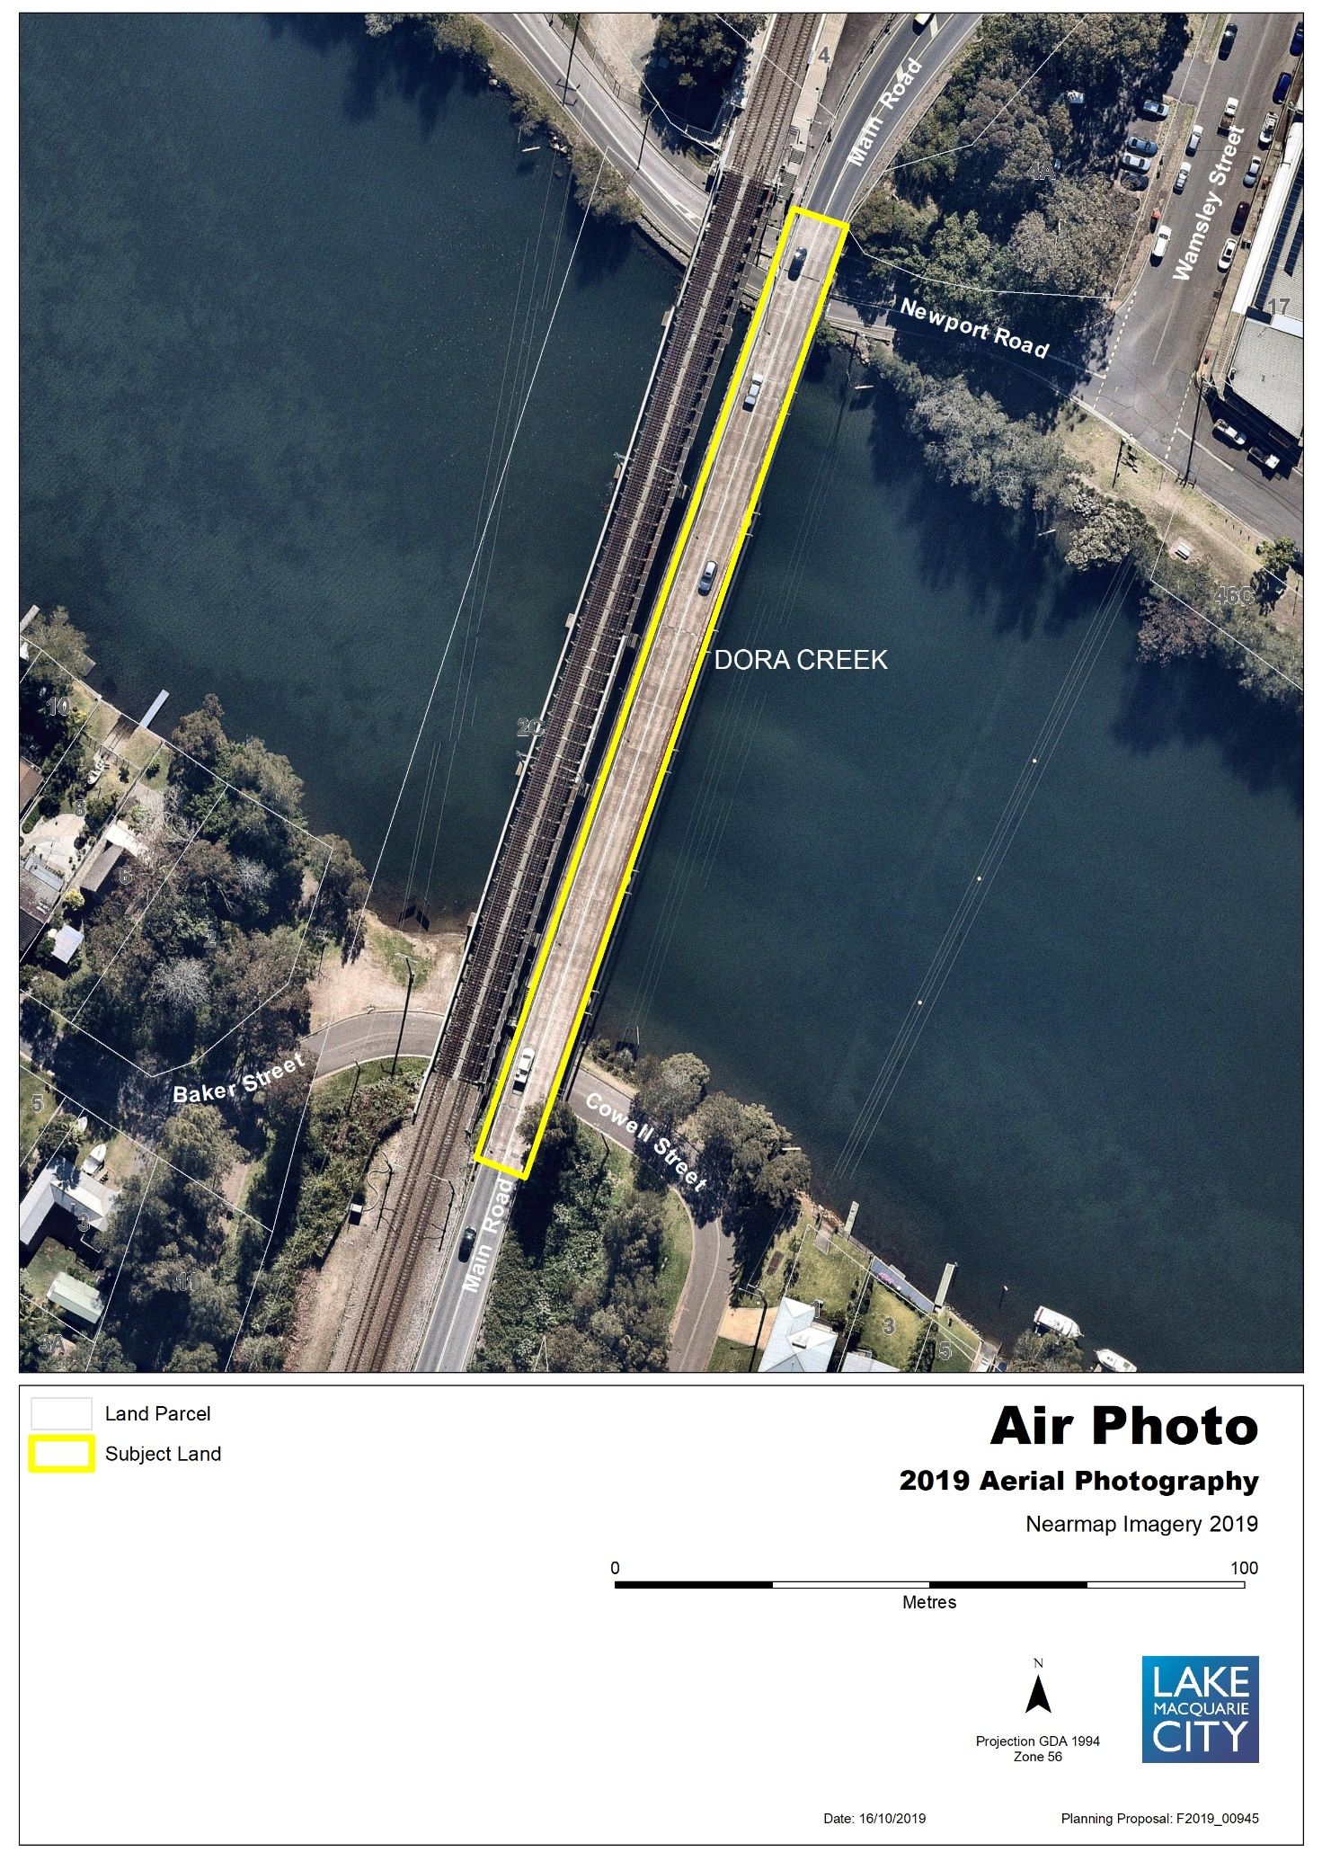
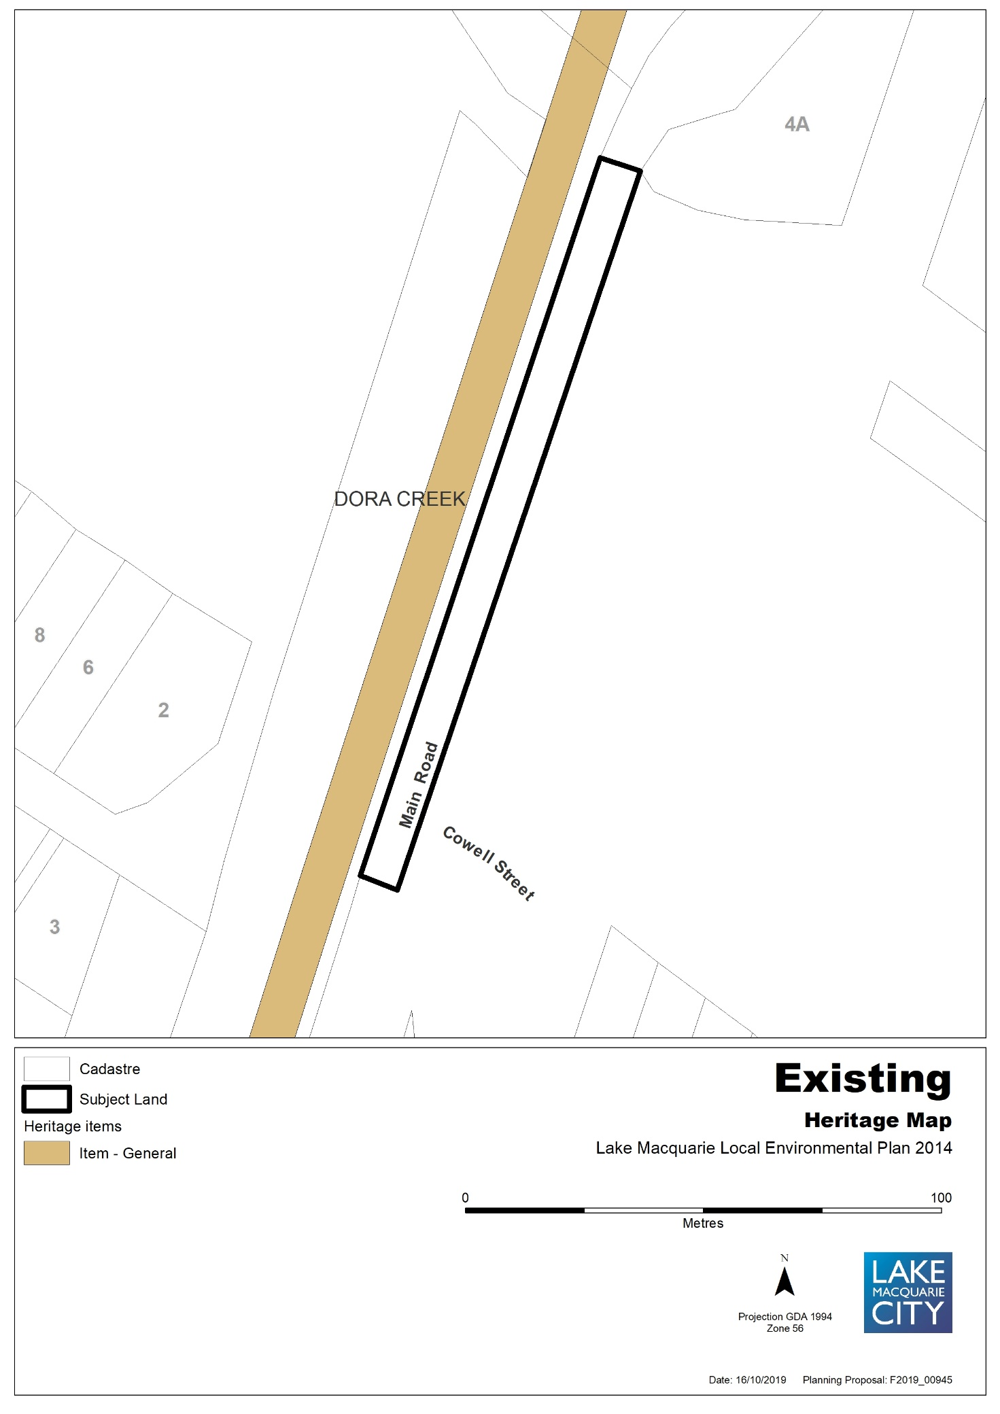

Map 16b - Item 16 – Proposed Heritage Map
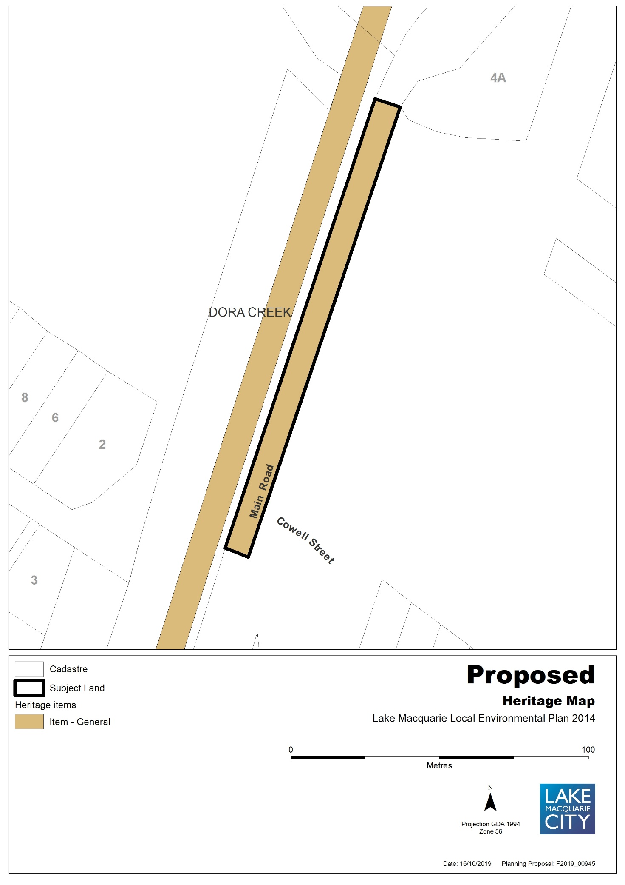
Map 17a – Item 17 - Aerial, Existing Heritage Map
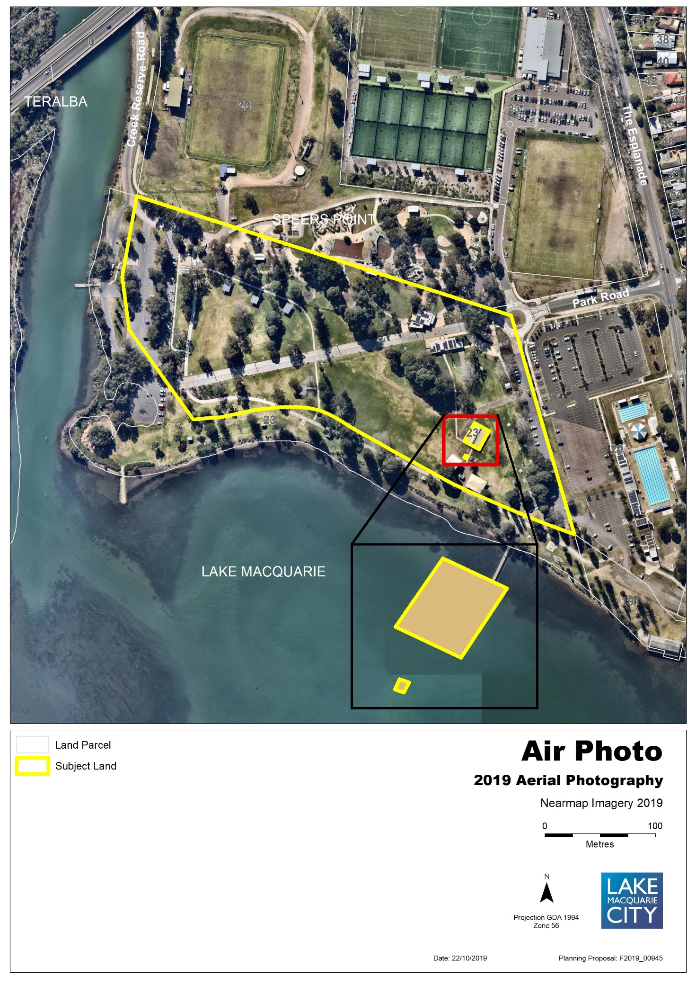
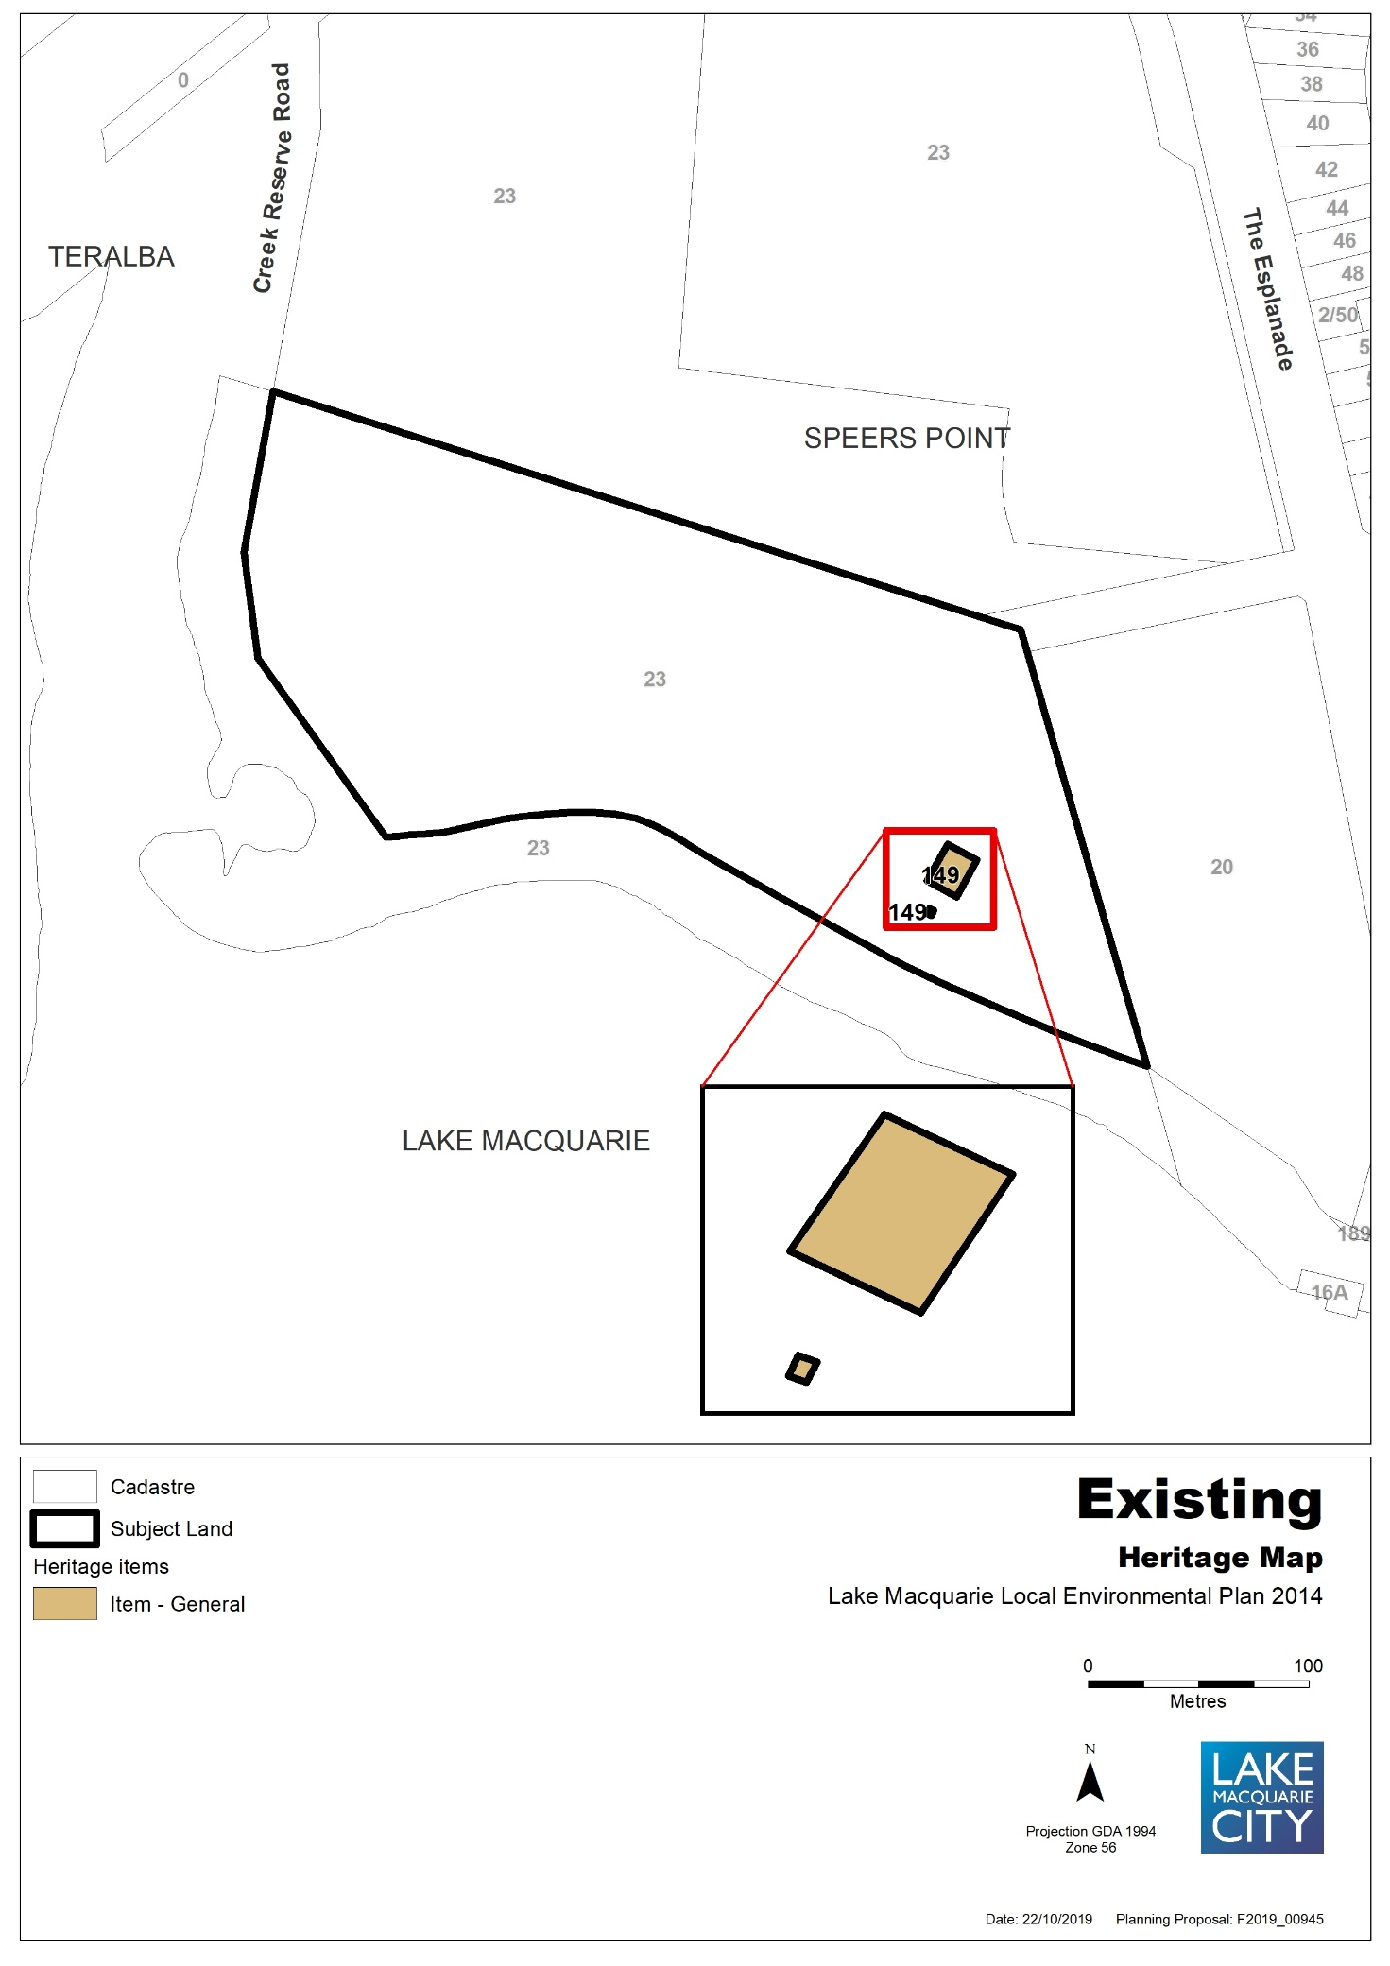

Map 17b – Item 17 – Proposed Heritage Map
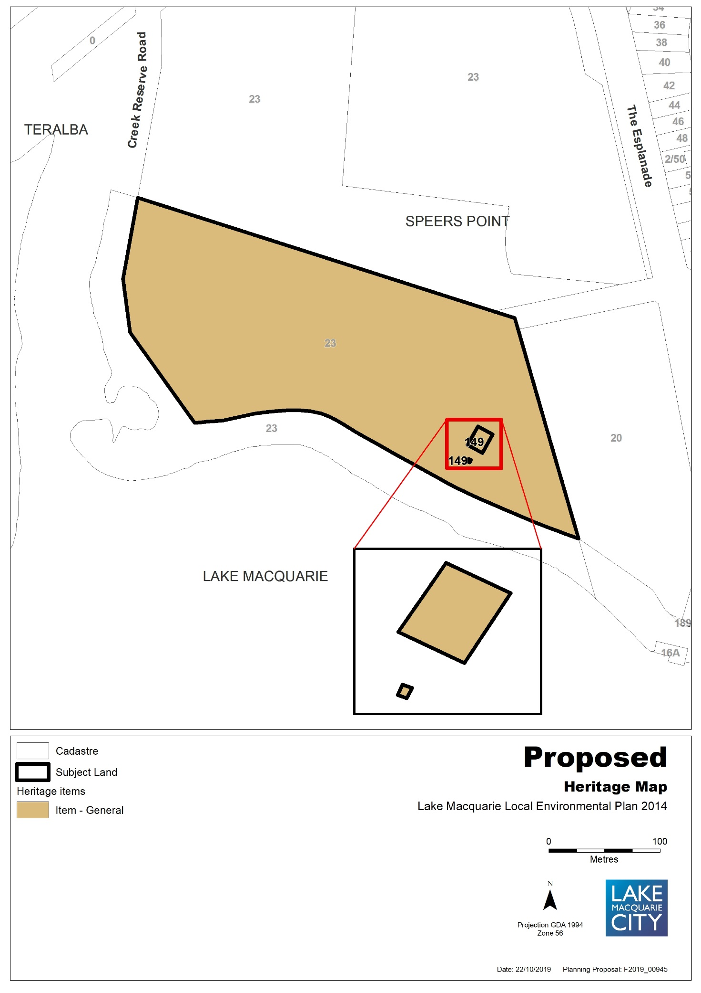
Map 18a – Item 18 – Aerial, Existing Urban Release Area Map
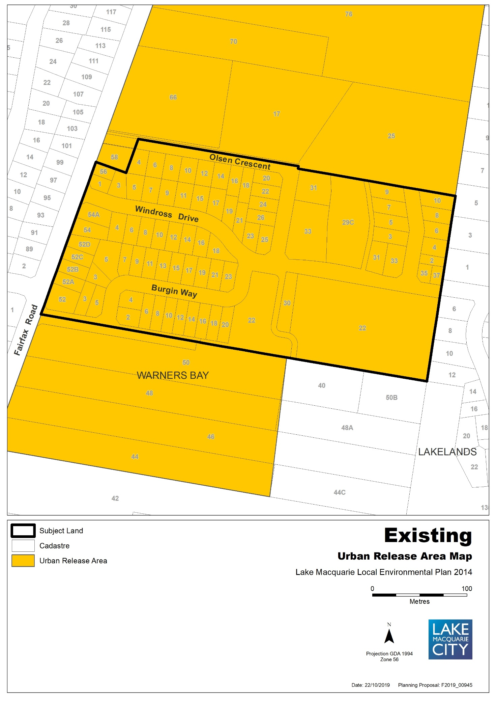
Map 18b – Item 18 – Proposed Urban Release Area Map
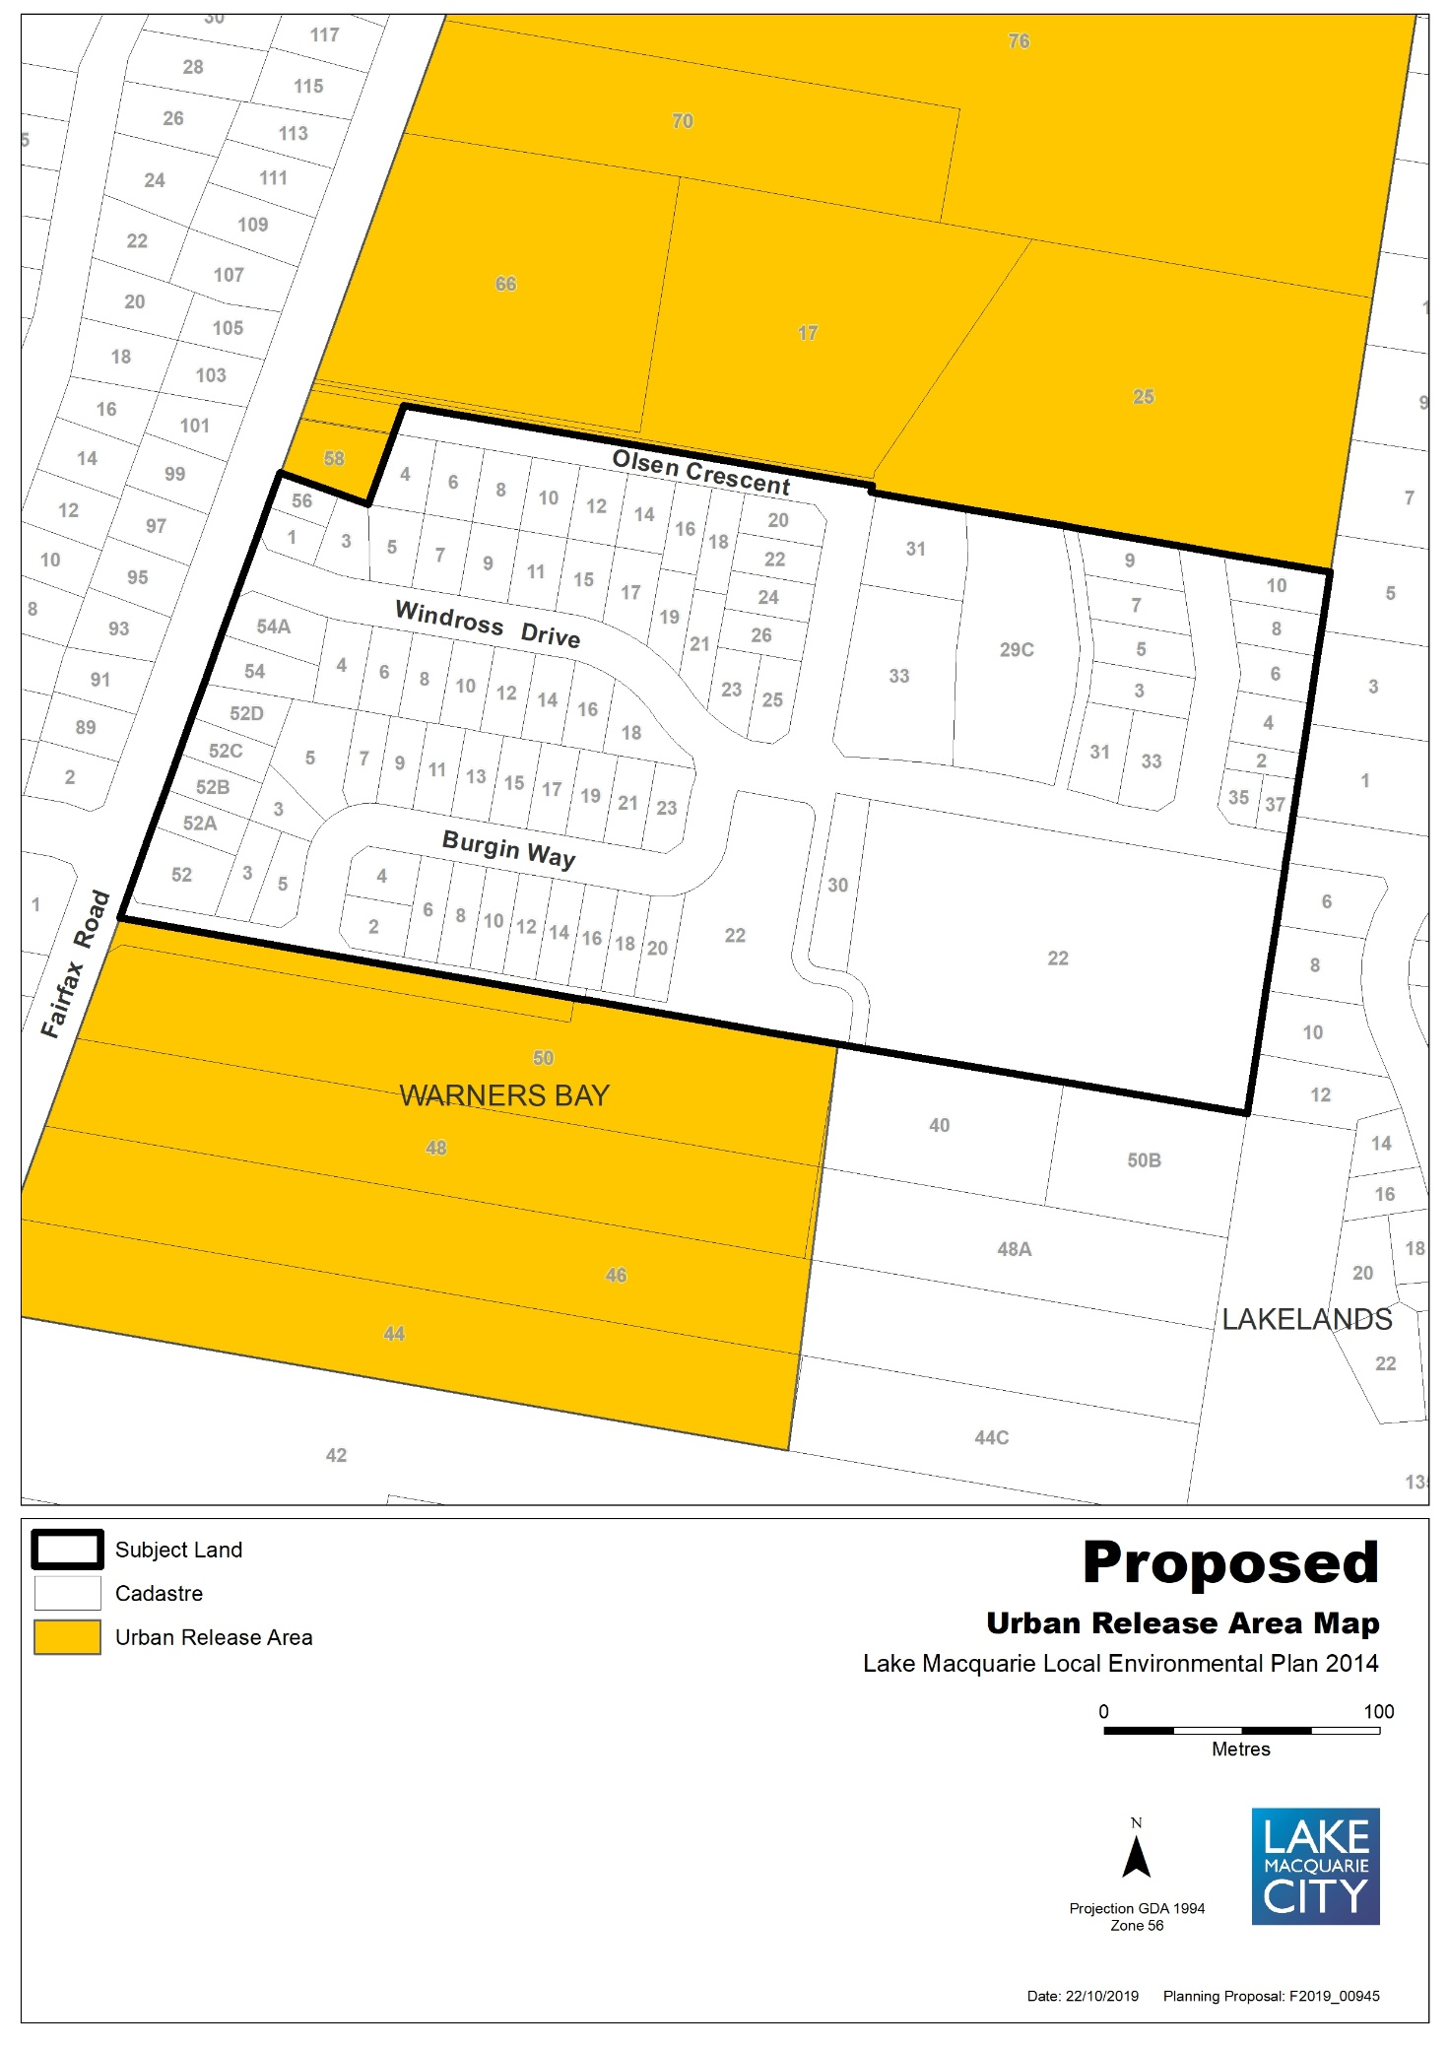
Part 5 – COMMUNITY CONSULTATION
Community consultation will be undertaken for a 28-day period. Landowners and stakeholders will be notified via mail of the public exhibition period.
Part 6 – PROJECT TIMELINE
Action | Timeframe
Anticipated commencement date (date of Gateway determination) | March 2020
Anticipated timeframe for completion of required technical information | Nil
Timeframe for government agency consultation (pre-exhibition) | 21 days
Public exhibition (commencement and completion dates) | 28 days
Date of Public hearing (if required) | Nil
Consideration of submissions | 2 weeks
Timeframe for government agency consultation (post exhibition if required) | 1 month
Post exhibition planning proposal consideration / preparation | September 2020
Submission to Department to finalise LEP | September 2020
Date RPA will make Plan (if delegated) | October 2020
Date RPA will forward to the Department for notification (if not delegated) | October 2020

Attachment 1
National Trust of Australia (NSW) Trust Register – Dora Creek road (former rail) bridge
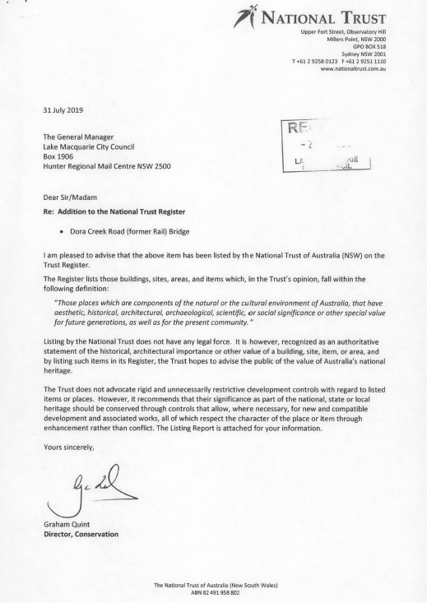

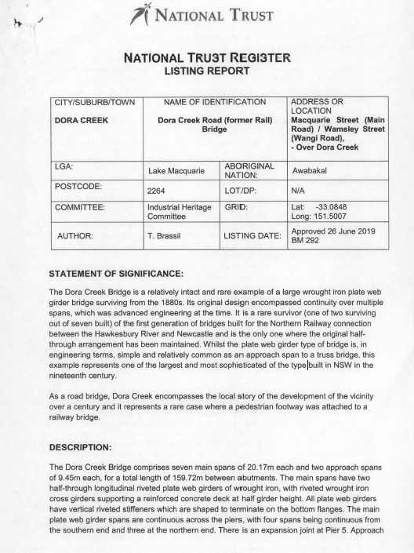

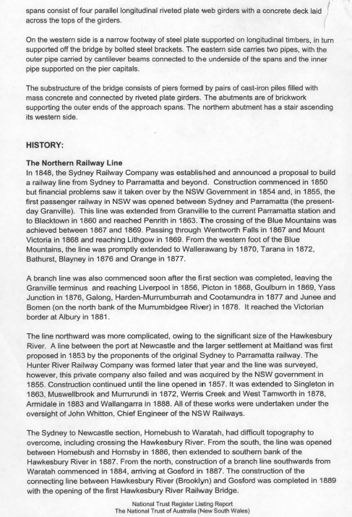

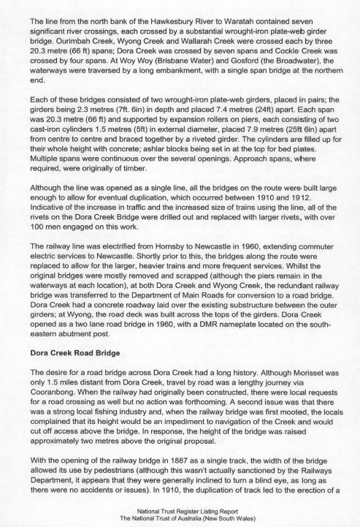

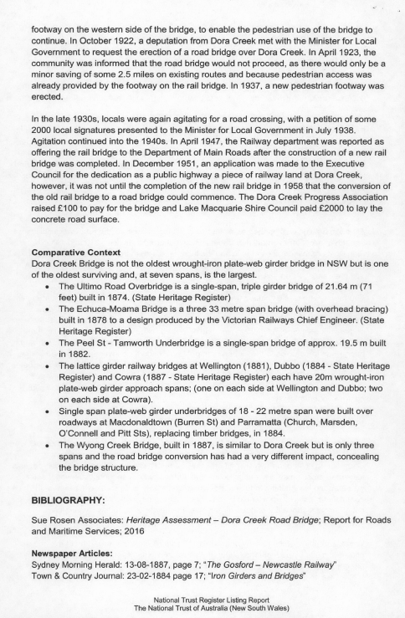

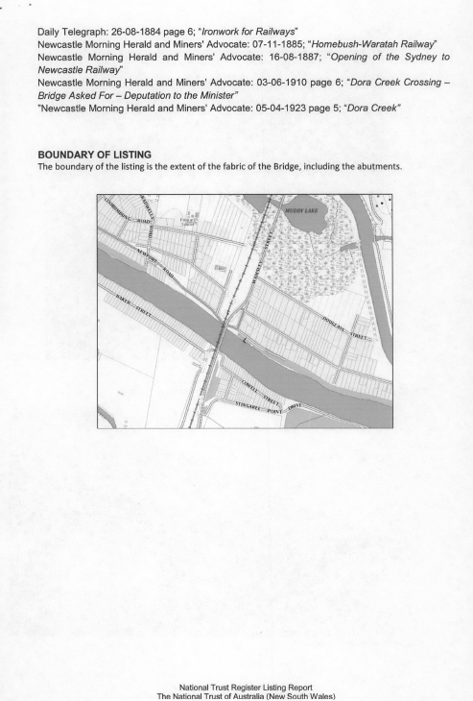

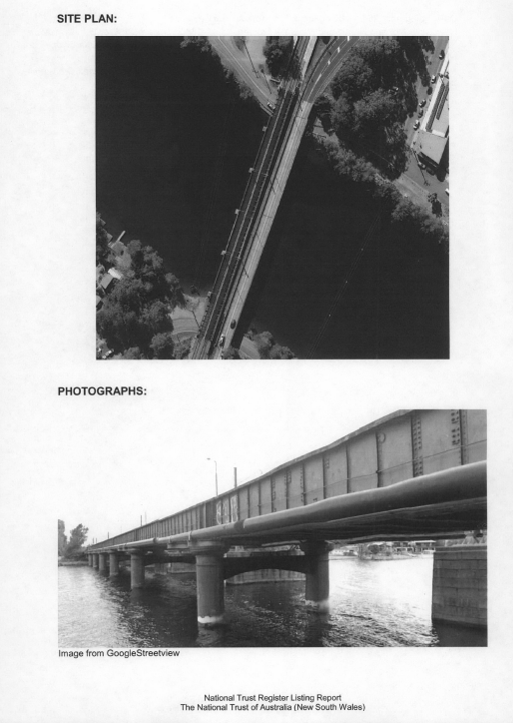

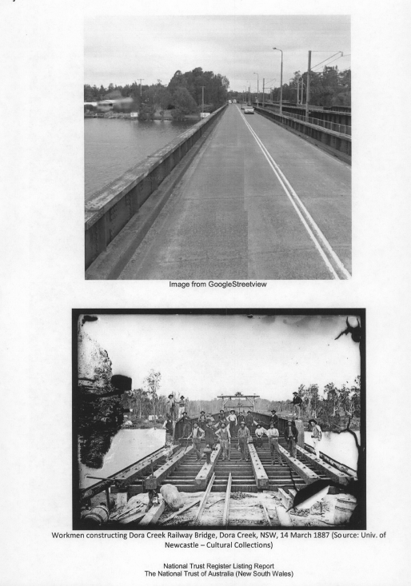

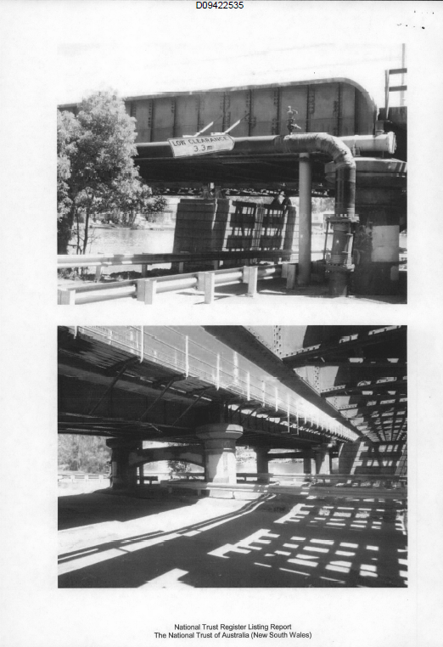
Attachment 2
Secretary’s Certificate – Satisfactory Arrangements for designated State public infrastructure – Development Application DA 1470/2013
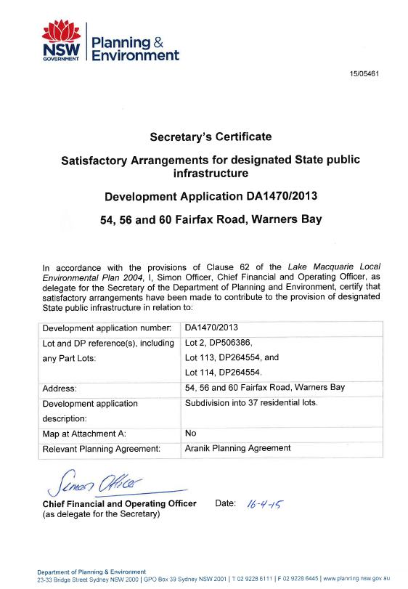
Attachment 3
Secretary’s Certificate – Satisfactory Arrangements for designated State public infrastructure – Development Application DA 791/2016
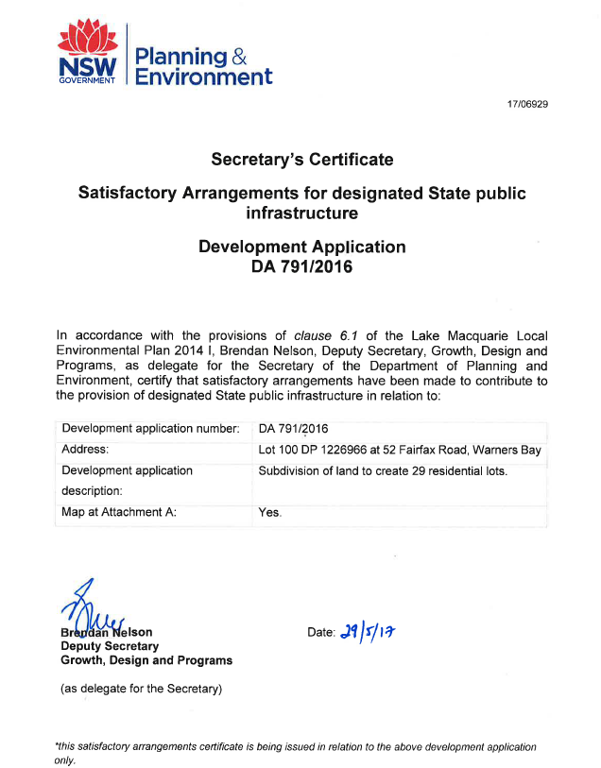

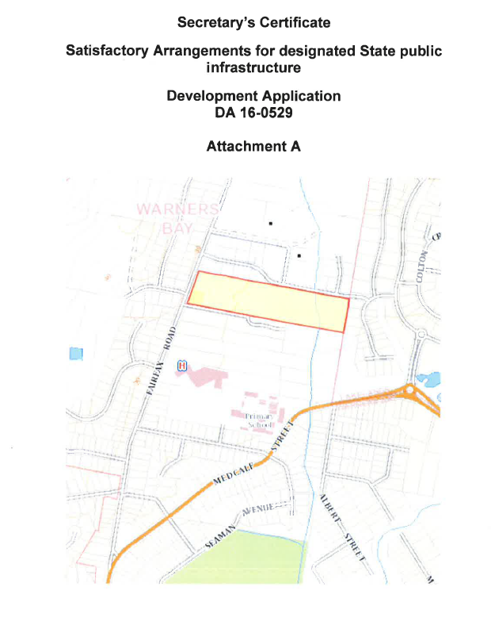

Attachment 4
Letter from Transport for NSW (former Roads and Maritime Service) regarding Item 16 – new heritage item - Dora Creek road (former rail) bridge at Main Road, Dora Creek

